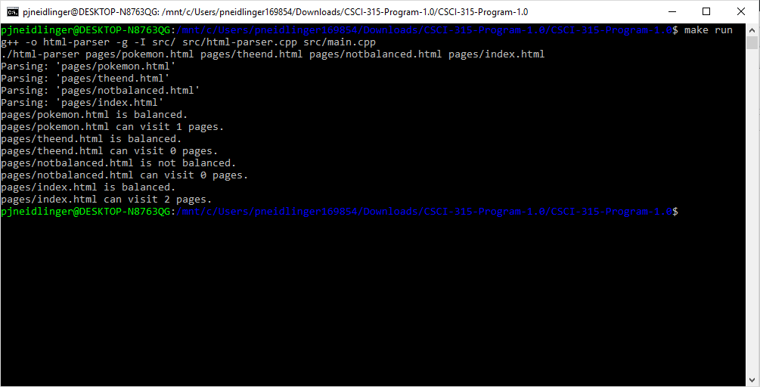

A screenshot of the program being run, passed the four HTML files, and the output of the program.

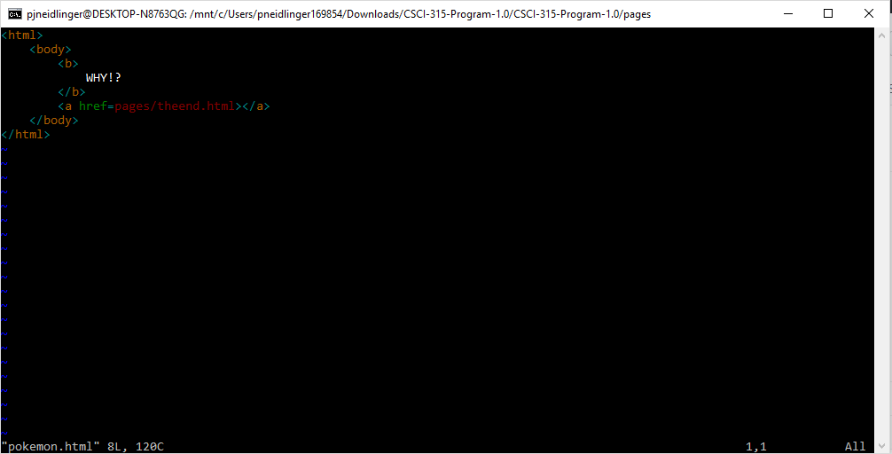

A screenshot of the first passed HTML file, which is balanced, and can visit one other unique, balanced, HTML file.

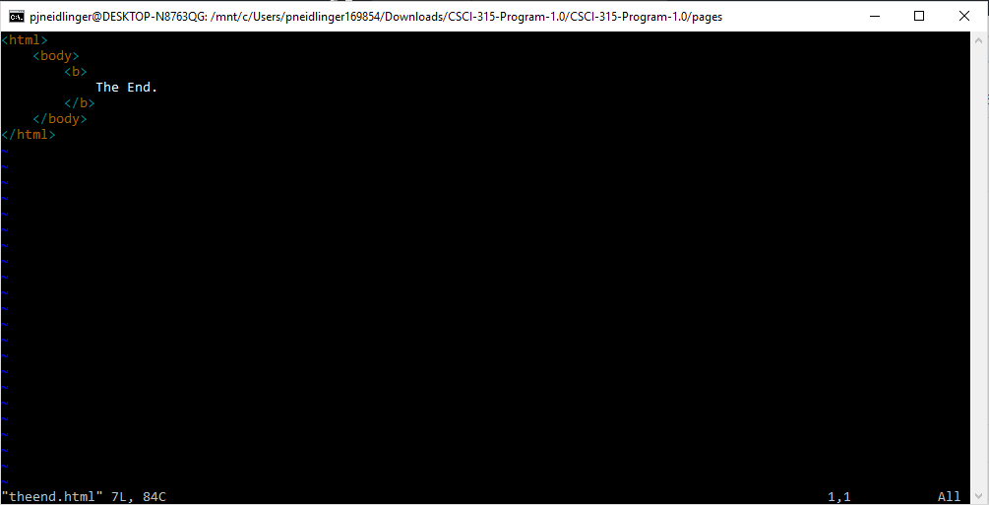

A screenshot of the second passed HTML file, which is balanced, and can visit no other files.

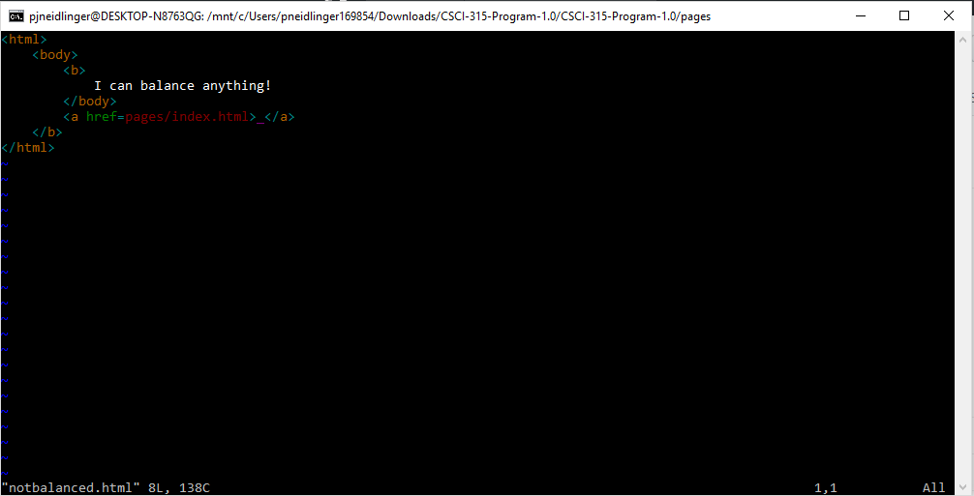

A screenshot of the third passed HTML file, which is not balanced.

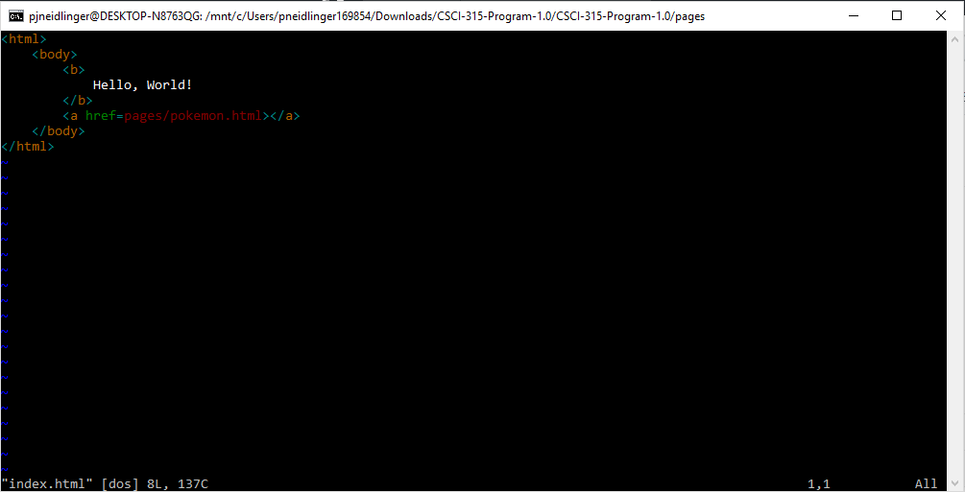

A screenshot of the fourth passed HTML file, which is balanced, and can visit two other unique, balanced, HTML files.