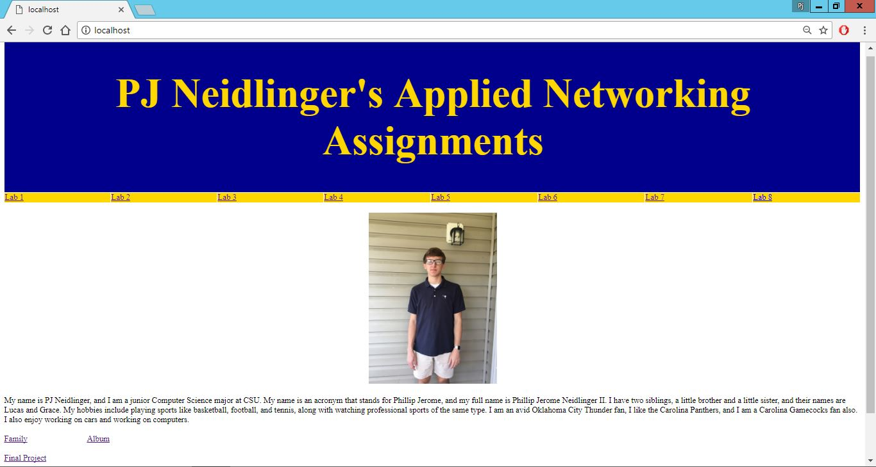

This is a screenshot of the home page of my Personal Website.

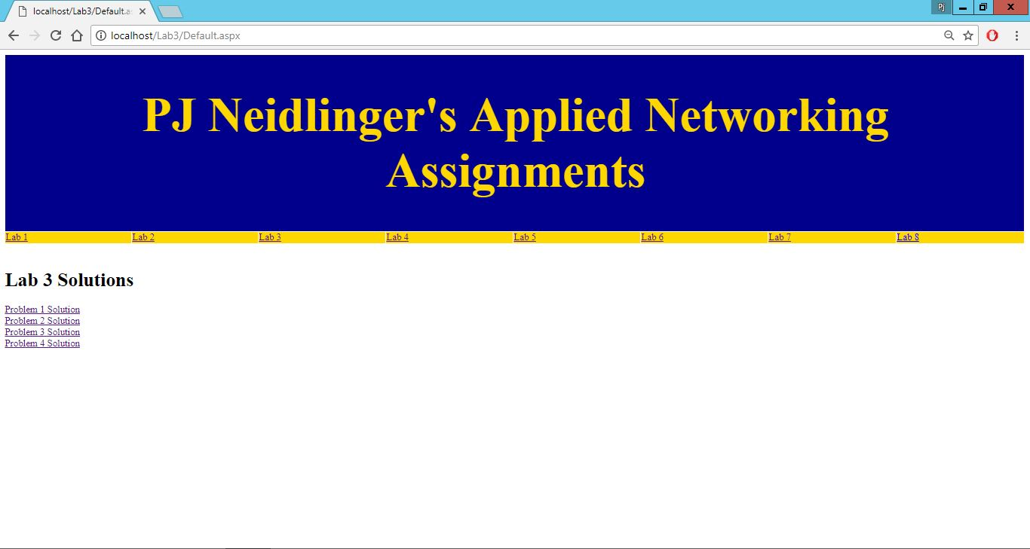

This is a screenshot of my solution page for the third lab we completed this semester.

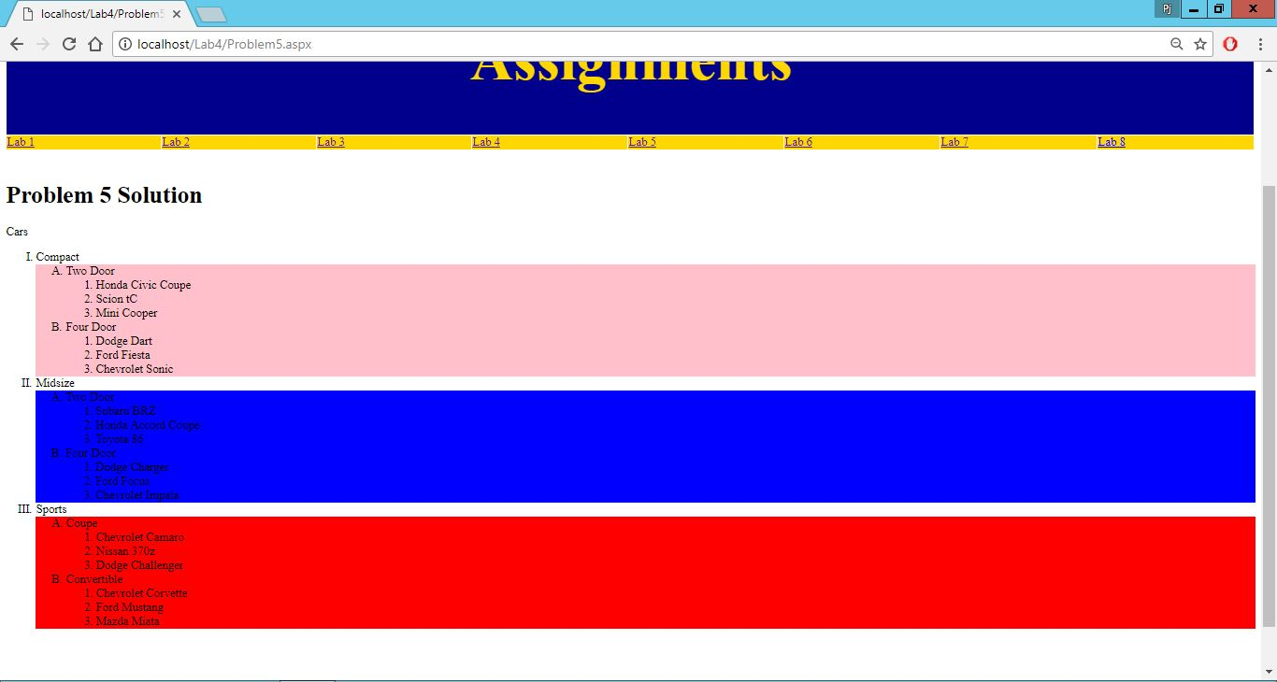

This is a screenshot of the solution for the fifth problem of the fourth lab we completed this semester.

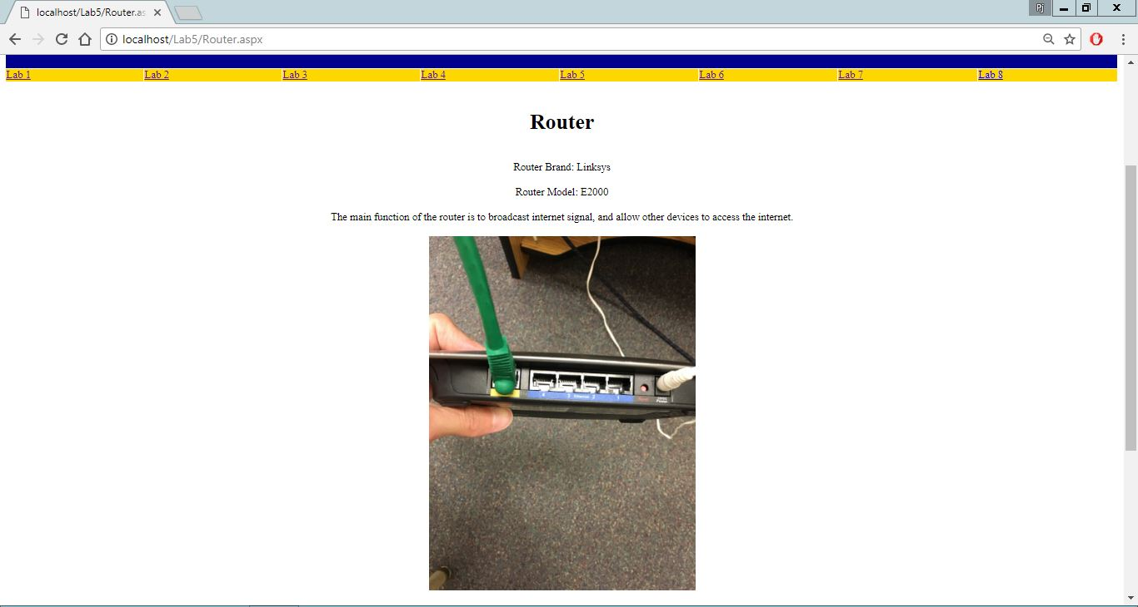

This is a screenshot of the Router page solution for the fifth lab we completed this semester.

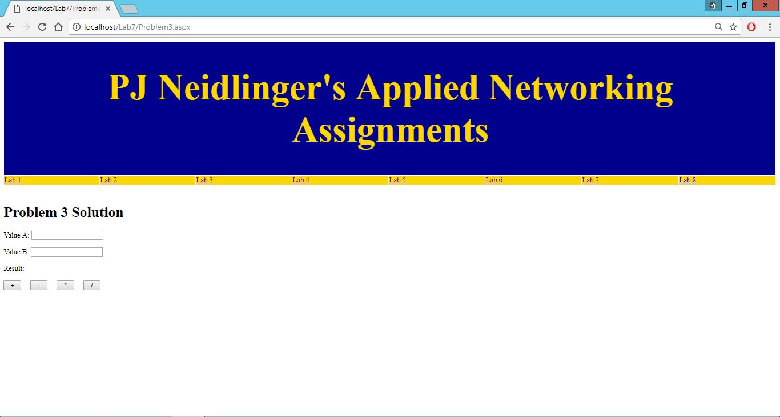

This is a screenshot of the solution for the third problem of the seventh lab we completed this semester.