P. PENIEL JOHN WHISTELY
penijo112@gmail.com

Abstract—Predicting how the stock market performs has become important with the increase in the number of people who invest in shares of a company and with the frequent fluctuations in the stock price of a company it has become more important. Several factors that affect the stocks are economic factors, industry trends, market sentiments, company news and performance, unexpected events such as natural disasters. Based on these factors the price of the stocks can be predicted. The successful prediction of a stock's future price could yield a significant profit. Stock price prediction can be done by three methods, they are, fundamental analysis, technical analysis and technological methods. With the advent of technology, here we use the technological method. We use machine learning for the stock price prediction. We predict the present stocks with the help of previous stock prices of the company. We use Python for the project and the model we will be using is the Sequential Regression Model which allows the greater control of the regression process. The result of this project shows the success of making profit.

Index Terms—SEQUENTIAL REGRESSION, RECURRENT NEURAL NETWORK AND STOCK PRICE PREDICTION
I. INTRODUCTION
Forecasting is the process of predicting the future values based on historical data and analysing the trend of current data. Processing powers of computers nowadays have become powerful enough to process large amount of data. By running simulations of future states based on present states, we can foresee the trend of stock market.
In the recent years, increasing prominence of machine learning in various industries have enlightened many traders to apply machine learning techniques to the field, and some of them have produced quite promising results. This paper will develop a financial data predictor program in which there will be a dataset storing all historical stock prices and data will be treated as training sets for the program. The main purpose of the prediction is to reduce uncertainty associated to investment decision making.

Stock Market follows the random walk, which implies that the best prediction you can have about tomorrow’s value is today’s value. Indisputably, the forecasting stock indices is very difficult because of the market volatility that needs accurate forecast model. The stock market

indices are highly fluctuating and it effects the investor’s belief. Stock prices are considered to be a very dynamic and susceptible to quick changes because of underlying nature of the financial domain and in part because of the mix of a known parameters (Previous day’s closing price, P/E ratio etc.) and the unknown factors (like Election Results, Rumours etc.). There have been numerous attempts to predict stock price with Machine Learning. The probable stock market prediction target can be the future stock price or the volatility of the prices or market trend. In the prediction there are two types like dummy and a real time prediction which is used in stock market prediction system. In Dummy prediction they have define some set of rules and predict the future price of shares by calculating the average price. In the real time prediction compulsory used internet and saw current price of shares of the company. Computational advances have led to introduction of machine learning techniques for the predictive systems in financial markets. In this paper we are using a Machine Learning technique in order to predict the stock market and we are using Python language for programming.
II. SEQUENTIAL REGRESSION ALGORITHM
Sequential regression or Stepwise regression is a way to build a model by adding or removing predictor variables, usually via a series of F-tests or T-tests. The variables to be added or removed are chosen based on the test statistics of the estimated coefficients. While the technique does have its benefits, it requires skill on the part of the researcher so should be performed by people who are very familiar with statistical testing. In essence, unlike most regression models, the models created with stepwise regression should be taken with a grain of salt: they require a keen eye to detect whether they make sense or not.

ARCHITECHTURE:

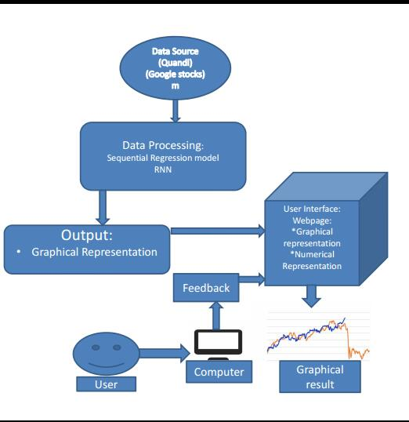
The data of google stocks is taken from the Quandl and then it is stored in the memory. Then the data is processed through Sequential regression model under Recurrent Neural Networks. Now the generated output is displayed in graphical representation. Finally, the predicted stock price is displayed to the user on the user web page. The user can even interact with us using the feedback system.

PROCEDURE:
- Assume a dataset of dimension (nxp) with item non-response/missingness.
- Partition the dataset into n1 variables with no missing obs, say X=(X1,X2,......,Xn1) and (n-n1) with missing values Y=(Y1,Y2,.......,Yn-n1).
- Y is ordered by degree of missingness, from least to most.
- Then, the conditional distrubution of Y1, i=1, 2, n-n1, given the observed values is modelled as a regression model of Yi on X, e.g. E(Y1|X) =Xβ + e.
- Missing values are imputed using this model.
- Once, Y1 is imputed, it is used as a predictor for Y2, i.e. X= (X1, X2,.....,Xn1,Y1,.....,Yn-n1).
- Now, a new round bigins, using the full dataset as predictor for Y1 again, thus updating the regression coefficients.
- The algorithm is repeated until the full convergence in the regression coefficients is achieved, i.e. change below a specified margin δ.
- Finally, the missing values for each Yi are imputed using the corresponding converged regression model.
- In order to yield multiple imputations, the complete algorithm is repeated m times, resulting in m completed datasets.
- The m datasets are analysed and the results combined to yield final parameter estimates.
FLEXIBILITY:
- Basically, all model types can be fitted.
- Stepwise regressions possible to ensure that only most important predictors enter the model.
- Introduction of randomization in the imputation process through prior distribution on regression coefficients, and/or perturbation of imputed values.
- No assumption of specific distribution for joint distribution necessary.
COMPUTATIONAL REALIZATION:
- SAS callable IVEware(Imputation, Variance Estimation software) developed by Raghunathan, Solenberger, Van Hoewyk.
- Allows for the modelling linear, logistic, Poisson and generalized logit distributions.
- Prior distributions on coefficients.
- Stepwise regressions with specified R2.
- Inclusion of interaction terms in model.
- Restrictions on imputed variables.

III. RECURRENT NEURAL NETWORK
Recurrent Neural Networks (RNNs) add an interesting twist to basic neural networks. A vanilla neural network takes in a fixed size vector as input which limits its usage in situations that involve a ‘series’ type input with no predetermined size.
Recurrent Neural Network remembers the past and its decisions are influenced by what it has learnt from the past. Note: Basic feed forward networks “remember” things too, but they remember things they learnt during training. For example, an image classifier learns what a “1” looks like during training and then uses that knowledge to classify things in production.
While RNNs learn similarly while training, in addition, they remember things learnt from prior input(s) while generating output(s). It’s part of the network. RNNs can take one or more input vectors and produce one or more output vectors and the output(s) are influenced not just by weights applied on inputs like a regular NN, but also by a “hidden” state vector representing the context based on prior input(s)/output(s). So, the same input could produce a different output depending on previous inputs in the series.
LSTM:
We cannot close any post that tries to look at what RNNs and related architectures are without mentioning LSTMs. This is not a different variant of RNN architecture, but rather it introduces changes to how we compute outputs and hidden state using the inputs.
In a vanilla RNN, the input and the hidden state are simply passed through a single tanh layer. LSTM (Long Short-Term Memory) networks improve on this simple transformation and introduces additional gates and a cell state, such that it fundamentally addresses the problem of keeping or resetting context, across sentences and regardless of the distance between such context resets. There are variants of LSTMs including GRUs that utilize the gates in different manners to address the problem of long-term dependencies.
What we have seen here so far are only the vanilla architecture and some additional well-known variants. But knowing about RNNs and the related variants has made it clearer that the trick to designing a good architecture is to get a sense of the different architectural variations, understand what benefit each of the changes bring to the table, and apply that knowledge to the problem at hand appropriately.
HOW RNN WORKS:
The working of an RNN can be understood with the help of below example:
Example:
Suppose there is a deeper network with one input layer, three hidden layers and one output layer. Then like other neural networks, each hidden layer will have its own set of weights and biases, let’s say, for hidden layer 1 the weights and biases are (w1, b1), (w2, b2) for second hidden layer and (w3, b3) for third hidden layer. This means that each of these layers are independent of each other, i.e. they do not memorize the previous outputs.
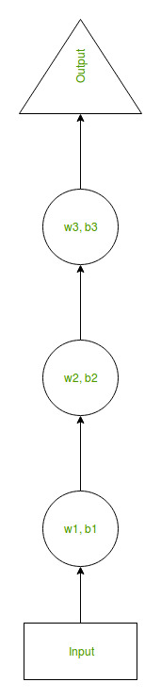
Fig. 1. Three Linear Threshold Units (LTUs) and input and output layers
Now the RNN will do the following:
- RNN converts the independent activations into dependent activations by providing the same weights and biases to all the layers, thus reducing the complexity of increasing parameters and memorizing each previous output by giving each output as input to the next hidden layer.
- Hence these three layers can be joined together such that the weights and bias of all the hidden layers is the same, into a single recurrent layer.
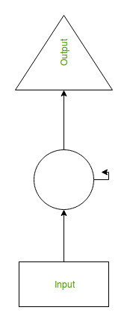
Fig. 2. Single recurrent layer with hidden layers.
- Formula for calculating current state:
ht = f(ht-1, xt)
where: ht --> current state
ht-1--> previous state
xt--> input state
- Formula for applying Activation function(tanh):
ht = tanh (Whhht-1+WxhXt)
where: Whh --> weight at recurrent neuron
Wxt --> weight at input neuron
- Formula for calculating output:
yt = Whyht
where: yt --> output
Why --> weight at output layer
TRAINING THROUGH RNN:
- A single time step of the input is provided to the network.
- Then calculate its current state using set of current input and the previous state.
- The current ht becomes ht-1 for the next time step.
- One can go as many time steps according to the problem and join the information from all the previous states.
- Once all the time steps are completed the final current state is used to calculate the output.
- The output is then compared to the actual output i.e. the target output and the error is generated.
- The error is then back-propagated to the network to update the weights and hence the network (RNN) is trained.

ADVANTAGES OF RECURRENT NEURAL NETWORKS:
- An RNN remembers each and every information through time. It is useful in time series prediction only because of the feature to remember previous inputs as well. This is called Long Short-Term Memory.
- Recurrent neural network is even used with conventional layers to extend the effective pixel neighbourhood.

IV. RESULTS AND DISCUSIIONS
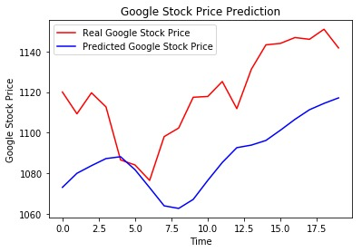
- The result we got from prediction is not much accurate but it reached the closeness of values at certain points.
- Having more data is always a good idea. It allows the “data to tell for itself,” instead of relying on assumptions and weak correlations. Presence of more data results in better and more accurate.
- The unwanted presence of missing and outlier values in the training data often reduces the accuracy of a model or leads to a biased model. It leads to inaccurate predictions.
- It is always a better idea to apply ensemble methods to improve the accuracy of our model.
- The model can be trained more number of times for increased accuracy by trial and error.

V. CONCLUSION
The popularity of stock market trading is growing rapidly, which is encouraging researchers to find out new methods for the prediction using new techniques. The forecasting technique is not only helping the researchers but it also helps investors and any person dealing with the stock market. In order to help predict the stock indices, a forecasting model with good accuracy is required. In this work, we have used one of the most precise forecasting technologies using Recurrent Neural Network and Long Short-Term Memory unit which helps investors, analysts or any person interested in investing in the stock market by providing them a good knowledge of the future situation of the stock market.

VI. REFERENCES

- https://blog.usejournal.com/stock-market-prediction-by-recurrent-neural-network-on-lstm-model-56de700bff68?gi=3b7cf3867922
- https://www.slideshare.net/mobile/anilsth91/stock-market-analysis-and-prediction
- https://www.kdnuggets.com/2018/11/keras-long-short-term-memory-lstm-model-predict-stock-prices.html
- https://www.statisticshowto.datasciencecentral.com/stepwise-regression/
- https://towardsdatascience.com/recurrent-neural-networks-d4642c9bc7ce
- https://www.google.com/url?sa=t&source=web&rct=j&url=https://unstats.un.org/unsd/methods/wgci/Sequential%2520Regression%2520A%2520Method%2520for%2520Multipe%2520Imputation.ppt&ved=2ahUKEwja9fux5cjjAhVdnI8KHfRvC1UQFjAMegQIBxAB&usg=AOvVaw13rs8ehlNijIr7JSoaNZUs
- https://blog.quantinsti.com/machine-learning-trading-predict-stock-prices-regression/

