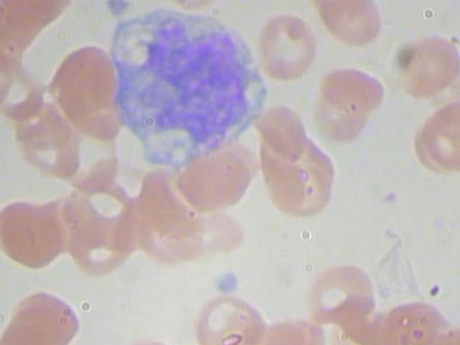Classifying White Blood Cells

**Problem Statement**

Images were taken of a patient’s blood sample to identify, characterize and count the various components present. Given an image containing a single white-blood-cell, classify what type of white-blood-cell is shown.

**Background**

White blood cells are the workers of your immune system. There are 5 main classes of white blood cells, each responding to different conditions such as bacterial infection or allergic reaction. An over- or under- representation of any class can provide vital information as to a patient’s illness or condition.

**Dataset**

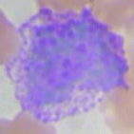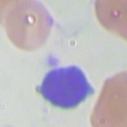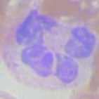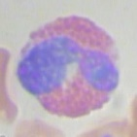Found on Kaggle (kaggle.com/paultimothymooney/blood-cells), the dataset comprises of approximately 400 (480x640x3) images. Due to lack of data, one of the 5 classes was dropped. Augmentation was used on the remaining classes to expand the dataset to hold 3,000 images per class. The images were down-sampled to a resolution of (120x160x3).

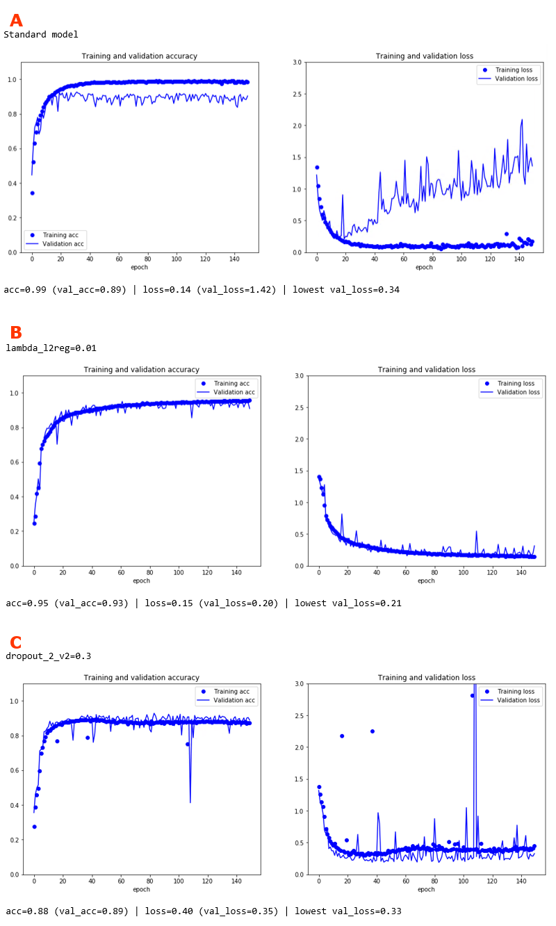**Project Steps**

- Gather source images

- Preprocess source images and augment to expand dataset

- Use subset of dataset for initial model building & tuning

- Investigate use of L2 Regularization and Dropout to correct for over-fitting

- Train model on full dataset to get final model, and gather sample predictions

**Hardware & Software**

**Machine Config**: Windows 10 on Ryzen 1950x, dual Nvidia GTX 1080 Ti, 64GB RAM

**Software:** Python 3.6 with cv2, Keras, Matplotlib, Numpy, Matplotlib, Pandas, PIL, and Tensorflow

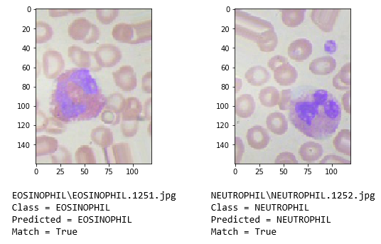**Lessons Learned**

- Adapt pre-existing model structures where possible

- Model tuning is time consuming therefore must be well planned

- Dropout layers can be effective but require significant testing

**YouTube URLs**

Short: <https://youtu.be/Ma6As_9qeGM>

Long: <https://youtu.be/kaxgFZIQDNk>

**Code Repository**

<https://github.com/pjonak/Classify_WhiteBloodCells>