**Atari SIO2PC Build Instructions for AspeQt-2020 (13L)**

Building an Atari SOP2PC cable is very simple and parts can be purchased on Amazon for under $15.00! Below outlines the pin layouts for building two different cables using a PL2303TA chipset and/or a FT232RL chipset. Both cables can be used with the RespeQt and the AspeQt disk drive/peripheral device emulator. The FT232RL chipset version can also be used with the APE Atarimax software. An Atari SIO connector is also required for the cable. SIO cables can be purchased often on eBay or here: [**http://www.best-electronics-ca.com/8-bit_.htm#SIO**](http://www.best-electronics-ca.com/8-bit_.htm#SIO)

As always, our BBS and more info can be found at:[**https://13leader.net**](https://13leader.net)

SIO2PC Cable Using USB-TTL PL2303TA Chipset

**AspeQt Handshake = “*None*”**

Atari SIO Connector USB-TTL PL2303TA Chipset

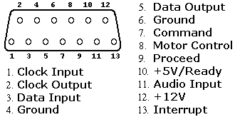 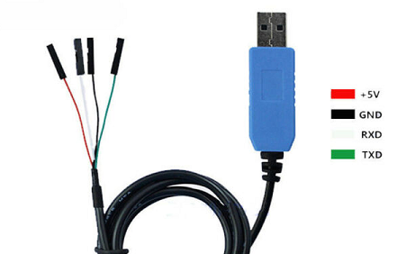

1 – Clock Input

2- Clock Output

3- Data In TXD (green)

4- Ground GND (black)

5-Data Out RXD (white)

6- Ground

7-Command Signal

8- Motor

9-Proceed

10- +5 Volts

11- Audio n

12- +12 Volts

13- Interrupt

SIO2PC Cable Using USB-TTL FTDI FT232RL Chipset

**AspeQt Handshake = “*CTS*”**

Atari SIO Connector USB-TTL FTDI FT232RL Chipset

 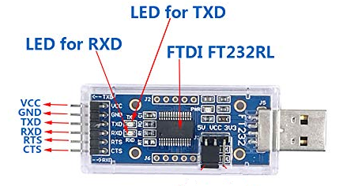

1 – Clock Input

2- Clock Output

3- Data In TXD

4- Ground  GND

5-Data Out  RXD

6- Ground

7-Command Signal  CTS

8- Motor

9-Proceed

10- +5 Volts

11- Audio n

12- +12 Volts

13- Interrupt