Atari USB2PC Build Instructions for AspeQt(13L)
Building an Atari USB2PC cable is very simple and parts can be purchased on Amazon for under $15.00! Below outlines the pin layouts for building two different cables using a PL2303TA chipset and/or a FT232RL chipset. Both cables can be used with the RespeQt and the AspeQt disk drive/peripheral device emulator. The FT232RL chipset version can also be used with the APE Atarimax software.

As always, our BBS and more info can be found at: https://13leader.net

SIO2PC Cable Using USB-TTL PL2303TA Chipset
RespeQt Handshake = “None”
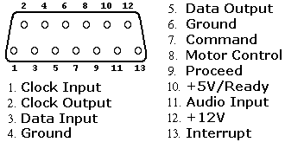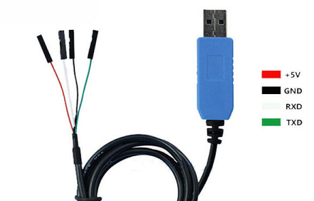
SIO Pins USB-TTL PL2303TA Chipset
1 – Clock Input
2- Clock Output
3- Data In TXD
4- Ground GND
5-Data Out RXD
6- Ground
7-Command Signal
8- Motor
9-Proceed
10- +5 Volts
11- Audio n
12- +12 Volts
13- Interrupt

SIO2PC Cable Using USB-TTL FTDI FT232RL Chipset
RespeQt Handshake = “CTS”
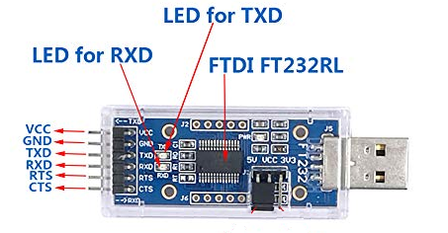
SIO Pins USB-TTL FTDI FT232RL Chipset

1 – Clock Input
2- Clock Output
3- Data In TXD
4- Ground GND
5-Data Out RXD
6- Ground
7-Command Signal CTS
8- Motor
9-Proceed
10- +5 Volts
11- Audio n
12- +12 Volts
13- Interrupt

