Atari SIO2PC Build Instructions for AspeQt (2k24)
Building an Atari SIO2PC cable is very simple and parts can be purchased on Amazon for under $15.00! Below outlines the pin layouts for building two different cables using a PL2303TA chipset and/or a FT232RL chipset. Both cables can be used with the RespeQt and the AspeQt disk drive/peripheral device emulator. The FT232RL chipset version can also be used with the APE Atarimax software. An Atari SIO connector is also required for the cable. SIO cables can be purchased often on eBay or here: http://www.best-electronics-ca.com/8-bit_.htm#SIO
As always, our BBS and more info can be found at: https://13leader.net

SIO2PC Cable Using USB-TTL PL2303TA Chipset
AspeQt Handshake = “None”

Atari SIO Connector USB-TTL PL2303TA Chipset
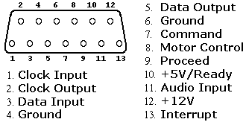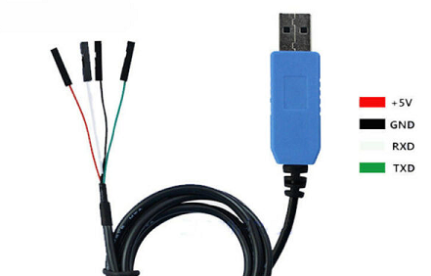
1 – Clock Input
2- Clock Output
3- Data In TXD (green)
4- Ground GND (black)
5-Data Out RXD (white)
6- Ground
7-Command Signal
8- Motor
9-Proceed
10- +5 Volts
11- Audio n
12- +12 Volts
13- Interrupt
SIO2PC Cable Using USB-TTL FTDI FT232RL Chipset
AspeQt Handshake = “CTS”

Atari SIO Connector USB-TTL FTDI FT232RL Chipset
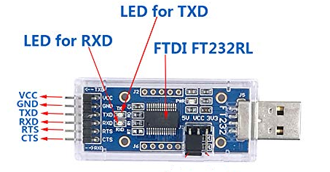
1 – Clock Input
2- Clock Output
3- Data In TXD
4- Ground GND
5-Data Out RXD
6- Ground
7-Command Signal CTS
8- Motor
9-Proceed
10- +5 Volts
11- Audio n
12- +12 Volts
13- Interrupt

