Poorval Joshi

Mar 9th, 2021

IT FDN 110 B Wi 21: Foundations Of Programming: Python

Assignment 8

<https://github.com/pjoshi-beep/IT-Fnd100-mod7>

# Write a python script to demonstrate working with classes

# Introduction

In this assignment, I wrote code to the python script Assignment08_PJ.py that demonstrates working with classes in python.

The script shown in Figure 1 begins with a script header that includes inline comments marked by a # at their start to indicate the title, developer, date and changes made to the python script file.

Classes: Classes provide a structure to organize functions and data in python. Classes have several customizable features that allow for efficient data handling and processing. Basically, classes can be thought of as a group of variables and functions. The class is loaded into the memory only once but several instances of the class can be created by using objects which means that each instance is like creating a new copy of the class.

The variables are known as fields or attributes depending on where they are declared in the class.

Classes have specialized functions called constructor, properties and methods.

The constructor is used to set initial values and types of the variables. It is indicated by _init_ and is the first thing called from the class when a class is used. The self keyword used in the constructor refers to the data and functions called in that particular instance of the class being called. Variables declared in the constructor are called as attributes.

The properties are functions that manage the fields/attributes in the class. Their job is to take value from the user and give it to the function or take value from a function and give it to the user. Typically, two properties are created – one for getting the data (getters) and one for setting the data (setters). The setters (indicated by the @product_name.setter directive) allow for validation and error handling of the data. The getters (indicated by the @property directive) allow for formatting the data.

The methods are other functions in the class that do not manage data but instead manage processing. One example used here is the @staticmethod that allows to call methods from the class without making an object. Methods can be made private by using double underscores to counts the number of times the class was called by creating objects.

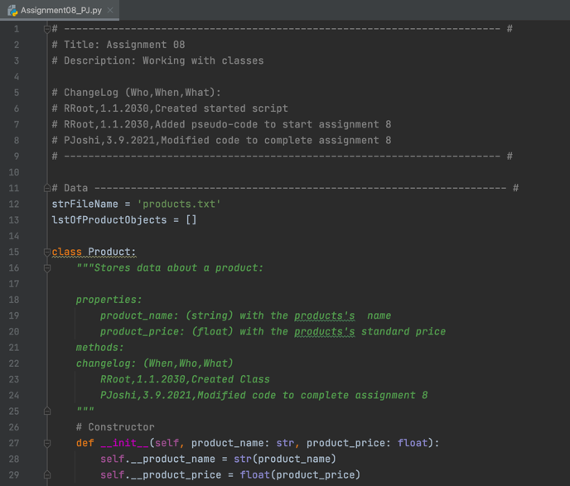

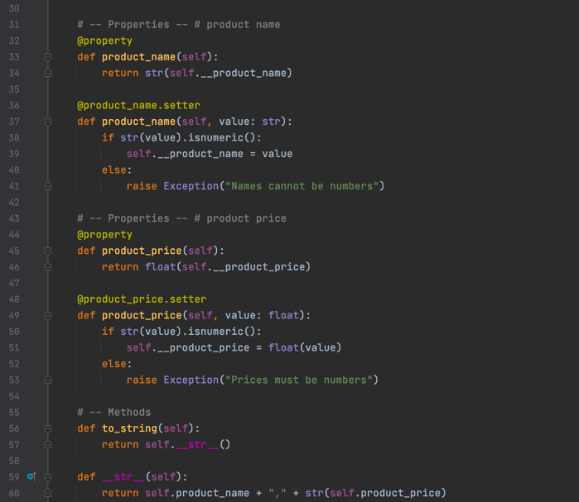

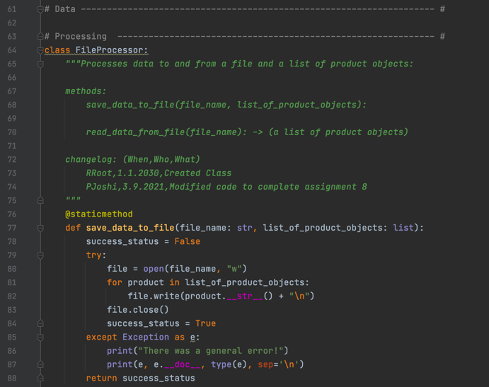

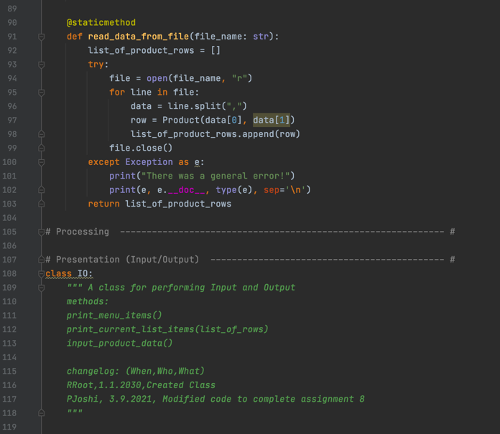

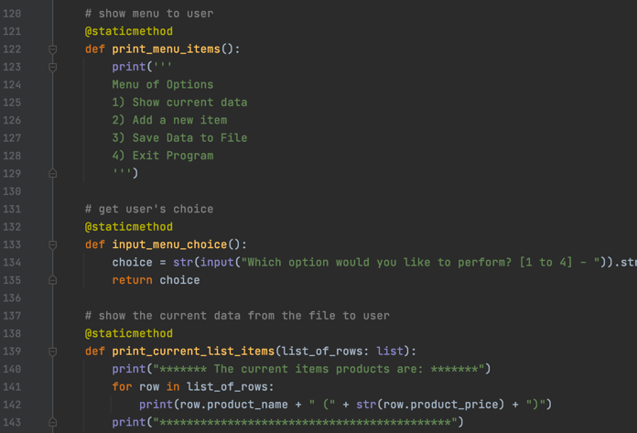

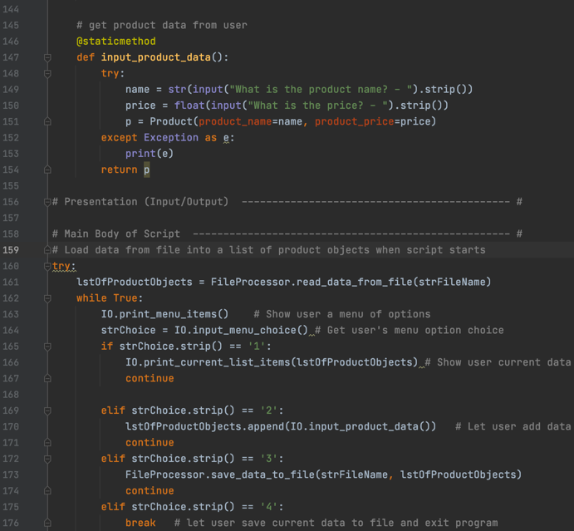

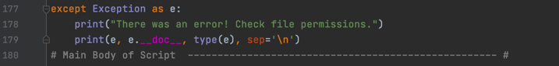

**Figure 1: Assignment08 script in PyCharm** **to demonstrate classes**

# Running the script in PyCharm

To run this script in PyCharm, I right clicked in the PyCharm open window and selected run Assigment08_PJ.py and the script ran as expected as shown below in Figure 2.

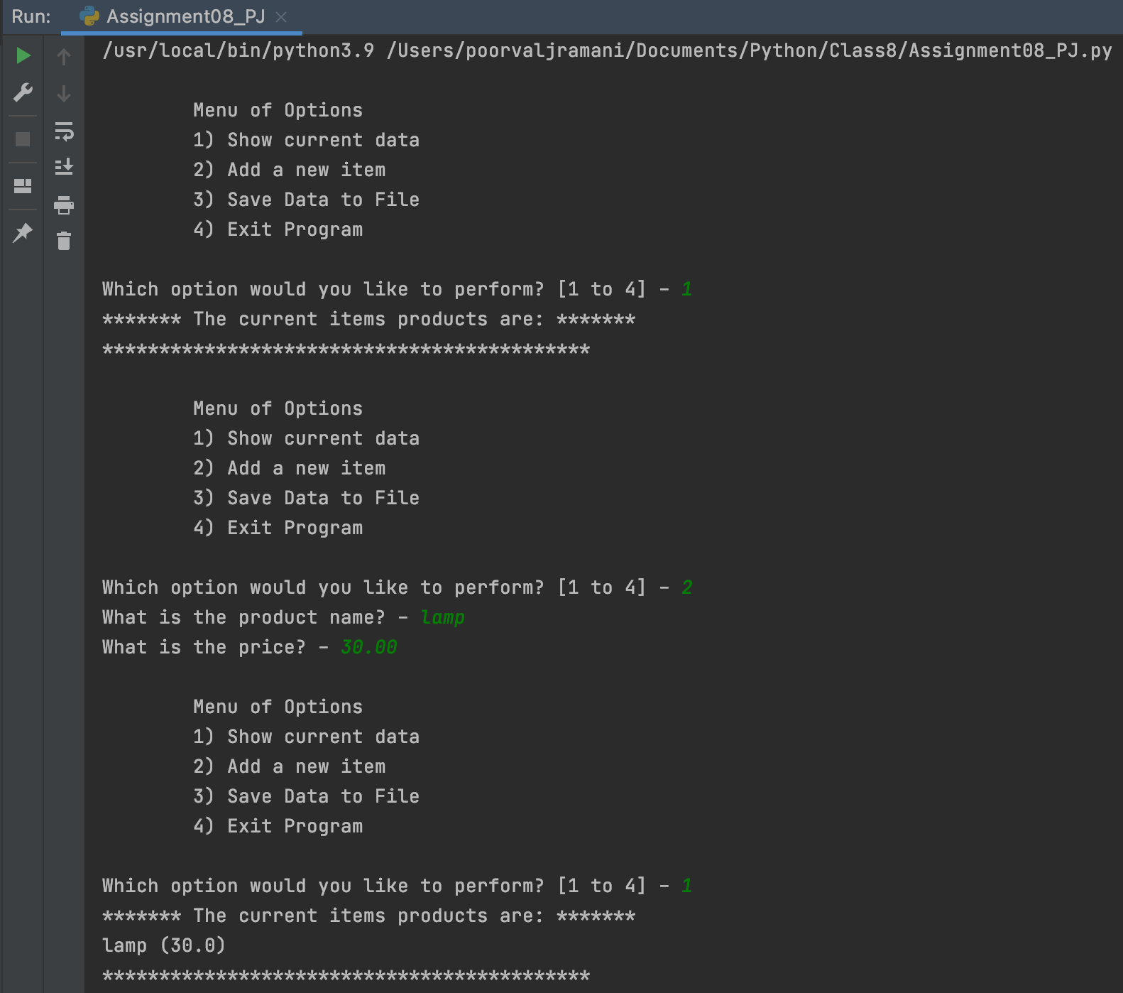

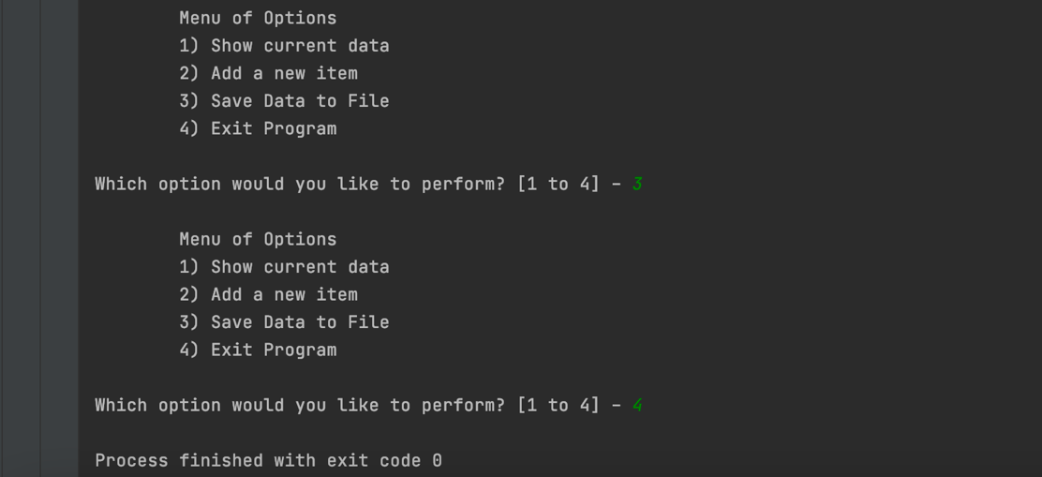

**Figure 2: Running the script in PyCharm**

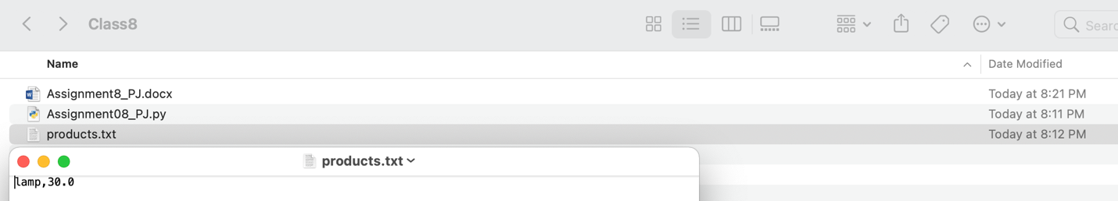

**Figure 3: Verifying that the products.txt file has the saved the data**

# Running the home inventory script on the terminal

To run the python script on the terminal, I first changed my directory to class8 where I had the Assigment08_PJ.py file so that the test.txt file gets created in the same location. Then I used the Python3 command followed by the path of the Assigment08_PJ.py file which allowed the terminal to create a python environment and run the python script. The script ran as shown in Figure 4 below and saved data to the products.txt file in the same folder as the script as shown in Figure 5.

# 

**Figure 4: Running the script on the terminal**

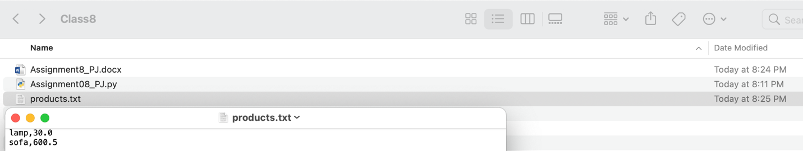

**Figure 5: Verifying that running the script on the terminal saved data to the products.txt file**

# Summary

In summary, I have learned about classes and their features and how to use them while writing code in python. Additionally, I installed GitHub Desktop and created new repository for the contents of module 8.