Poorval Joshi

Feb 23rd, 2021

IT FDN 110 B Wi 21: Foundations Of Programming: Python

Assignment 6

# Write a python script to maintain a “TO DO” list using functions and classes

# Introduction

In this assignment, I added code to the python script Assigment06_Starter.py that uses functions to manage a To Do List allowing the user to add, delete or save the contents of the list in a file on a drive. To write the script for this assignment, I launched PyCharm and opened the Class 6 project and modified the python file called Assigment06_Starter.py as shown in Figure 1.

The script begins with a script header that includes inline comments marked by a # at their start to indicate the title, developer, date and changes made to the python script file.

Here I have made use of functions that allow for grouping of one or more statements together. The function is defined prior to the executable code. In the executable code, the function gets called and the statements that are a part of the function are executed. Functions have parameters that allow us to pass arguments to the function. Here I have mainly used the filename and the lstTable as the main parameters that allow us to manipulate the data in the To Do List. The beauty of functions is that they are able to return values which can be captured in variables which I have made use of in this script. I have also used class called processor in this script which essentially functions as a collection of functions, variables and constants. For this code to work, I had to define global variables at the top of the code and create a ToDoList.txt file and enter data a line of data into it. The data I entered are tasks and priorities.

The input/output section begins with the use of a while loop which essentially allows to print the menu of options multiple times as long as the condition is true. Then the input () functions asks the user to choose an option from the menu. The type of option chosen by the user is evaluated by the conditional if and elif statements and the equity operator (==) that allows to call a specific function based on the user`s choice.

This script ran successfully in PyCharm as shown in Figure 2 and was able to edit and save the ToDoList.txt file with the user input as shown in Figure 3.

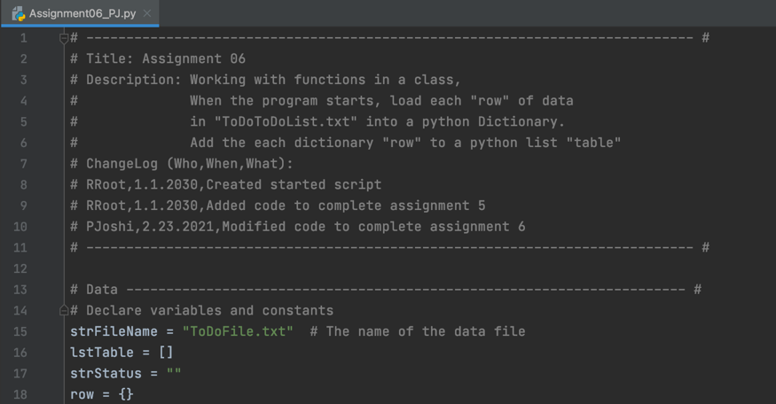

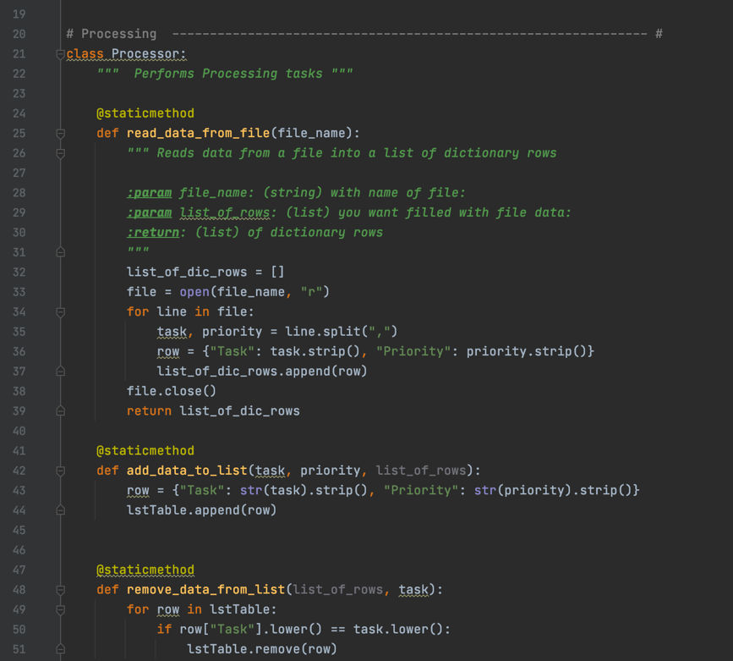

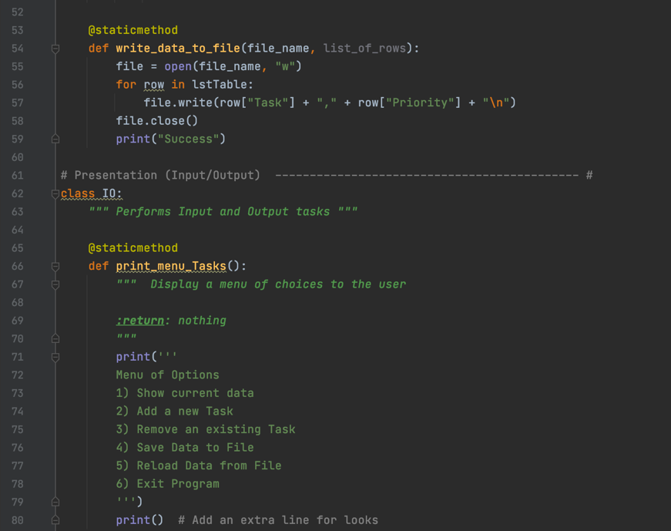

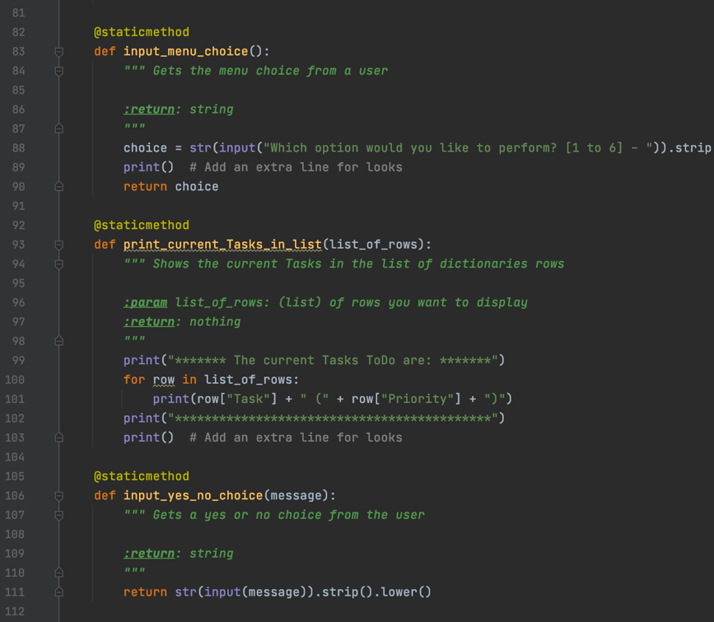

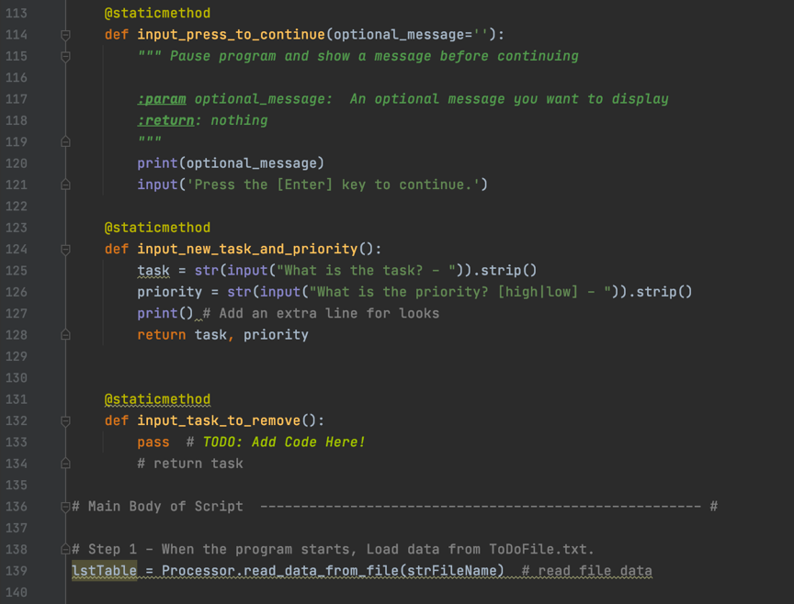

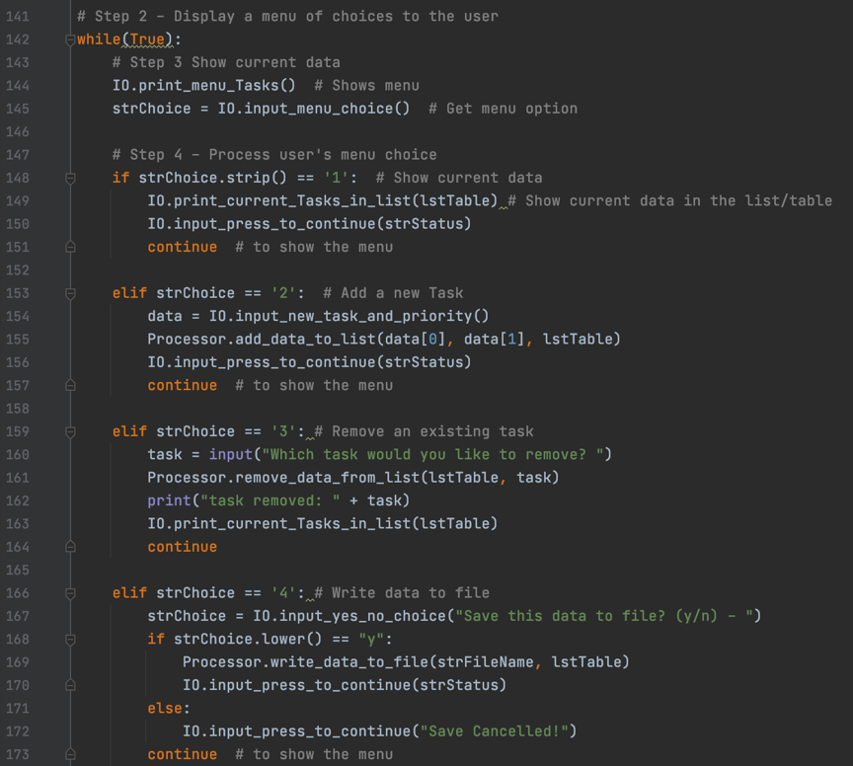

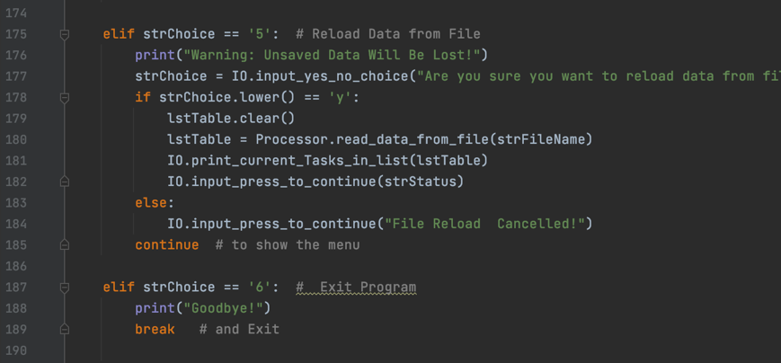

**Figure 1: Assignment6 script in PyCharm** **to create a To Do list.**

# Running the script in PyCharm

To run this script in PyCharm, I right clicked in the PyCharm open window and selected run Assigment06_PJ.py and the script ran as expected as shown below in Figure 2.

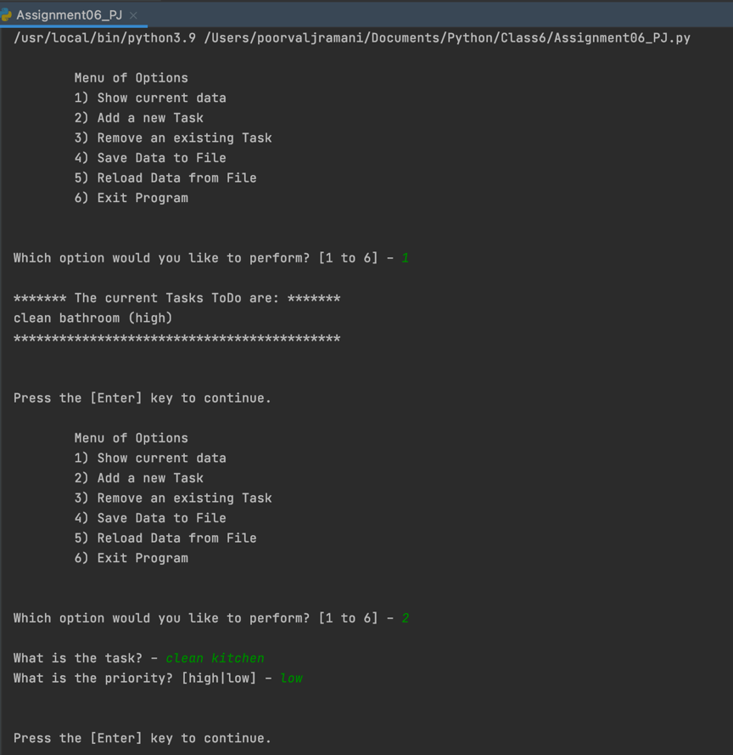

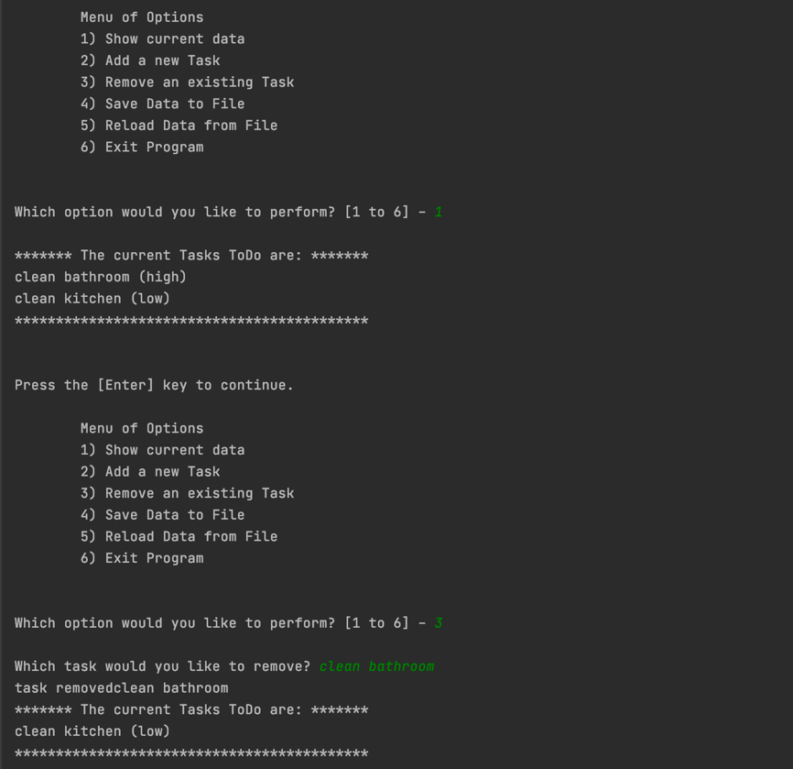

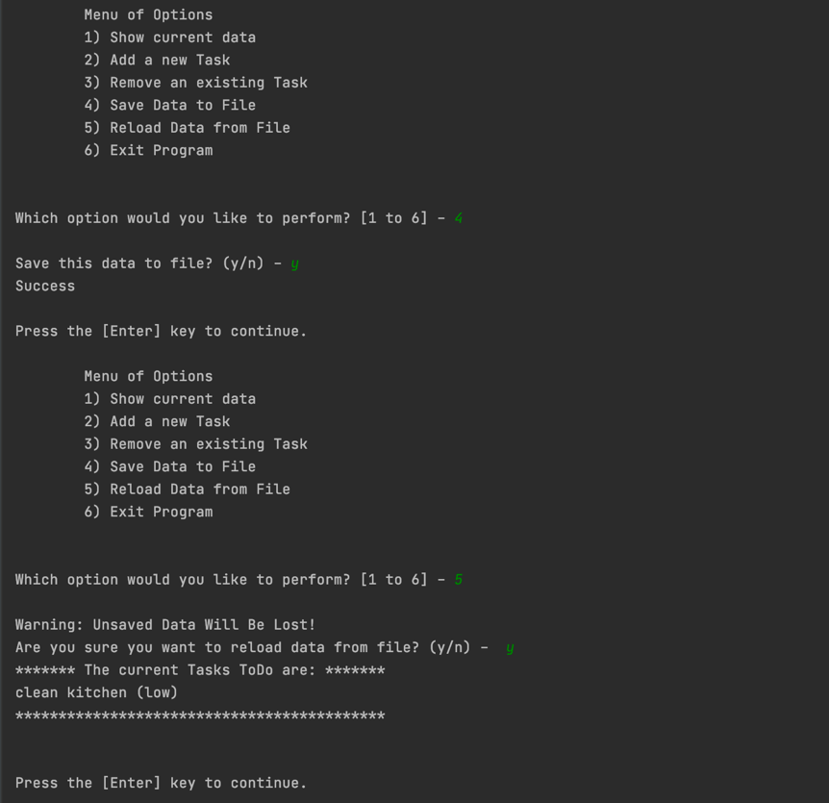

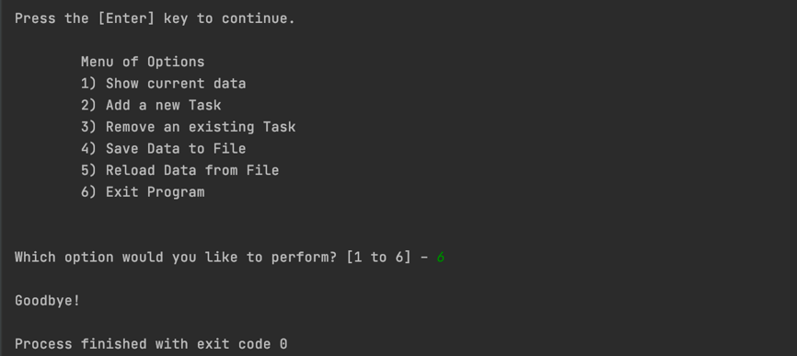

**Figure 2: Running the script in PyCharm**

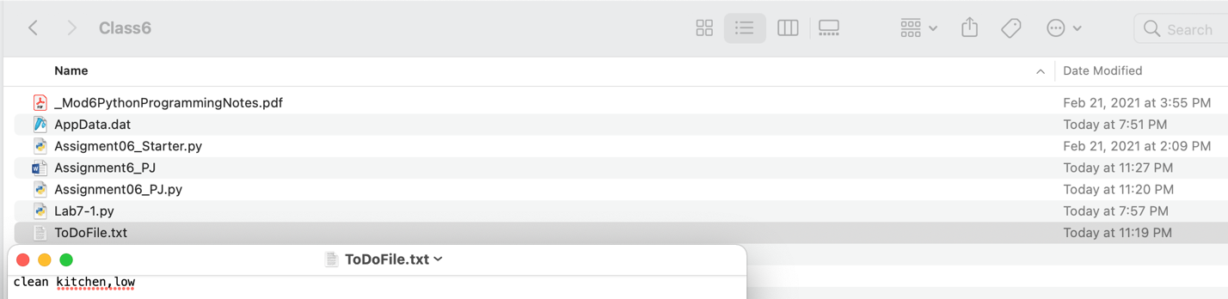

**Figure 3: Verifying that the ToDoList.txt file has the saved the data**

# Running the home inventory script on the terminal

To run the python script on the terminal, I first changed my directory to class6 where I had the Assigment06_PJ.py file so that the ToDoList.txt file gets created in the same location. Then I used the Python3 command followed by the path of the Assigment06_PJ.py file which allowed the terminal to create a python environment and run the python script. The script ran as shown in Figure 4 below and created a ToDoList.txt file in the same folder as the script as shown in Figure 5.

# 

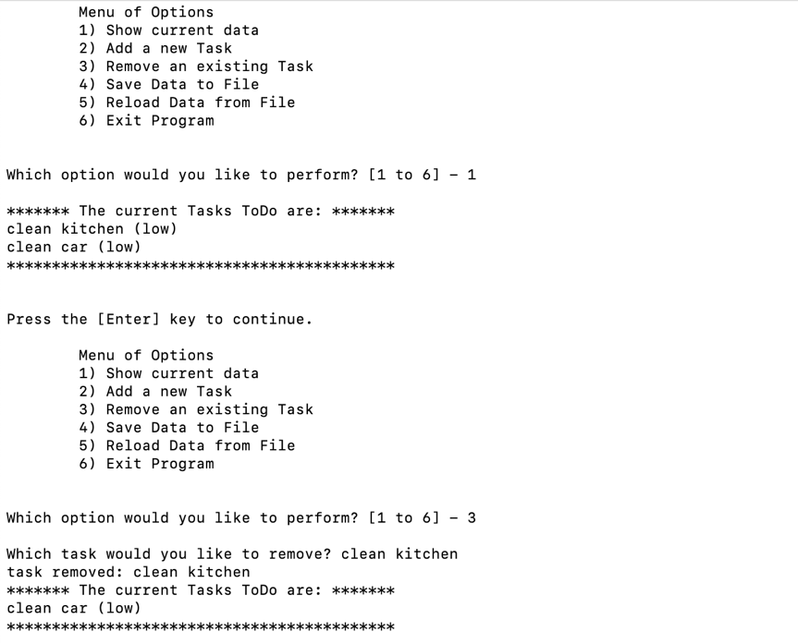

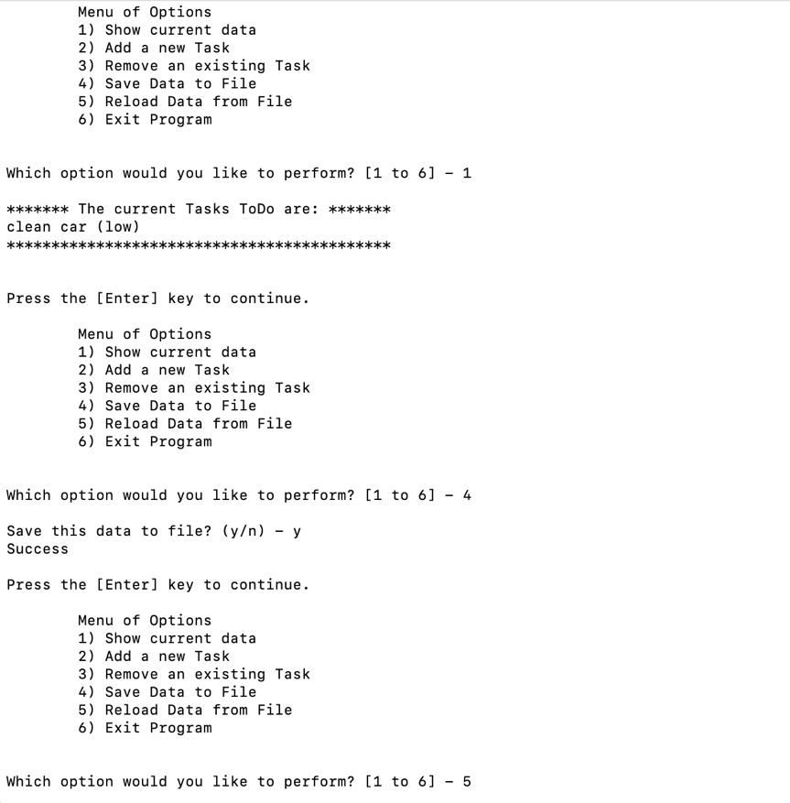

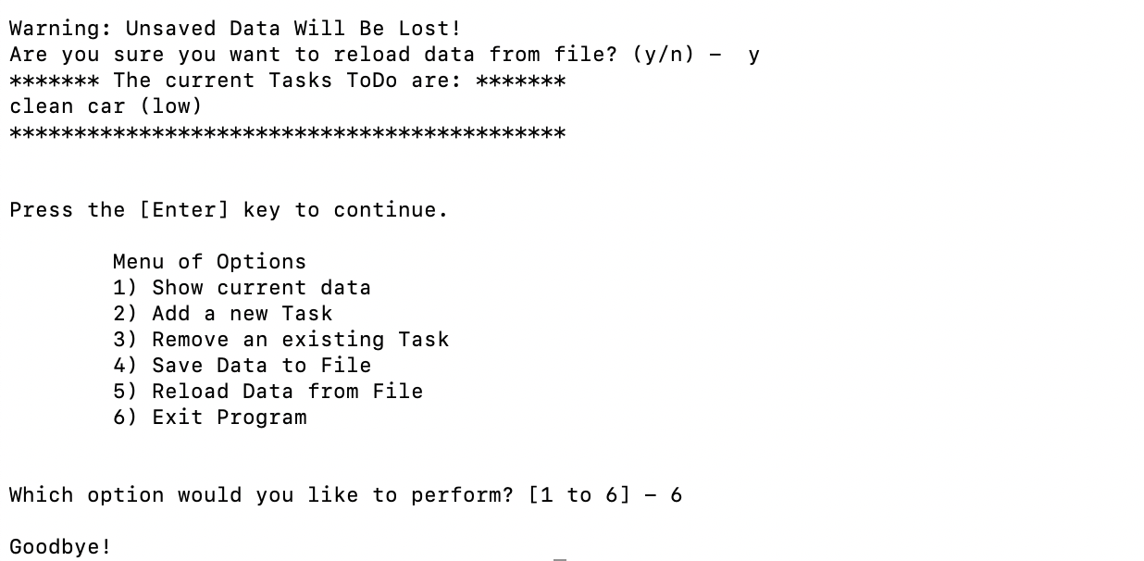

**Figure 4: Running the script on the terminal**

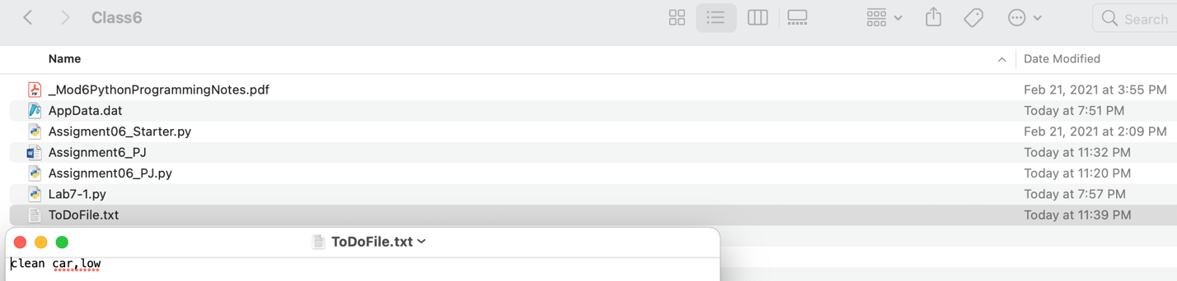

**Figure 5: Verifying that running the script on the terminal created a ToDoList.txt file and saved data**

# Summary

In summary, I have become more comfortable using functions in python. I am now able to define functions and call the functions as needed. I have also uploaded my code in GitHub (https://github.com/pjoshi-beep/UW_intro_to_python_classfiles) and this document with it to make the code easier to understand.