# Introduction

The **Supplier Recommendation System** is designed to help users find the best suppliers based on their needs. The system allows users to select a supplier and receive relevant recommendations in an easy-to-use interface.

# Accessing the Website

To use the Supplier Recommendation System, open a web browser and navigate to the application’s URL. The homepage provides access to the recommendation tool.

# Using the System Home Page (Supplier Selection)

* The homepage displays a dropdown list of available suppliers.

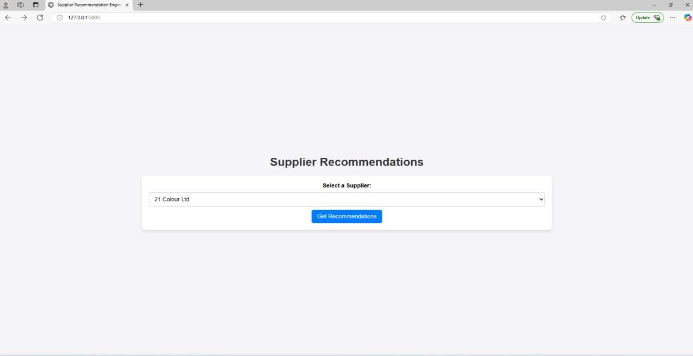

* Select a supplier from the dropdown menu.

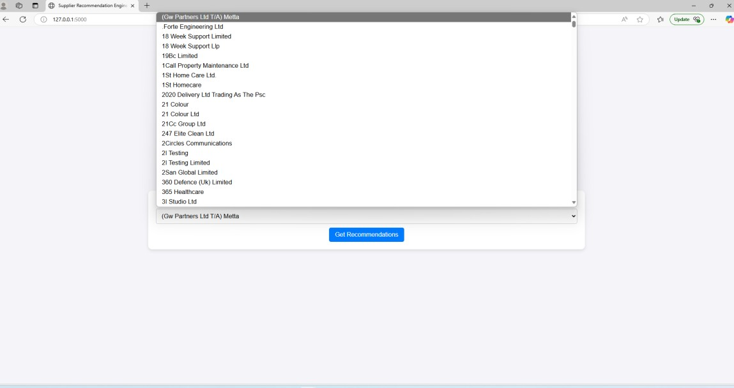

* Click the **"Get Recommendations"** button to generate relevant supplier recommendations.

# Recommendations Page

• If recommendations are available, they will be displayed in a table format. • Selected Supplier: **21 Colour Ltd**

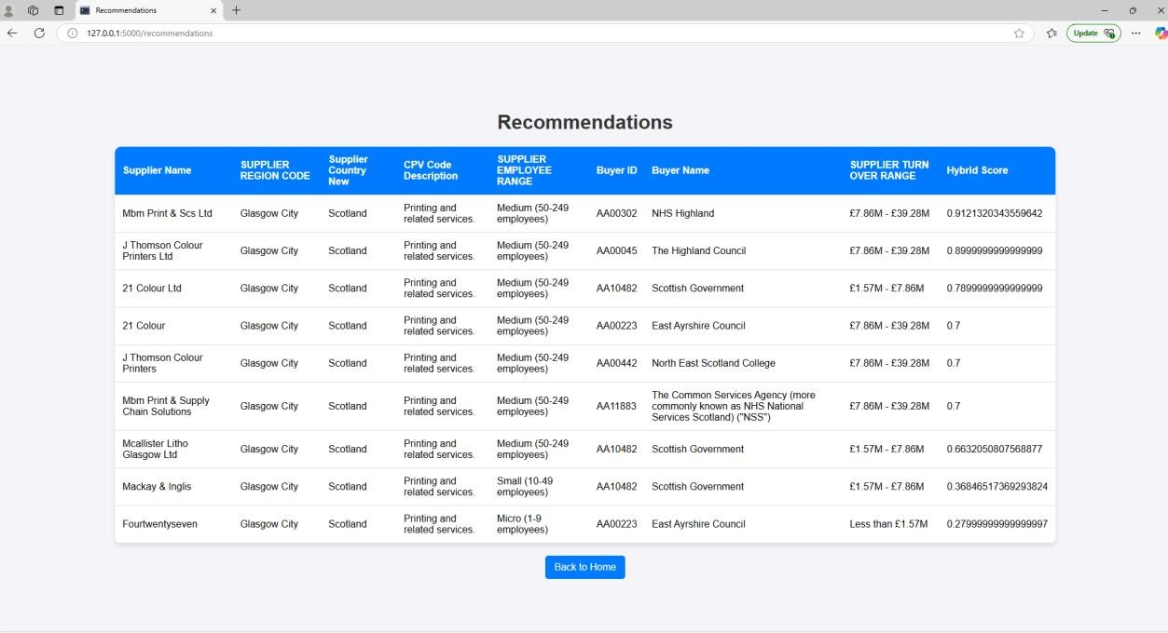

# • Selected Supplier: Gm Civil & Structural Consulting Engineers

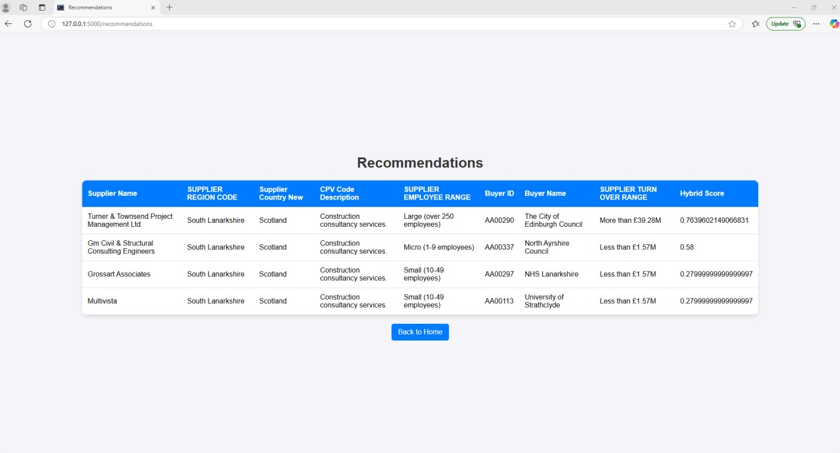

* The table includes multiple columns with relevant supplier details.
* If no recommendations are available, a message will be displayed.
* Click **"Back to Home"** to return to the supplier selection page. **Features**
* **User-Friendly Interface**: The system is designed with a clean and responsive layout for easy navigation.
* **Supplier Selection**: Users can quickly choose a supplier from the dropdown list.
* **Recommendation Table**: The results are presented in a structured table for clarity.
* **Navigation**: Users can return to the homepage at any time. **Troubleshooting**
* If the recommendation table is empty, ensure that valid supplier data is available.
* If the page does not load properly, try refreshing the browser or clearing cache.

# Contact Support

For assistance, please contact the Elcom Data Analytics team.

**Note**: This is a test/prototype site, and the final look and feel will vary after integration. Additionally, development efforts will be required from both CXAIR and Elcom teams.