**We perform ANOVA when we want to compare more the 2-population group means.**

When the response is continuous, and the predictor variables are categorical. We construct the boxplots to see the graphical representation where the Y-axis is the response and the X-axis is the predictor categorical variables.

After constructing the boxplots for different categories say in case as shown below then there is an association between the variables else there is no association between X and Y.

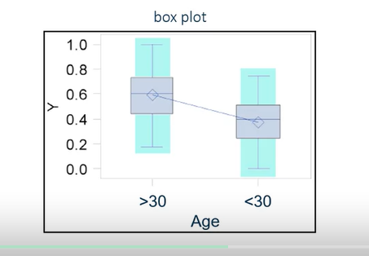

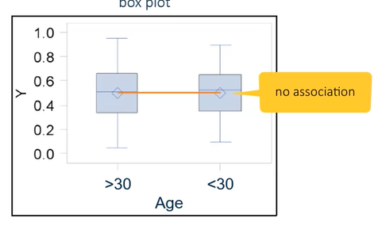

When we want to compare heating, quality has impact on the housing prices. So, for instance we want to see if houses with better heating quality sell for more than the houses than without. We use One Way ANOVA.

With ANOVA we have,

$$H_{0}:μ_{1}=μ_{2}=μ_{3}=μ_{4}$$

$$H_{a}:atleast one of μ_{i}≠μ_{\dot{j}}$$

The goal is to determine whether there are significant differences among the group means. This is accomplished by splitting the *total variation in to between group and within group variations.*

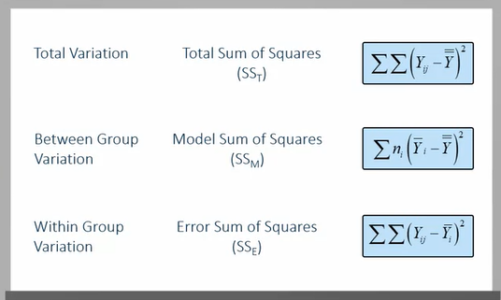

***Coefficient of Variation:***

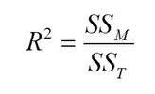

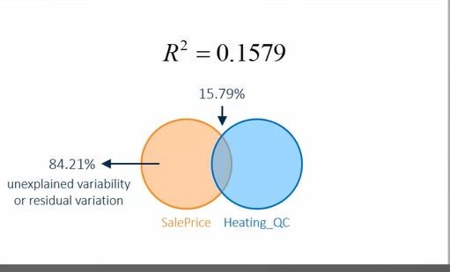

As an example of the coeff. Of variation as shown in the above graph.

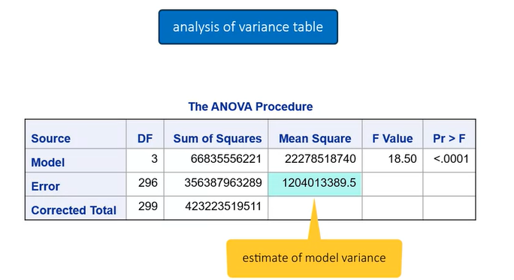

As per the ANOVA table as above we have as the F value increases the more evidence, we have that not all groups are equal. Here p-value is significant, and we can conclude that the group means are significantly different as we reject the null hypothesis.

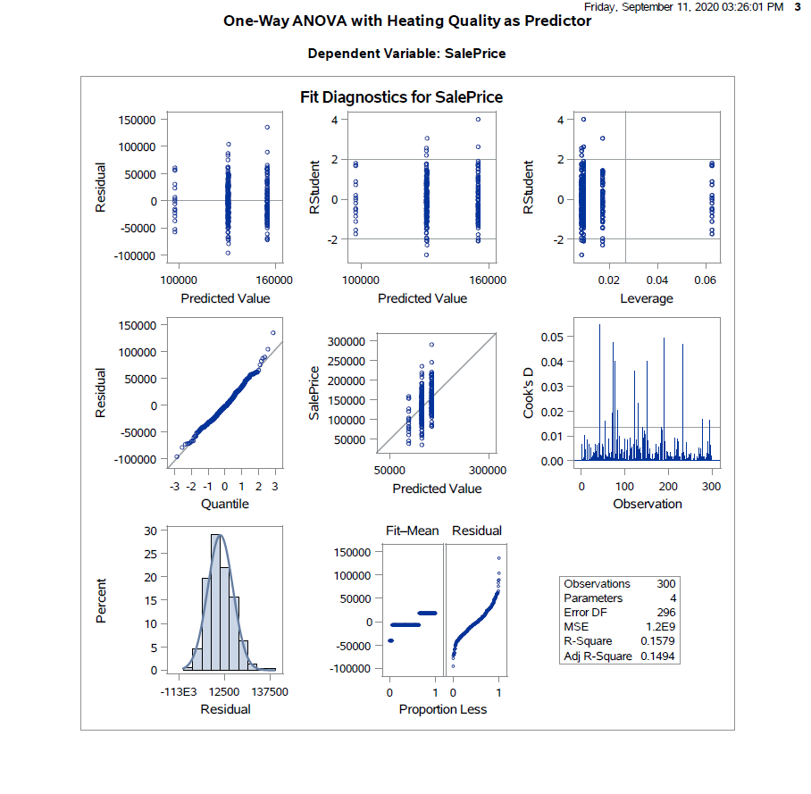

Basing on the above graphs we try to check if the assumptions hold for the test conducted to be valid.

We can see from the residual plots that there are no trends and the points are placed above and below the axis also the Q-Q plot and the histogram shows that the errors are normally distributed holds basing on the above plots we can conclude that the performed test is a valid test for either the means of the groups are equal or not and as the p-value from the ANOVA table is statistically significant we reject the null hypothesis of equal means between the groups.