DAM - Coffee bean production in a changing climate: a case study of Hawaii

Ella Jansma (s1114516), Max Claessens (s1097783), Gijs Bomert (1117543), Jochem Oude Groeniger (s1141308), Pieterjan Pauwelyn (s1089656)

In this document, the data action model is presented in the form of a flowchart that visually outlines all analysis steps undertaken in this project. The flowchart provides a structured overview of the workflow, from data acquisition and preprocessing to transformation, analysis, and final suitability modelling. Each step represents a specific GIS operation applied to the datasets, ensuring transparency and reproducibility of the methodology. Below the flowchart, a detailed action table is included, describing every individual step, including the type of data handling, the operations performed, and the objective of each action.
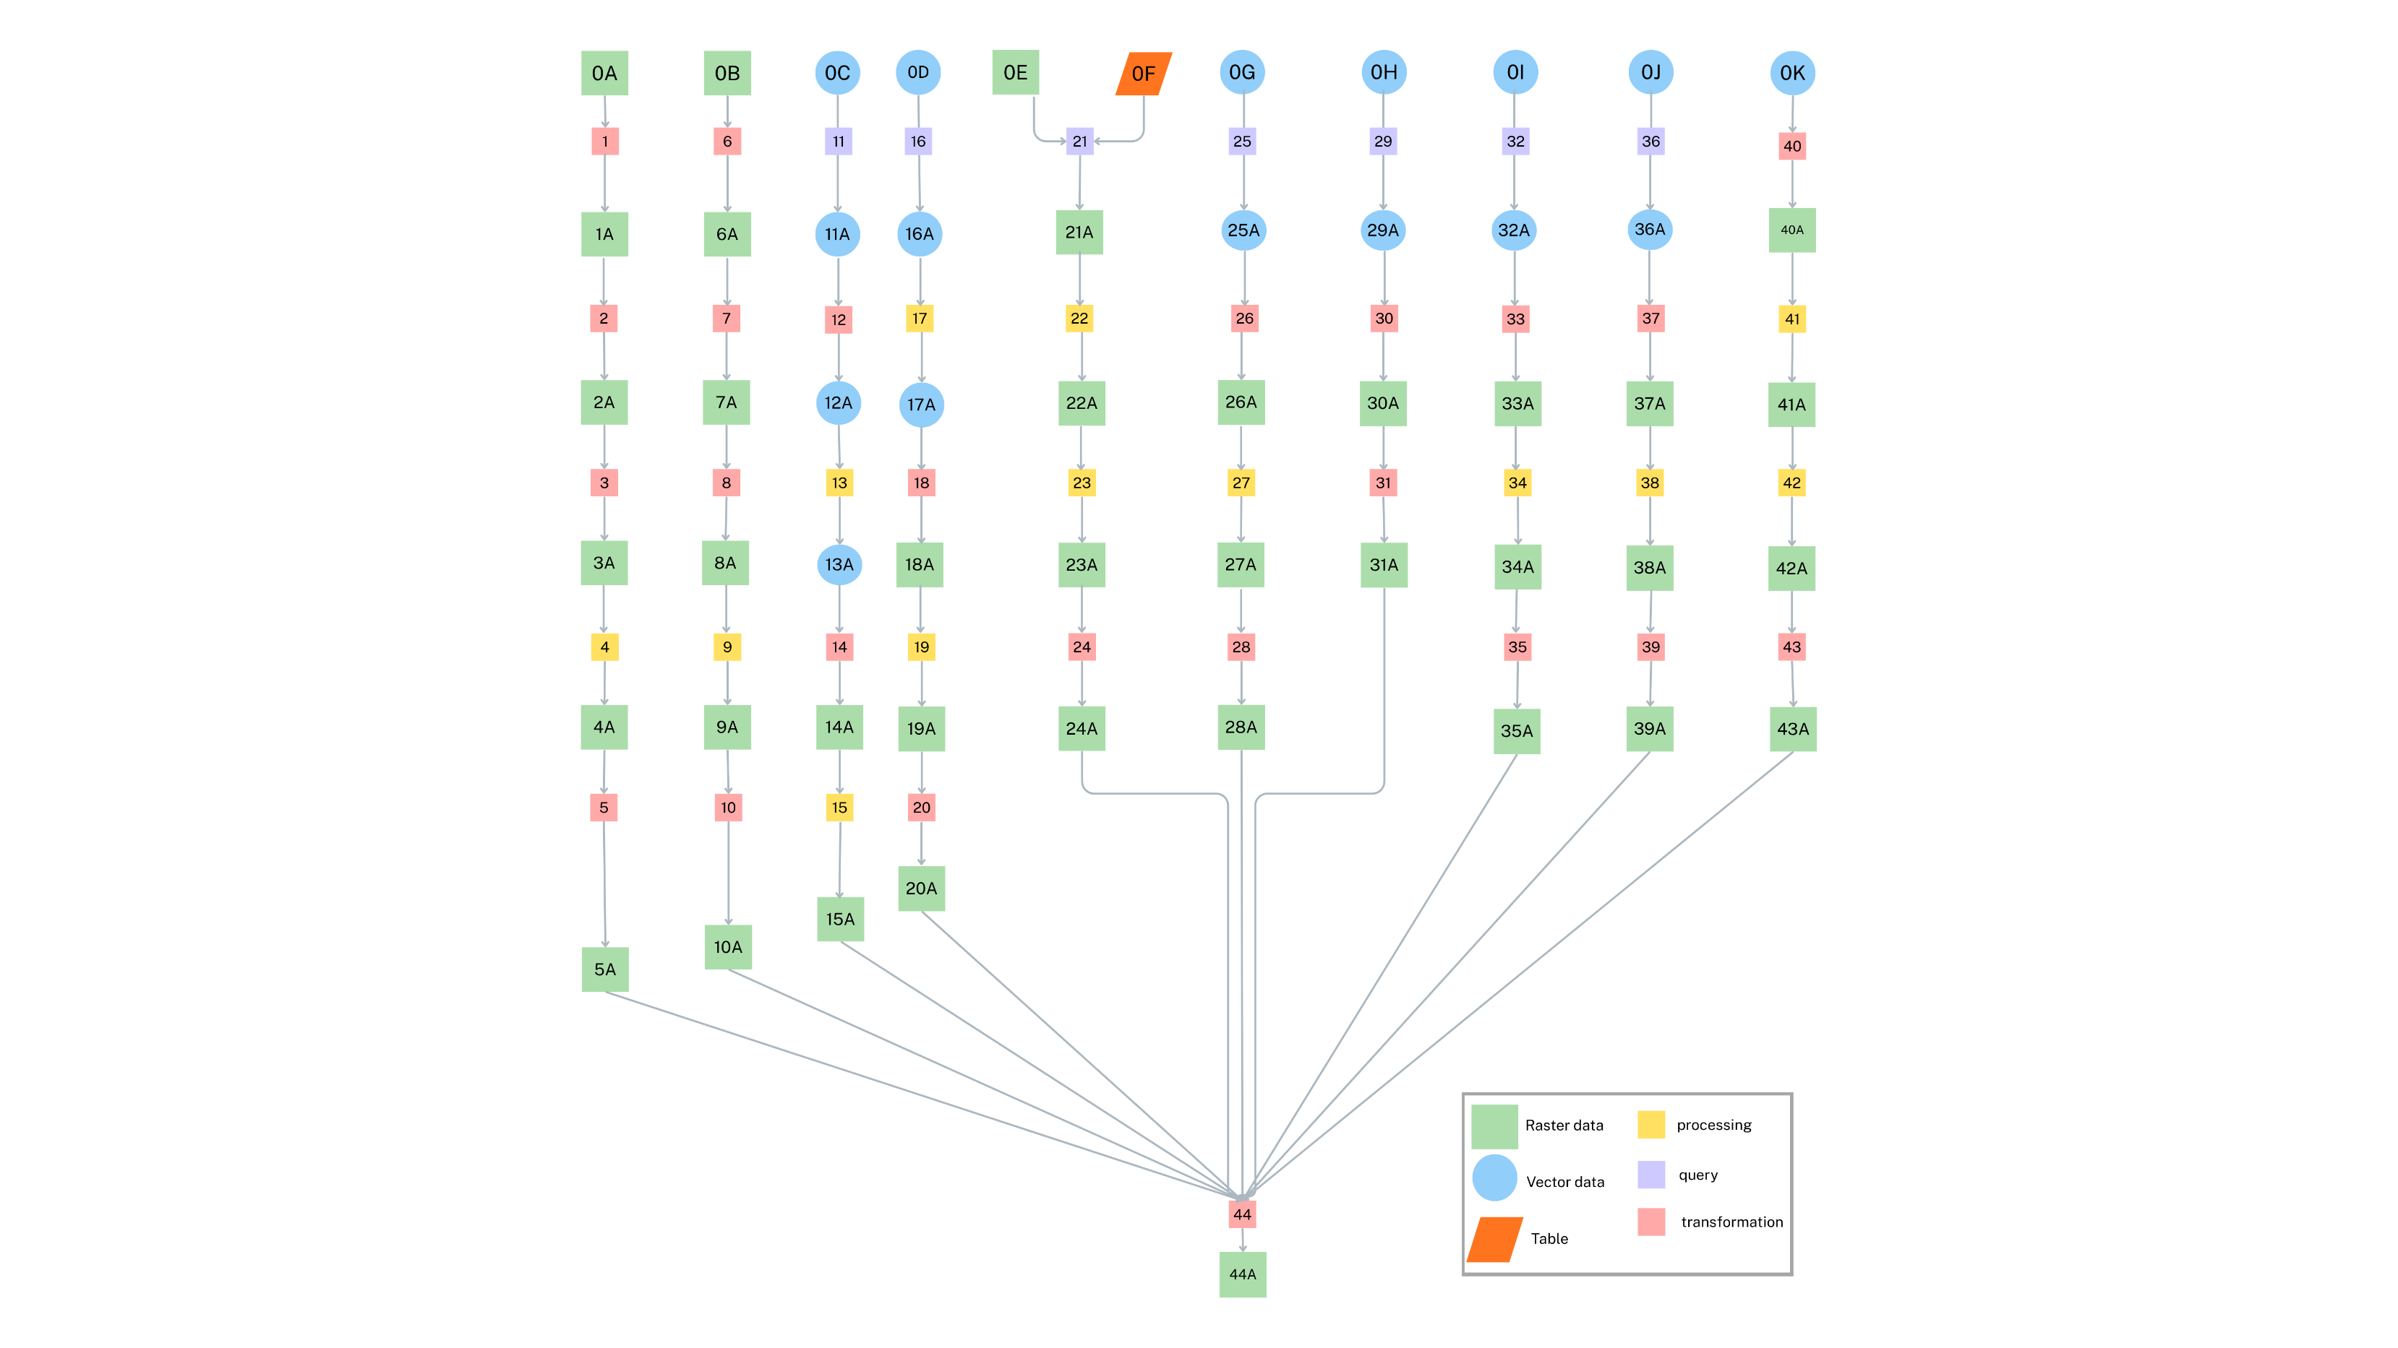
Figure 1: Data action model showing the steps of the analysis. See tables 1 and 2 for an explanation of the steps and intermediate results.

Table 1: action description table, describing all analysis actions.
Action | Type of handling | Operation | Objective
Precipitation (for all three projections)
1 | Transformation | Clip Raster | Restrict rasters current precipitation + ssp126 + ssp370 + ssp585 to Hawaiʻi study area to remove irrelevant data
2 | Transformation | Project Raster (if needed), Resample, Set Snap Raster | Ensure all rasters share the same CRS, spatial resolution, and alignment as the common raster framework
3 | Transformation | Unit Check and Conversion (Raster Calculator if needed) | Convert monthly values (mm/month) to annual precipitation (mm/year). Range for 3-tier suitability scoring: <1100 mm (score 1), 1100–1600 mm or 1800–2000 mm (score 2), 1600–1800 mm (score 3), >2000 mm (score 1)  (thresholds adapted from Alves et al. (2020) )
4 | Processing | Reclassify Raster | Reclassify annual precipitation raster to 3-tier suitability scores on a 1–3 scale:  <1100 mm/year → 1 (unsuitable)  1100–1600 mm/year → 2 (suboptimal)  1600–1800 mm/year → 3 (optimal)  1800–2000 mm/year → 2 (suboptimal)  >2000 mm/year → 1 (unsuitable)
5 | Transformation | Copy Raster / Export Raster (separate outputs per dataset) | Store each precipitation suitability raster separately to enable later comparison and overlay analysis
Temperature (for all three projections)
6 | Transformation | Clip Raster | Restrict rasters current temperature + ssp126 + ssp370 + ssp585 to Hawaiʻi study area to remove irrelevant data and ensure spatial consistency
7 | Transformation | Project Raster (if needed), Resample, Set Snap Raster | Ensure all rasters share the same CRS, spatial resolution, and alignment as the common raster framework
8 | Transformation | Unit Check and Conversion (Raster Calculator if needed) | Convert tenths of °C (°C × 10) to degrees Celsius if needed. Target range for 3-tier suitability scoring: <15°C (score 1), 15–18°C or 23–26°C (score 2), 18–23°C (score 3), >26°C (score 1)
9 | Processing | Reclassify Raster | Reclassify temperature raster to 3-tier suitability scores on a 1–3 scale:  <15°C → 1 (unsuitable)  15–18°C → 2 (suboptimal)  18–23°C → 3 (optimal)  23–26°C → 2 (suboptimal)  >26°C → 1 (unsuitable)
10 | Transformation | Copy Raster / Export Raster (separate outputs per dataset) | Store each temperature suitability raster separately to enable later comparison and overlay analysis
Roads
11 | Selection | Select Layer By Attribute | Filter Roads_-_Hawaii_County to retain only roads with class “A35, A31 or Q05” , removing local roads leaving only roads relevant to our analysis
12 | Transformation | Distance accumulation | Creates a raster dataset where the distances are calculated to the nearest usable road
13 | Processing | Reclassify | Creates a 3 tier suitability score where: < 2000 m à optimal (3), 2000 – 5000 m àsuboptimal and > 5000 à unsuitable
Geological units
16
17
18 | Query: thematic | Select by Attribute | In the database Geological_Units, selects only records located on the island of Hawaiʻi
19 | Processing by overlay | Clip | Clip selected records to the area of interest, removing all other islands
20 | Transformation | Feature to Raster (Value field = name) | Transform the vector dataset to raster format (required for suitability analysis), using geological unit name as value field
Soil type | Processing | Reclassify Raster | Convert geological units to suitability scores: Hualalai Volcanics → 1 (suitable);; Kau Basalt → 1 (suitable);; all others → 0 (not suitable)
21 | Transformation | Copy Raster / Export Raster | Store the geological unit suitability raster to enable later comparison and overlay analysis
22
23 | Query: thematic | Join (Value field – Number) | Join the raster TAXOUSDA_250m_ll.tif with the table TAXOUSDA_250m_ll.tif.csv to link numeric values of the raster to generic soil type names in the table
24 | Processing by overlay | Clip Raster | Clip the raster to the main island of Hawaiʻi, removing all other areas
Land Use, Conservation and Terrain | Processing | Reclassify Raster | Convert generic soil types to suitability scores: Andisols → 1 (suitable);; Histosols → 1 (suitable);; all others → 0 (not suitable)
25 | Transformation | Copy Raster / Export Raster | Store the soil type suitability raster to enable later comparison and overlay analysis
26
27 | Query: thematic | Select by Attribute | In the dataset 0G, select for records present on Hawai’i and clip the dataset.
28 | Transformation | Polygon to Raster | Transform conservation district data for Hawai’i to be converted into a Raster
29 | Processing | Reclassify raster | Convert to suitability scores ; G (general), C (undesignated) = 1 (suitable) ;  R (Resource) = 0.75 ;  L (Limited) = 0.25 ;  P (Protective), SS (Special (subzone)) = 0 (Unsuitable)
30 | Transformation | Export Raster | Store Conservation District data raster to enable later comparison and overlay analysis
31 | Query: Thematic | Select by Attribute | In the dataset 0H, select for records present on Hawai’i.
32 | Transformation | Polygon to Raster | Transform Critical Habitat data for Hawai’i to be converted into a Raster
33 | Transformation | Export Raster | Store Critical Habitat data raster to enable later comparison and overlay analysis. The suitability score of 0 is already included in the unmodified dataset.
34 | Query: thematic | Select by Attribute | In the dataset 0I, select for records present on Hawai’i and clip the dataset.
35 | Transformation | Polygon to Raster | Transform Department of Defense data for Hawai’i to be converted into a Raster
36 | Processing | Reclassify raster | Convert to suitability scores: =0 (unsuitable)
37 | Transformation | Export Raster | Store Department of Defense data raster to enable later comparison and overlay analysis. The suitability score of 0 is already included in the unmodified dataset.
38 | Query: thematic | Select by Attribute | In the dataset 0J, select for records present on Hawai’i and clip the dataset.
39 | Transformation | Polygon to Raster | Transform Land Use Land Cover data for Hawai’i to be converted into a Raster
Elevation | Processing | Reclassify raster | Convert to suitability scores: 1~, 5~, 7~, 8~, 9~ =0 (unsuitable) ; 2~, 3~ = 1 (suitable) ; 4~, 6~ = 0.5 (not preferred)
40 | Transformation | Export Raster | Store Land Use Cover data raster to enable later comparison and overlay analysis. The suitability score of 0 is already included in the unmodified dataset.
41
42 | transformation | Topo to raster | Transform the given polyline dataset into a usable Raster
43 | processing | Raster calculator | Remove all the negative elevation gradients from ocean floor
44 | Processing | Raster calculator | Reclassify elevation raster to 3-tier suitability scores on a 1–3 scale:  <900 m → 1 (unsuitable)  900–1400 m → 2 (suboptimal)  1400–1800 m → 3 (optimal)  1800–2500 m → 2 (suboptimal)  >2500 m → 1 (unsuitable)
45 | Transformation | Copy raster/ export raster | Store elevation level suitability raster for later comparison and overlay analysis
Suitability Modeling | (ALL PROJECTIONS)
46 | Processing | Suitability Modeler | Store climate sub-model for use in action 47
 | Processing | Suitability Modeler | Store final suitabilty raster for final pojections

Table 2: Data description table of data used for analysis

ID | Dataset | Attribute | Measurement scale | Attribute domain | Data structure
0A | Assignment data | Precipitation (mm/month) | Ratio | 0 - … | Raster
0B | Assignment data | Temperature (˚C) | Interval | … | Raster
0C | Roads_-_Hawaii_County | Roads | Nominal | All | Vector
0D | Geological_Units | Geological unit | Nominal | All | Vector
0E | TAXOUSDA_250m_ll.tif | Value | Nominal | 1-99 | Raster
0F | TAXOUSDA_250m_ll.tif.csv | Generic | Nominal | All | Table
0G | Conservation District Subzones | Conservation District Code | Nominal | All | Vector
0H | Areas of Critical Habitat (Consolidated) | Critical Habitats | Nominal | All | Vector
0I | Department of Defense Lands | Base_Name | Nominal | All | Vector
0J | Land Use Land Cover (LULC) | LandCover | Nominal | 1-92 | Vector
0L | Hawaii_100_Foot_Contours | Elevation | Ratio | 100-13700 ft | vector
1A |  | Precipitation (mm/month) | Ratio | 0 - … | Raster
2A |  | Precipitation (mm/month) | Ratio | 0 - … | Raster
3A |  | Precipitation (mm/year) | Ratio | 0 - … | Raster
4A |  | Precipitation (mm/year) | Ordinal | 1 (unsuitable: <1100 or >2000 mm), 2 (suboptimal: 1100–1600 or 1800–2000 mm), 3 (optimal: 1600–1800 mm) | Raster
5A |  | Precipitation (mm/year) | Ordinal | 1 (unsuitable: <1100 or >2000 mm), 2 (suboptimal: 1100–1600 or 1800–2000 mm), 3 (optimal: 1600–1800 mm) | Raster
6A |  | Temperature (˚C) | Interval | … | Raster
7A |  | Temperature (˚C) | Interval | … | Raster
8A |  | Temperature (˚C) | Interval | … | Raster
9A |  | Temperature (˚C) | Ordinal | 1 (unsuitable: <15°C or >26°C), 2 (suboptimal: 15–18°C or 23–26°C), 3 (optimal: 18–23°C) | Raster
10A |  | Temperature (˚C) | Ordinal | 1 (unsuitable: <15°C or >26°C), 2 (suboptimal: 15–18°C or 23–26°C), 3 (optimal: 18–23°C) | Raster
11A | Highways_Hawaii | Roads | Binary | 1 (HWY, HIGHWAY) | vector
12A | Distance from roads | Roads | Ratio | 0 – … Km | raster
13A | Road suitability | roads | Ordinal | 1 (unsuitable), 2 (suboptimal),  3 (optimal) | raster
16A
17A
18A | Geological_Units | Island | Binary | 0 (not Hawaii), 1 (Hawaii) | Vector
19A | Geological_UnitsClip | Geological Unit | Nominal | All | Vector
20A | Raster_GeoClip | Geological Unit | Nominal | All | Raster
21A | Reclass_Raster_GeoClip | Geological Unit | Binary | 0 (all others), 1 (Kau basalt, Hualalai volcanics) | Raster
22A | Reclass_Raster_GeoClip | Geological Unit | Binary | 0 (all others), 1 (Kau basalt, Hualalai volcanics) | Raster
23A | TAXOUSDA_250m_ll.tif | Generic | Nominal | All | Raster
24A | TAXOUSDA_250m_ll_Clip | Generic | Nominal | All | Raster
25A | Reclass_TAXClip | Generic | Binary | 0 (all others), 1 (Andisols, Histosols) | Raster
26A | Reclass_TAXClip | Generic | Binary | 0 (all others), 1 (Andisols, Histosols) | Raster
27A | Conservation_Districts_Hawaii | Terrain | Nominal | G (General)  C (Common)  R (Resource)  L (Limited)  P (Protected)  SS (Special) | Vector
28A | CD_Hawaii_Raster | Terrain | Nominal | G (General)  C (Common)  R (Resource)  L (Limited)  P (Protected)  SS (Special) | Raster
29A | CD_Suitability | Terrain | Categorical | 1 = (G, C)  0.75 = (R)  0.25 = (L)  0 = (P, SS) | Raster
30A | CD_Suitability | Terrain | Categorical | 1 = (G, C)  0.75 = (R)  0.25 = (L)  0 = (P, SS) | Raster
31A | Critical_Habitat_Hawai’i | Conservation | Categorical | 0 = Critical Habitat | Vector
32A | CHR | Conservation | Categorical | 0= Critical Habitat | Raster
33A | CHR | Conservation | Categorical | 0= Critical Habitat | Raster
34A | DeptofDefense_Hawaii | Land Use | Nominal | Base_Name | Vector
35A | DDR | Land Use | Nominal | Base_Name | Raster
36A | ArmyArea | Land Use | Categorical | 0 = Army area | Raster
37A | ArmyArea | Land Use | Categorical | 0 = Army area | Raster
38A | LandUseLandCover | Land Use | Nominal | 1~ (Urban)  2~ (Agriculture)  3~ (Rangeland)  4~ (Forest)  5~ (Water)  6~ (Wetland)  7~ (Barren)  8~ (Tundra)  9~ (Perm. Snow) | Vector
39A | USLUR | Land Use | Nominal | 1~ (Urban)  2~ (Agriculture)  3~ (Rangeland)  4~ (Forest)  5~ (Water)  6~ (Wetland)  7~ (Barren)  8~ (Tundra)  9~ (Perm. Snow) | Raster
40A | LandUseSuitability | Land Use | Categorical | 1~, 5~, 7~, 8~, 9~ =0  2~, 3~ = 1  4~, 6~ = 0.5 | Raster
41A | LandUseSuitability | Land Use | Categorical | 1~, 5~, 7~, 8~, 9~ =0  2~, 3~ = 1  4~, 6~ = 0.5 | Raster
42A | Elevation raster | Elevation | Ratio | -2562, 13493 ft | raster
43A | Positive Elevation raster | Elevation | Ratio | 0,13493 ft | Raster
44A | Suitable elevation raster | Elevation | Ratio | 1000, 1500 m | Raster
 | Suitable areas | Elevation | Ordinal | 1 (unsuitable: <900 m or >2500 m), 2 (suboptimal: 900–1400 m or 1800–2500 m), 3 (optimal: 1400–1800 m) | Raster
 | Coffee Plantation Suitability | Suitability Model | Ratio | - | Raster

