Case study: Coffee bean production in Hawaii in a changing climate

Ella Jansma (s1114516), Max Claessnes (s…)…

Introduction
Coffee is one of the most widely consumed beverages in the world, with hundreds of billions of cups enjoyed each year. It is produced from the roasted seeds of plants belonging to the Coffea genus, of which Coffea arabica is the most commonly used species, accounting for 70% of global production. In its natural environment, Arabica coffee grows in tropical highland regions, where it is typically found in humid forest ecosystems. Originally native to parts of East Africa, particularly Ethiopia and South Sudan, the species has since been widely introduced to suitable regions across the globe (Coffea Arabica L. | Plants of the World Online | Kew Science, n.d.). The global distribution of both native and cultivated Arabica coffee is illustrated in Figure 1.
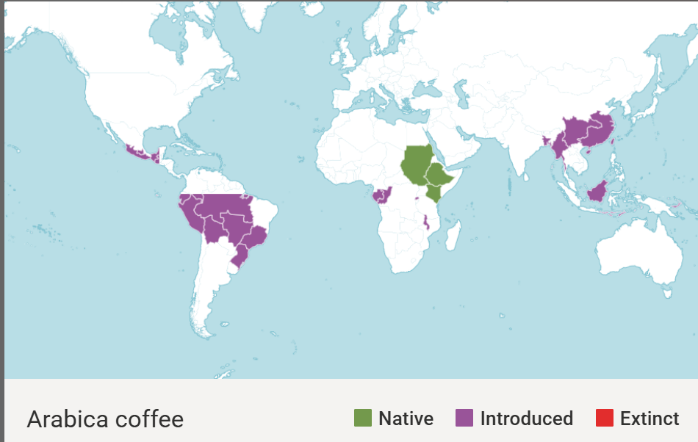
Figure 1: shows the natural distribution of Coffea arabica ( E. South Sudan, SW. Ethiopia, N. Kenya (Mt. Marsibit) in green and in purple the areas it has been introduced in due to favourable conditions (Coffea Arabica L. | Plants of the World Online | Kew Science, n.d.).
Coffea arabica is commonly cultivated in tropical highland regions where temperatures remain relatively moderate. Optimal temperature conditions for Arabica coffee are generally reported to be around 18–21°C, with tolerance up to approximately 24°C. Above these moderate temperatures, plant development and productivity decline, and prolonged exposure to higher temperatures can negatively affect plant growth and yield (Scott, 2015). Temperature is therefore a key limiting factor in the distribution and cultivation of the species.
In addition to temperature, Arabica coffee growth is influenced by stable environmental conditions across its development cycle, from early growth to fruit development, with temperature playing a central role in all stages. The germination process of Coffea arabica is strongly temperature-dependent and relatively slow compared to many other crops. At around 30°C, germination can occur within approximately three weeks, while at lower temperatures, such as 17°C, it may take up to three months to complete. This demonstrates a strong sensitivity to temperature, with warmer conditions significantly accelerating early development. Overall, successful germination requires consistent warmth and suitable environmental conditions to support seedling establishment (Tummakate, A.,1991).
In addition to climatic requirements, Coffea arabica is strongly influenced by soil characteristics, which play a key role in root development and overall plant performance. According to DaMatta and Ramalho (2006), Arabica coffee generally performs best in deep, well-drained soils with good structural properties that allow adequate root penetration and water movement. Soils with high organic matter content are considered favourable, as they support nutrient availability and water retention without causing waterlogging, which can negatively affect root health. The species is also commonly associated with slightly acidic soil conditions, which contribute to optimal nutrient uptake. Overall, soil physical structure and drainage capacity are identified as critical factors influencing the suitability of sites for Arabica coffee cultivation (DaMatta & Ramalho, 2006).
(im definitely not done, but its late so ill continue tomorrow)

Coffea arabica plantations are a highly profitable land-use system under threat by climate change, with a narrow exploitable range and high irrigation requirements being increased pressure with proliverence of draughts and temperature out of the optimal range.

C. arabica has an optimal temperature produce production range between 18-21 deg. C, with loss of fruit quality at higher temperatures and depressed growth under 18 deg. C.
Optimal temperature changes with phenological stage. Germination is optimum around 30-32, (reducing germination time to 3 weeks) with germination at 17 dgC costs 3 months. Above 35 germination is inhib.
It takes a year for C.arabica to fit within the mature plant temperature range.
Bud initiation also requires 30 dg. C.

Rainfall needs depend on retention of the soil, atmH, and cloud c. Also look at culticvation methods – link to agroforestry?.
A 2-4 month “dry-spell” is needed for stimulation of flowering
Arabica requires a less humid atmosphere, comp. to ethio. Highlands

Hawaii gvt. Wants a prediction / report on future coffee bean production on the island“improve overall efficiency and effectiveness in gov. decision making.
considering soil type, precipitation and temperature levels,
Find most suitable locations for coffee bean prod. On Hawai’I both under current climate and assess current yield
Find most suitable locations for coffee bean prod. On Hawai’I both under expected climate in 10 years and assess expected yield?
Find most suitable locations for coffee bean prod. On Hawai’I both under expected climate in 50 years and assess expected yield?
Evaluate future trends in available land
Assert mitigation possibilities that municipalities can take to diminish the impact of climate change on optimally selected sites.
Coffee plantations are a well-established plantation crop in many developing parts of the world. Hawaii is seeking to further develop the economic potential of the southernmost island of Hawai’i through the production of coffee.
Hawai’i currently sits within the viable range of Coffea arabica (source) as a subtropical island between (coordinates).
As a volcanic island, it contains large areas of … (something about the benefits of volcanic soil) soil, increasing potential yield. (source). Other soil types present on the island are .. .. .., which are less suited or even unfit for the growth of production crops.
Under climate change … many potential factors may affect the future productivity of and environmental impact of coffee plantations. Coffee worldwide is already experiencing stressors (Della Peruta et al. 2025) which are affecting farm yield and C. arabica proliferation in similar climates ((de Freitas et al. 2024))((Grandez-Alberca et al. 2025)).
Optimum temperature range for C. arabica sits at 18-21 deg.C (source). With a further increase in temperature a decline occurs in the quality of the fruit, with faster desiccation of the fruit after 25 deg.C(source). Some research has shown that successful yield can be achieved up to 24-25 deg.C (source)

DAM
Temperature and precipitation sections:

PRECIPITATION – Data Action Model
Objective: Prepare and standardize precipitation datasets (current and future scenarios) and convert them into suitability rasters for coffee production.
Step 1
Type: Transformation
Operation: Clip Raster (current precipitation + ssp126 + ssp370 + ssp585)
Motivation: Restricts all precipitation rasters to the Hawaiʻi study area to remove irrelevant data and ensure spatial consistency.
Step 2
Type: Transformation
Operation: Project Raster (if needed), Resample, Set Snap Raster
Motivation: Ensures all precipitation rasters share the same coordinate system, spatial resolution, and alignment as the common raster framework used in the project.
Step 3
Type: Transformation
Operation: Unit Check and Conversion (Raster Calculator if needed)
Motivation: CHELSA precipitation is often provided in monthly values (mm/month). Convert to annual precipitation (mm/year) if necessary to match the suitability range (1000–2500 mm/year).
Step 4
Type: Processing
Operation: Reclassify Raster (same scheme for all datasets: current + ssp126 + ssp370 + ssp585)
Motivation: Converts precipitation values into suitability scores based on coffee requirements:
- < 1000 mm → unsuitable (0)
- 1000–2500 mm → suitable (1 or scaled suitability)
- > 2500 mm → unsuitable (0)
Using identical thresholds ensures comparability across scenarios.
Step 5
Type: Transformation
Operation: Copy Raster / Export Raster (separate outputs per dataset)
Motivation: Stores each precipitation suitability raster (current, ssp126, ssp370, ssp585) separately to enable later comparison and overlay analysis.

TEMPERATURE – Data Action Model
Objective: Prepare and standardize temperature datasets (current and future scenarios) and convert them into suitability rasters for coffee production.
Step 1
Type: Transformation
Operation: Clip Raster (current temperature + ssp126 + ssp370 + ssp585)
Motivation: Restricts all temperature rasters to the Hawaiʻi study area to remove irrelevant data and ensure spatial consistency.
Step 2
Type: Transformation
Operation: Project Raster (if needed), Resample, Set Snap Raster
Motivation: Ensures all temperature rasters share the same coordinate system, spatial resolution, and alignment as the common raster framework used in the project.
Step 3
Type: Transformation
Operation: Unit Check and Conversion (Raster Calculator if needed)
Motivation: CHELSA temperature is often stored in tenths of degrees Celsius (°C × 10). Convert to degrees Celsius if necessary to match the suitability range (15–25°C).
Step 4
Type: Processing
Operation: Reclassify Raster (same scheme for all datasets: current + ssp126 + ssp370 + ssp585)
Motivation: Converts temperature values into suitability scores based on coffee requirements:
- < 15°C → unsuitable (0)
- 15–25°C → suitable (1 or scaled suitability)
- > 25°C → unsuitable (0)
Using identical thresholds ensures comparability across scenarios.
Step 5
Type: Transformation
Operation: Copy Raster / Export Raster (separate outputs per dataset)
Motivation: Stores each temperature suitability raster (current, ssp126, ssp370, ssp585) separately to enable later comparison and overlay analysis.

Roads Data action model:
Objective: Extract highways from the Hawaiʻi road network, create a 2000 m buffer zone, and convert it into a binary suitability raster for coffee plantation site selection (proximity to roads).
Step 1
Type: Selection
Operation: Select Layer By Attribute
Motivation: Filters the Roads_-_Hawaii_County dataset to retain only roads whose name contains "HWY" or "HIGHWAY". This removes local roads and ensures the analysis focuses on highways, which are the relevant road type for accessibility to potential coffee plantation sites.
Step 2
Type: Transformation
Operation: Copy Features
Motivation: Creates a permanent standalone feature class (Highways_Export) from the temporary selection layer. This preserves the highway subset for further processing and prevents data loss if the original selection is cleared.

Step 3
Type: Processing
Operation: Buffer (2000 m)
Motivation: in the assigment it stated:’’A plantation needs to be within 2000 meters of a highway’’. This step ensures this criteria is met and Creates a 2000-meter buffer polygon around all selected highways.

Step 4
Type: Transformation
Operation: Polygon to Raster (value field = FID)
Motivation: Converts the vector buffer polygon into a raster format, making future analysis with other variables easier. Using FID as the value field lead to the the raster showing many colors, each polygon has a unique FID.

Step 5
Type: Processing
Operation: Raster Calculator (Raster > 0)
Motivation: Converts the multi-valued buffer raster into a clean binary raster (Highways_Binary_Raster) where:
- 1 = within 2000 m of a highway (suitable)
- 0 / NoData = outside 2000 m (not suitable)
This simplifies the data to a single suitability class, ready for combination with other factor rasters from the group.

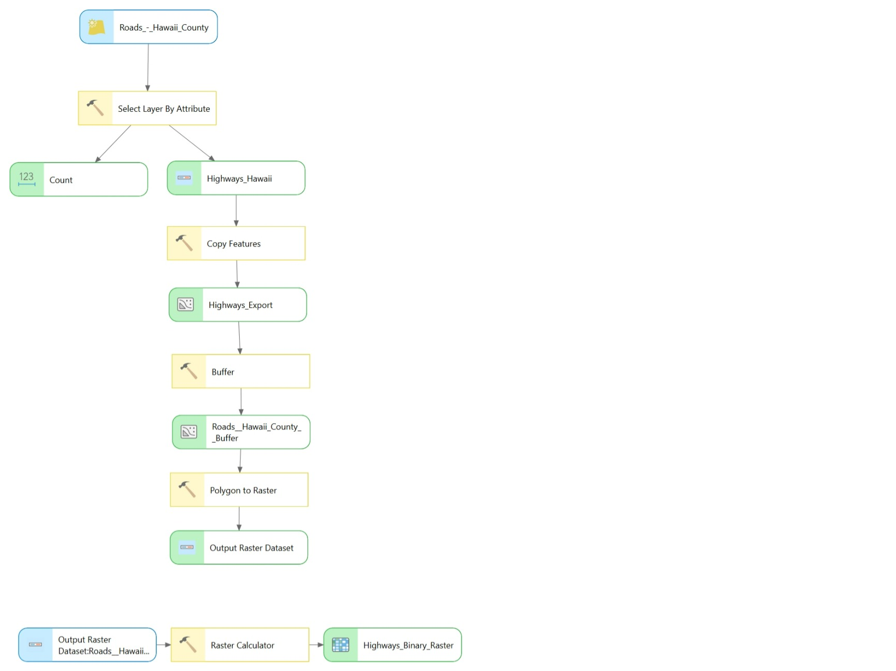
SOIL TYPE – Data Action Model
Geological units
Step 1
Type: Query
Operation: Select by attribute
Motivation: Only selects the records in the database Geological Units located on our island of interest, Hawaii
Step 2
Type: Processing by overlay
Operation: Clip
Motivation: Clips the selected records from the whole dataset, allowing us to work on only the area of interest.
Step 3
Type: Transformation
Operation: Feature to raster (Value field = name)
Motivation: transforms the vector dataset containing only the records on Hawaii, to a raster, as this is required for the suitability analysis
Step 4
Type: Processing
Operation: Reclassify raster
Motivation: Converts the geological units into suitability scores based on coffee requirements:
- Hualalai Volcanics: suitable (1)
- Kau Basalt: suitable (1)
- All others: 0
Step 5
Type: Transformation
Operation: Copy Raster / Export Raster (separate outputs per dataset)
Motivation: Stores the geologic unit suitability raster to enable later comparison and overlay analysis.
Soil type
Step 1
Type: Query
Operation: Join (Join TAXOUSDA_250m_ll.tif.csv Value and TAXOUSDA_250m_ll.tif) Number
Motivation: This joins the raster dataset which only contains Value to identify the soil type, with the CSV file which contains the generic soil type which corresponds to the Value
Step 2
Type: Processing by overlay
Operation: Clip Raster (Clip only the main island)
Motivation: Clips the selected records from the whole dataset, allowing us to work on only the area of interest.
Step 3
Type: Processing
Operation: Reclassify raster
Motivation: Converts the generic soil type into suitability scores based on coffee requirements:
- Andisols: suitable (1)
- Histosols: suitable (1)
- All others: 0
Step 4
Type: Transformation
Operation: Copy Raster / Export Raster (separate outputs per dataset)
Motivation: Stores the soil type suitability raster to enable later comparison and overlay analysis.

Elevation
Step 1
Type: transformation
Operation: topo to raster
Motivation: this converts the polyline elevation file into a raster file
Step 2
Type: processing
Operation: raster calculator
Motivation: select all the positive elevation, and thus omits the negative values below sea level
Step 3
Type: Processing
Operation: raster calculator
Motivation: makes a selection on whether elevation falls between the 1000 and 1500 meter
- Suitable (1)
- Not suitable (0)

Step 4
Type: Transformation
Operation: Copy Raster / Export Raster (separate outputs per dataset)
Motivation: Stores elevation level suitability raster to enable later comparison and overlay analysis.

Discussion paragraph?

Increase in suitable area, overall suitability is lower – area may be more comparable to the climate system where C. arabica originated from (eth. Highlands)
The growing of C. arabica under “classical” plantation format also has a high requirement for irrigation to supplement the (water?)) provided through precipitation in the current climate(source). With climate change, freshwater supply may undergo (thorough?) changes/ decrease in availability. Precipitation figures are projected to (… increase/…decrease) (source)… (leading to…). Groundwater recharge also decreases when land use changes from native forestry, further negatively impacting freshwater availability on Hawai’i. A census projection analysis with expected water consumption, irrigation needs and freshwater availability metrics under different land use scenarios will be required to fully consider the impact of coffee plantations on the Hawai’ian hydro system.
There is also evidence for the redistribution and/or loss of pollinators under the effects of climate change causing a shift in viable plantation area. Pollinator populations and thus the viable area for coffee in other south American coffee producing countries are projected to see serious decline (Imbach et al. 2017). We assert that it will be necessary to further assess these risks before making a definitive conclusion on the feasibility of expanding the coffee plantations on Hawai’i.
Agroforestry might offer solutions, as it has shown significant increases in biodiversity, insect populations and retention of water by the land-use system when compared to regular plantation as shown in a study in peru (Grandez-Alberca et al. 2025). Increasing the feasibility of actually implementing sustainable farming practices systems may be done successfully with financial incentives as shown in honduras (Quiñónez Camarillo et al. 2025) where farmers are stimulated by local governments by direct funding or increasing the price points farmers are allowed to set their products to with sustainable farming charges.

de Freitas CH, Coelho RD, de Oliveira Costa J, Sentelhas PC. 2024. A bitter cup of coffee? Assessing the impact of climate change on arabica coffee production in brazil. The Science of the total environment. 957:177546.
Della Peruta R, Mereu V, Spano D, Marras S, Vezy R, Trabucco A. 2025. Projecting trends of arabica coffee yield under climate change: A process-based modelling study at continental scale. Agricultural Systems. 227:104353.
Grandez-Alberca MA, Cotrina-Sanchez A, Haro N, Zabaleta-Santisteban JA, Silva-Melendez TB, Sanchez-Vega JA, Medina-Medina AJ, Tuesta-Trauco KM, Rivera-Fernandez AS, Granda-Santos M et al. 2025. Agronomic and economic sustainability perspectives in coffee-based agroforestry system (coffea arabica l.) in rodríguez de mendoza, amazonas, peru. Trees, Forests and People. 21.
Imbach P, Fung E, Hannah L, Navarro-Racines CE, Roubik DW, Ricketts TH, Harvey CA, Donatti CI, Läderach P, Locatelli B et al. 2017. Coupling of pollination services and coffee suitability under climate change. Proceedings of the National Academy of Sciences of the United States of America. 114(39):10438–10442.
Quiñónez Camarillo AL, Schuhmann PW, Randhir T, Orellana J. 2025. Coffee farmers willingness to accept payments for ecosystem services: Evidence from a choice experiment in honduras. Journal of Environmental Management. 378.

