USA COVID-19 Data Visualization App

| Patrick Straub  Huntsville, AL  [pjs0005@uah.edu](mailto:pjs0005@uah.edu) |
| --- |

# ABSTRACT

UPDATED—30 April 2020. This paper discusses the creation of a data visualization application representing COVID-19 data in the United States. The application was designed specifically for mobile devices and was intended to test the viability of non-traditional data visualization concepts when targeting an audience of those unfamiliar with data visualization.

## Keywords

COVID-19; Data visualization; mobile devices; non-traditional.

# INTRODUCTION

For my project, I created an animation representing the states of the USA visualizing COVID-19 data. The goal of this app is to use COVID-19 data provided by Johns Hopkins Center for Systems Science and Engineering to create a visualization that is immediately recognizable, understandable, and, most importantly, impactful for the average person. Following the spread of COVID-19 is applicable to everyone, so making the information accessible and relatable to everyone, and not just data scientists, is important. Therefore, the target audience is the average layperson. At the moment, there is plenty of data regarding COVID-19 and the coronavirus going around. A simple google search will bring easily bring about a plethora of tables, datasets, and visualizations. However, in researching these visualizations, it has been hard to find many visualizations that use animation, and even harder to find visualizations that do not conform to the standard language of data science. The vast majority of my findings were bar charts and line graphs, but many people that do not have a STEM background may not find such graphs to be very intuitive. For instance, consider the charts pictured below. These charts are presenting a lot of valuable information, but for someone who is not the most comfortable with graphs, they may be overwhelming.

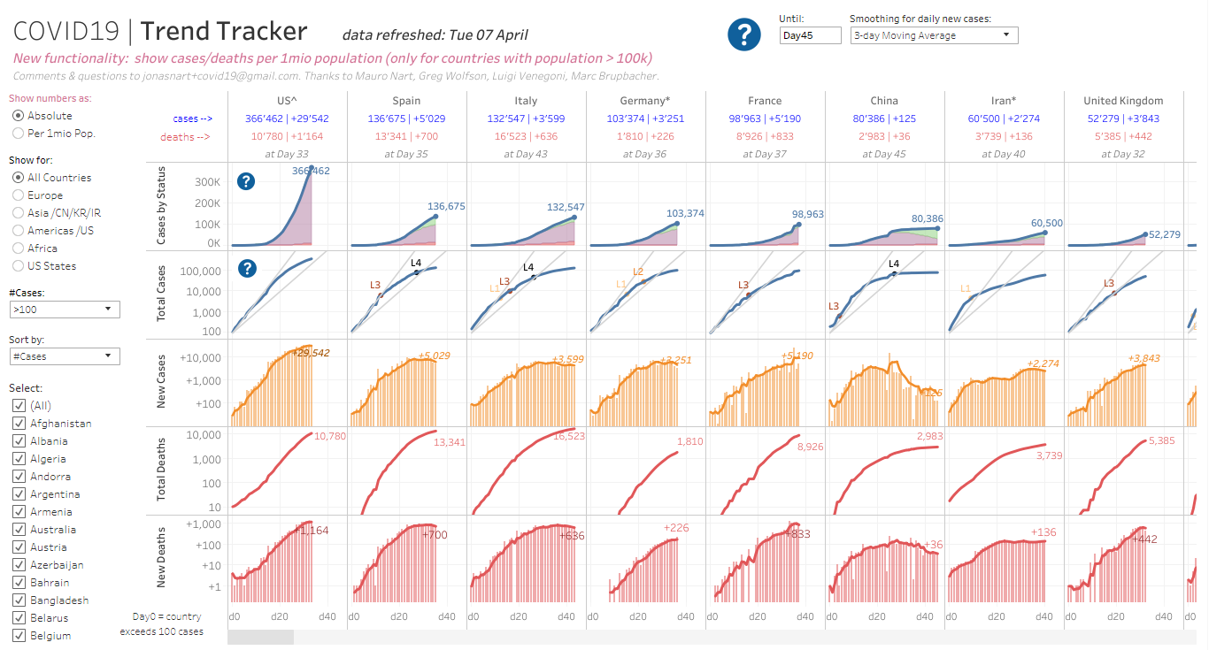

Using this app, I would like to study how the use of commanding imagery and animation can be used to make a data visualization more impactful and relatable. I plan on doing this through using the image of a beating heart and to represent data. It will not be as easy to identify specifics using this approach, but I hypothesize that the representation of a heart beating faster/slower will have more weight than a simpler design and will lead to greater understanding and retention than otherwise. In future, this app could be compared to a simpler design to test the hypothesis. Users could be surveyed and tested for information retention.

This visualization should be a mobile platform because it provides the best opportunity for the greatest amount of people to access the data. Mobile devices are ubiquitous, and people already understand the language of these devices. People are already familiar with tapping and swiping, which will be the main methods of interacting with the visualization. Also, this visualization is dealing with data that is relevant on the go, so having it available always is valuable. This visualization is suitable for the mobile platform because it is easily broken down in sizes that are digestible on a mobile screen and it uses manipulations that people with mobile devices are already familiar with.

# Related Work

The easiest piece of related work I could find was the COVID-19 Dashboard by the Center for Systems Science and Engineering (CSSE) at Johns Hopkins University (JHU). This visualization is using the same data set that I am using, but it is a vastly different visualization. As seen below, this visualization uses a series of red dots of varying sizes on a map to represent the number of confirmed cases of COVID-19. It also uses a number of traditional scatterplot graphs and tables.

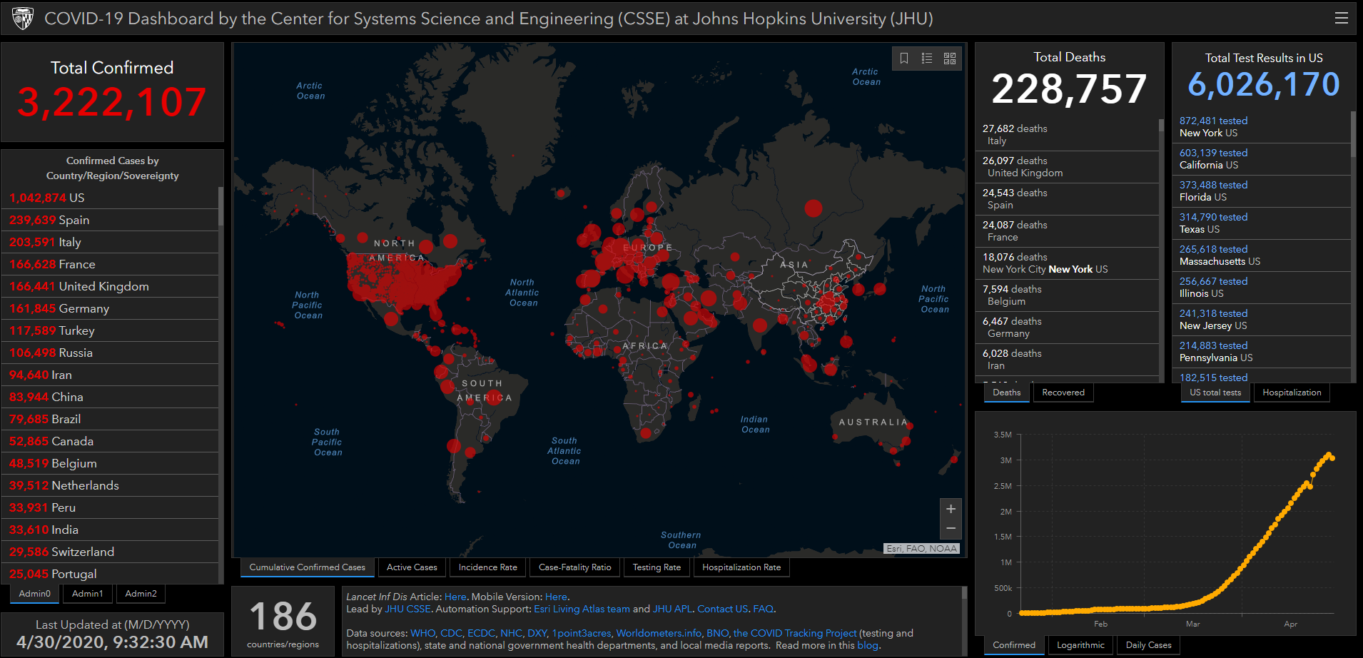

This is pretty different from my visualization because it only really uses traditional data visualization concepts. The amount of information displayed on the page is staggering and overwhelming. Another visualization I would like to reference is my own USA COVID-19 visualization that I made for my final exam for my CS571 class. This visualization is fairly similar to my own, but mine differs specifically in choosing to use non-traditional data visualization techniques. It also uses a different data set.

These are the two data visualizations I would like to compare my app to in order to test whether non-traditional data visualization techniques are viable in this case.

# Overview

The USA COVID-19 Data Visualization App presents a data visualization presenting a current view of the COVID-19 pandemic in the USA. The app is made using Lua and the Corona SDK. The application uses the Scene Composer API to create several different scenes for the app. The first scene of the app is the menu scene.

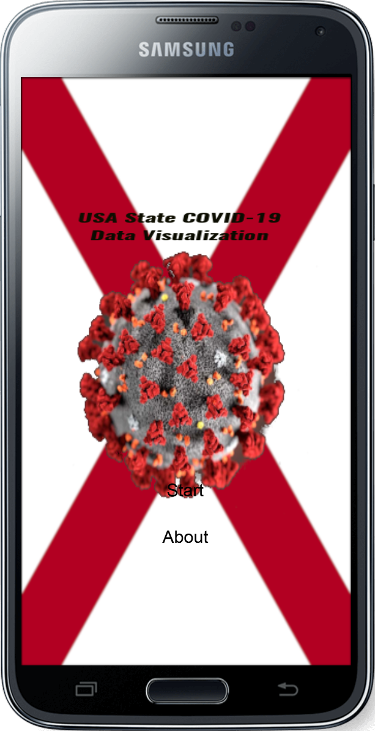

This scene displays the title of the app and contains two button widgets that lead to different scenes. The one button leads to the About scene.

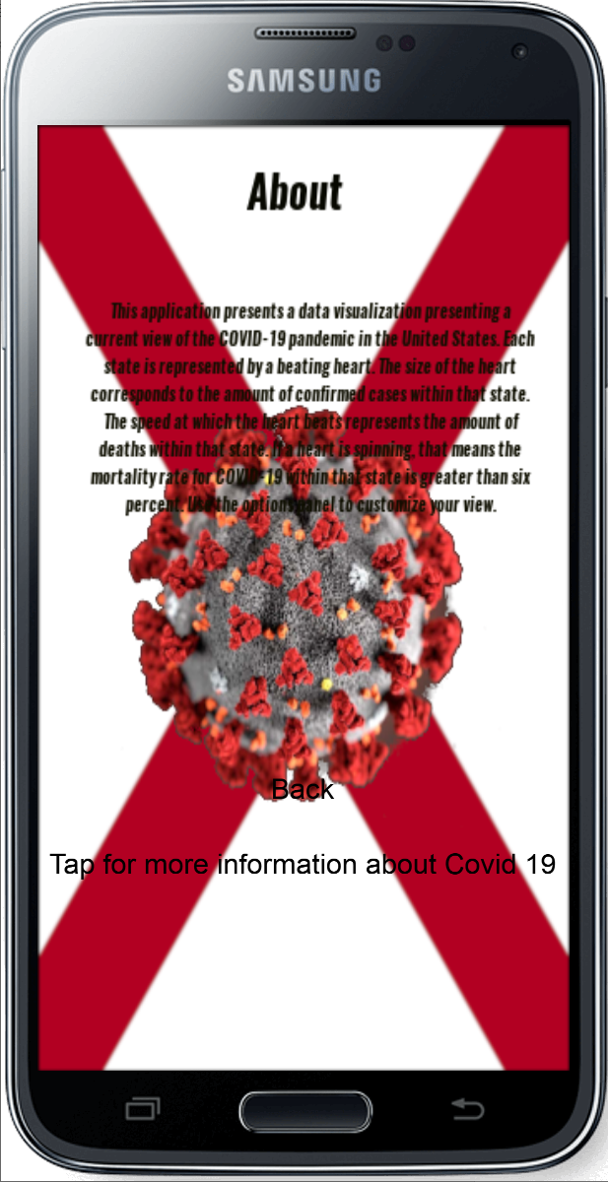

This scene gives a brief text overview of the application and how to use it. It also contains two button widgets. The first button takes users back to the menu. The second button will take users to <https://www.cdc.gov/coronavirus/2019-ncov/index.html> through their web browser. It uses system.OpenURL() to accomplish this.

The main scene of the application is the actual data visualization.

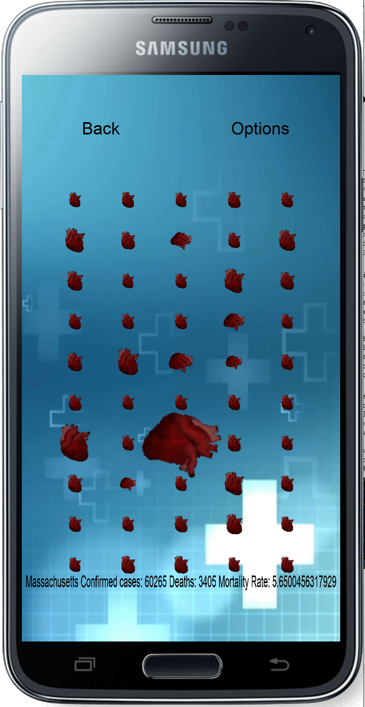

This scene shows a number of hearts on the screen. Each heart represents a different state in the United States. The size of each heart directly corresponds to the number of confirmed cases in each state. You cannot see it in a still image, but each heart is actually beating. This is done through the use of a sprite sheet. The sprite sheet has 6 images that it runs through at a different pace to make it look as if the heart is beating. The pace of the heart beating corresponds directly to the number of COVID-19 deaths in each state. The faster the heart beats equates to a higher number of deaths. You may notice that some of the hearts are lopsided. This is because they are actually spinning. Through the use of a custom event, the app detects which states have a mortality rate greater than six percent. The hearts corresponding to those states then have a dynamic physics body attached to them. A torque is then applied to those physics bodies. To keep the physics bodies from interacting in a way we do not want, gravity is set to 0 and the radius of the object’s colliders is quite small. There was no way I could find to actually lock the position of a dynamic physics object, although the rotation could be locked.

Each heart has an event handler that detects whether the heart has been “tapped”. When a heart is tapped, the text at the bottom of the screen changes to correspond to data regarding the state of the heart that is tapped.

Finally you can see that there are two widget buttons at the top. The first button will return users to the menu, while the second button will take users to the options scene.

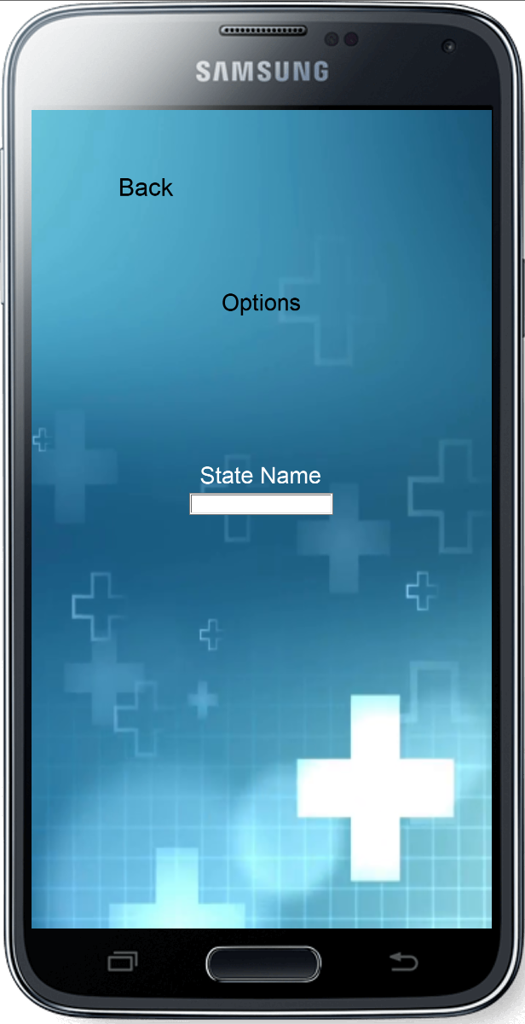

The options scene contains a textfield that users can type a state name into. Whatever letters are typed into the textfield will relate back to the data visualization. Letters corresponding to the state names will cause the hearts corresponding to those hearts to remain visible, while all other hearts become invisible. There is also a button to return to the data visualization.

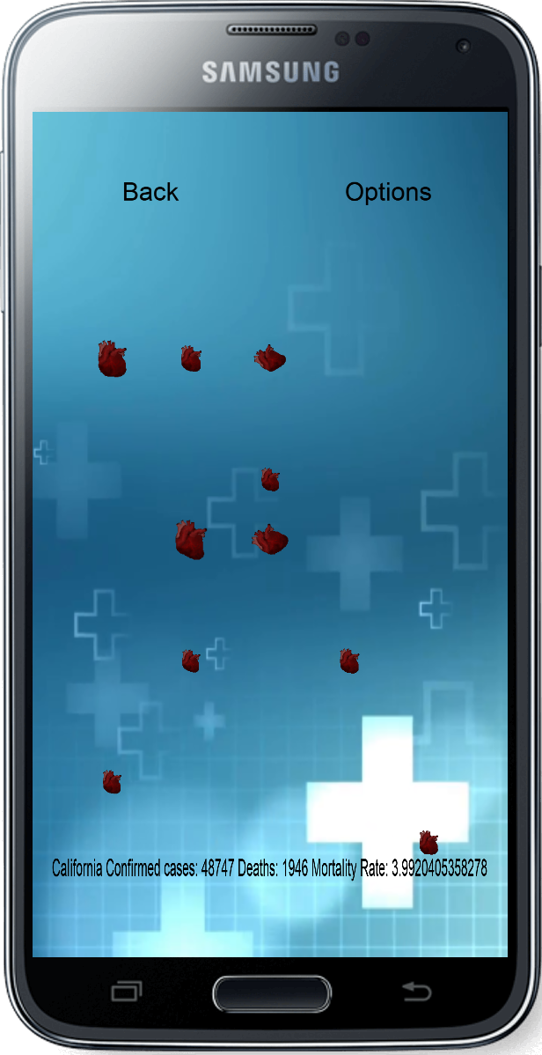

# USe Case

The dataset I used was COVID-19 data provided by Johns Hopkins Center for Systems Science and Engineering. Specifically, it was state data. The main question I had was whether non-traditional data visualizations could be more intuitive and lead to more information retention than traditional data visualizations. I felt like the image of a beating heart was striking and memorable. I still need to test my hypothesis by comparing experimental data versus other data visualizations. Personally, I feel as if it is not viable. Looking at my app, I feel like it is very hard to judge information by “beating” and spinning. However, I am very comfortable with traditional data visualizations so I am not the target audience.

# Discussion and Conclusion

Ultimately this approach is limited because it can lead to more confusion than enlightenment. “Beating” is impossible to really gauge the value of. Only the fastest beating hearts were really recognizable. Initially I intended to make a map of counties of the state of Alabama, but I decided to switch to a visualization of the states of the US for several reasons. First off, there was more data available per state rather than per county. Second, I felt there was more related work I could compare my visualization to. Third, I felt that state data was more relevant in the current climate with states deciding when to “reopen”. Finally, I decided not to include a map because it felt like it was hindering the scope of the app. I also intended to show data changing over time, but that was more difficult to find related work to compare to my own.

In the future, the app could be updated to include more areas, variables, and times. However, the most important work to be done is to actually test whether the non-traditional data visualization is actually viable by surveying the target audience after experiencing this app and a traditional data visualization. I believe that the data visualization is complete in regards to being able to perform that experiment.

# REFERENCES

1. <https://www.cdc.gov/coronavirus/2019-ncov/index.html>
2. <https://coronavirus.jhu.edu/us-map>
3. <https://github.com/CSSEGISandData/COVID-19>