**Lab 7**

**Name: Krishna Chapla**

**Roll No: CE024**

**Id:21CEUOD006**

1)TO CREATE A STATELESS WIDGET – SHORTCUT:

Just type stless and press the ‘tab’ key....it will create automatically a class of stateless widget...just change the class name according to your requirements.

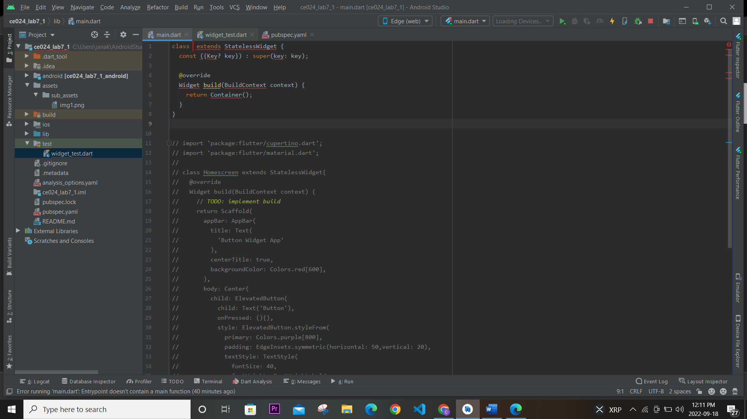

2) ADDING IMAGES IN PROJECT:

Similar to adding font we can add images. Create an assets directory and put your images inside it, declare assets in pubsec.yaml, and then get and upgrade the dependencies and do a hot restart.

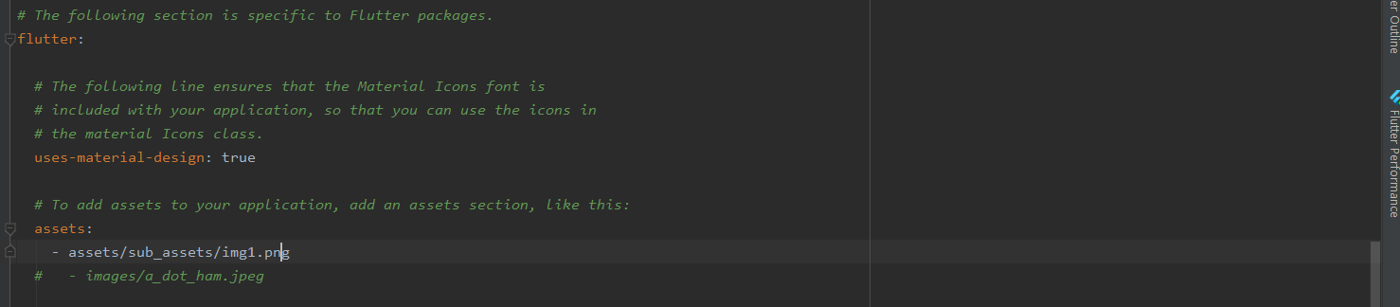

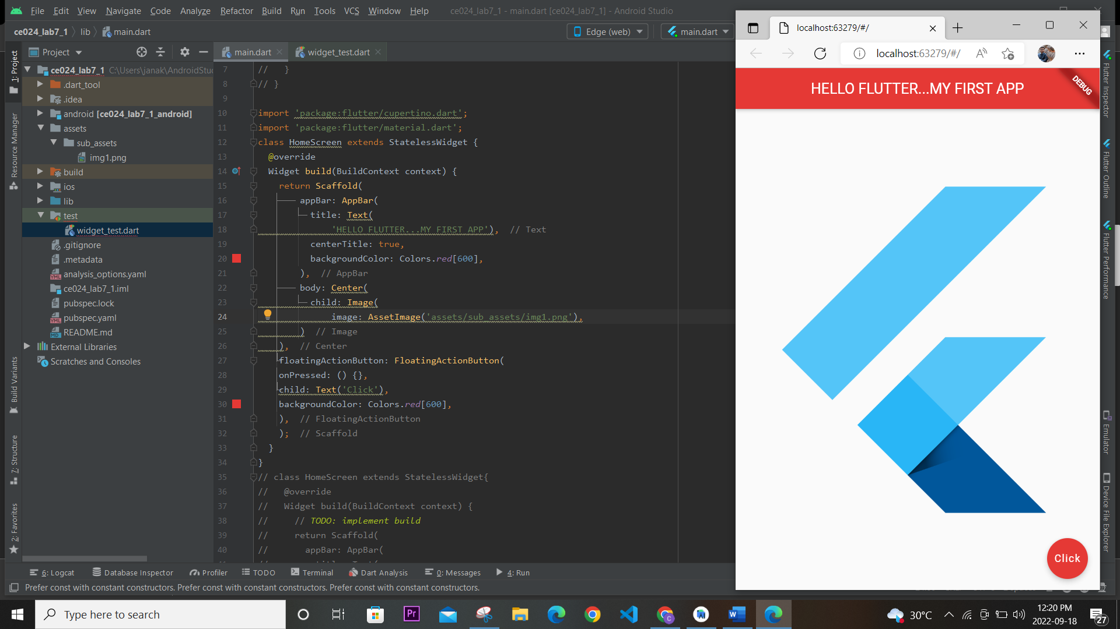

Scaffold: Creates a visual scaffold for material design widgets. Scaffold is a class in flutter which provides many widgets or we can say APIs like Drawer, SnackBar, BottomNavigationBar, FloatingActionButton, AppBar, etc. Scaffold will expand or occupy the whole device screen. It will occupy the available space

AppBar: AppBar is usually the topmost component of the app (or sometimes the bottom-most), it contains the toolbar and some other common action buttons. As all the components in a flutter application are a widget or a combination of widgets. So AppBar is also a built-in class or widget in flutter which gives the functionality of the AppBar out of the box. The **AppBar** widget is based on Material Design and much of the information is already provided by other classes like MediaQuery, Scaffold as to where the content of the AppBar should be placed.

FloatingActionButton: A floating action button is a circular icon button that hovers over content to promote a primary action in the application. Floating action buttons are most used in the [Scaffold.floatingActionButton](https://www.geeksforgeeks.org/floatingactionbutton-in-flutter/" \t "_blank) field.

AssetImage: Used for Adding assets and images.

3) Code test : 2 : Icon

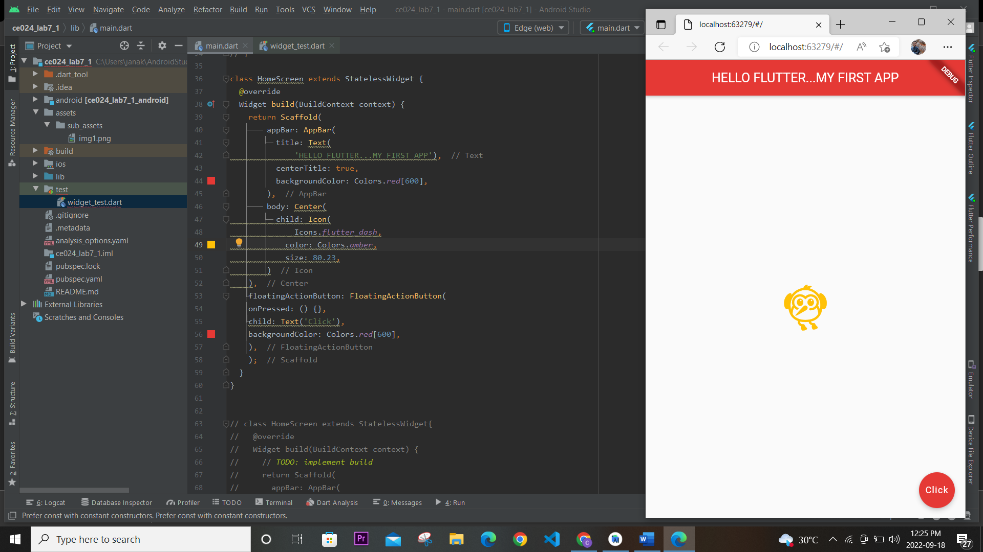

Icon: Creates an icon.

The size and color default to the value given by the current IconTheme.

Many options for icons are available Icons.add , Icons.edit\_location , Icons.flutter\_dash etc. Where Icons is the class.

4) Code test 3 : Buttons

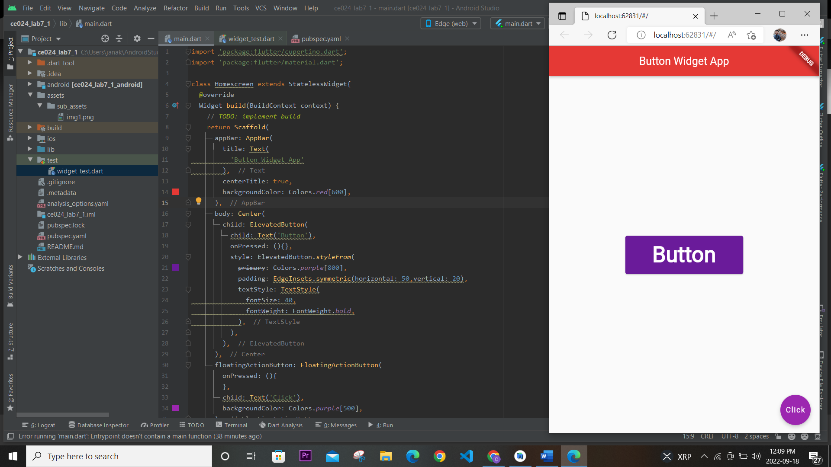

ElevatedButton: Elevated Button is a flutter component included inside the material package i.e. “package:flutter/material.dart“. The main characteristic these buttons hold is the slight elevation in their surface towards the screen on getting tapped by the user. In simple language, elevated buttons are un-deprecated raised buttons with no explicitly defined button styling. Elevated Buttons cannot be styled i.e. you cannot modify the color of the button, font size, text style, etc explicitly like raised buttons. This class was launched in version 1.22 of flutter. You can pass text or icons as a child to them. To handle the styling of the Elevated Button, a ButtonStyle class is used which allows the styling of a button according to requirements.

Parameters:1)child,2) OnPressed

Properties: autofocus, ButtonStyle, enabled, etc.

5)Flat Button:

Flat Button: FlatButton is the material design widget in flutter. It is a text label material widget that performs an action when the button is tapped. Let’s understand with the help of examples. As of May 2021 the FlatButton class in flutter is deprecated. TextButton class should be used instead.

6)Icon Button:

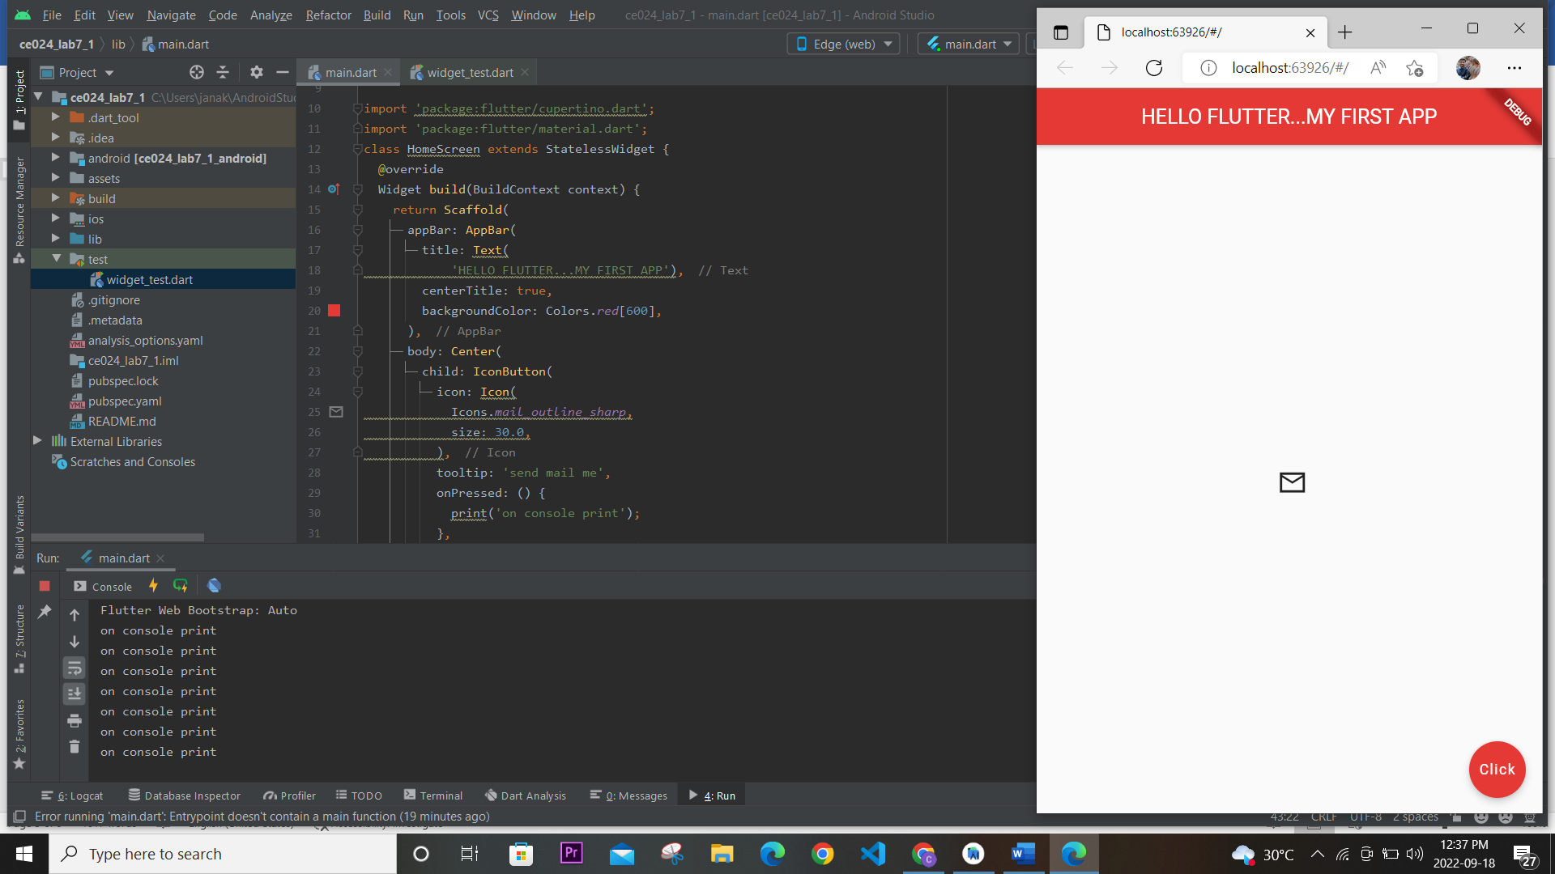

IconButton:  It is one of the most widely used buttons in the flutter library. First, as the name suggests, the icon button is the button having an icon, and ontap it does something .

7)TextButton:

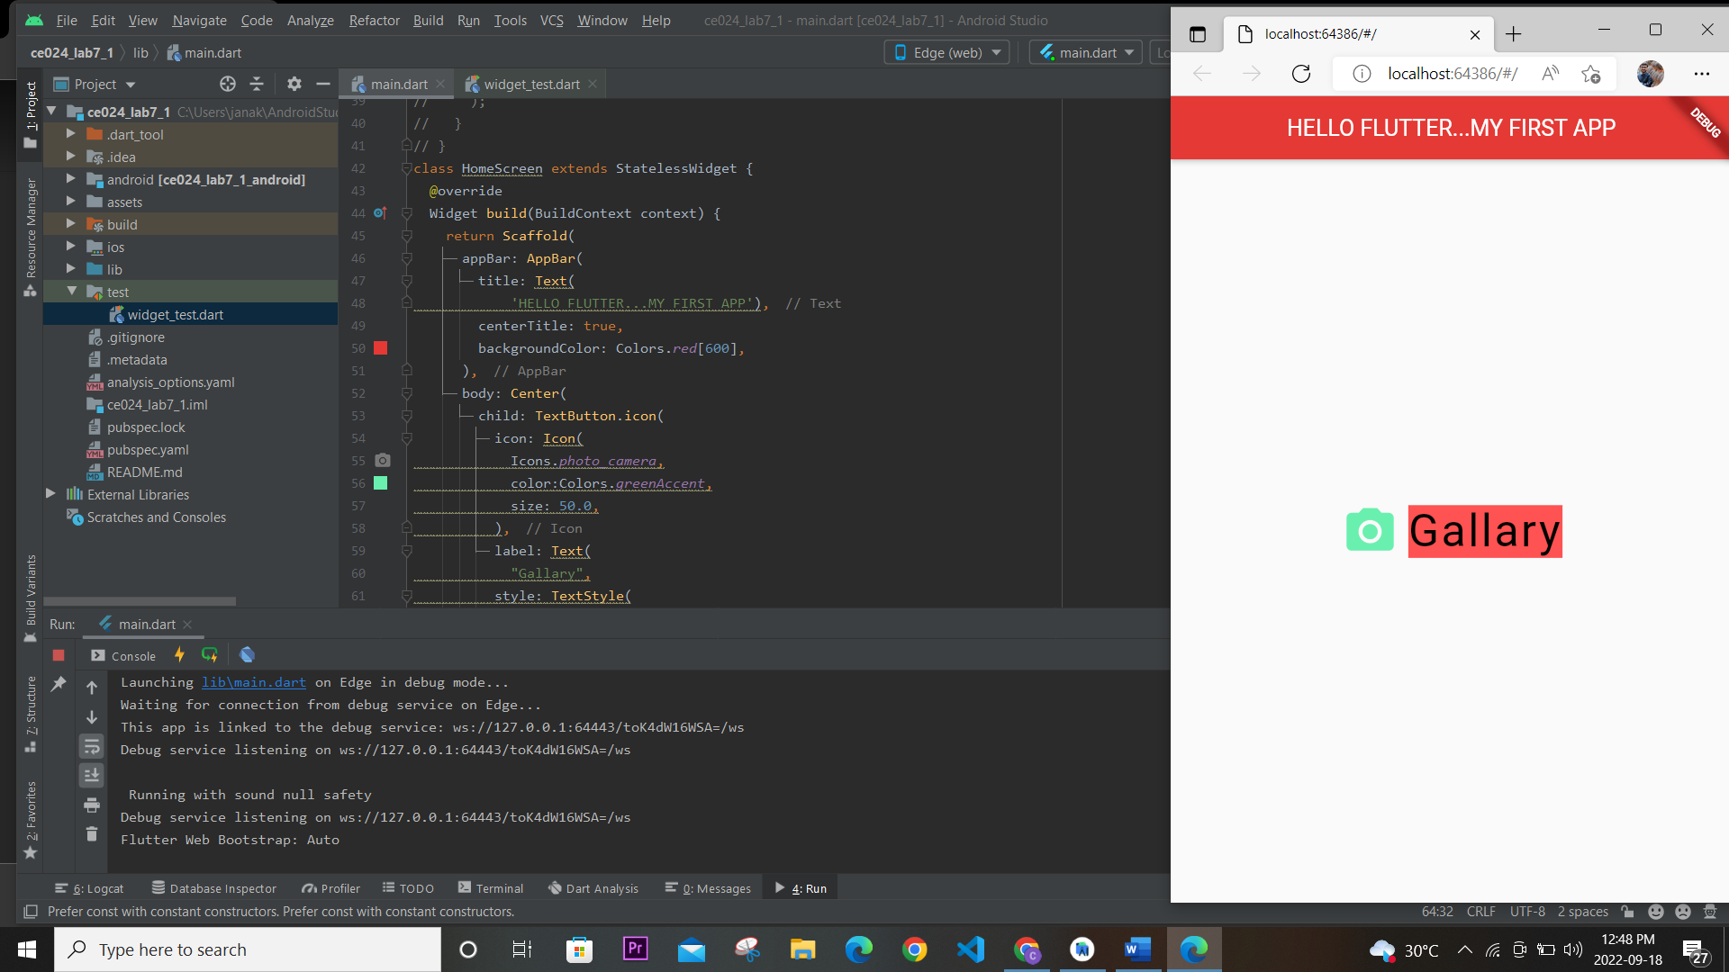

TextButton : TextButton is a built-in widget in[Flutter](https://www.geeksforgeeks.org/flutter-an-introduction-to-the-open-source-sdk-by-google/) which derives its design from Google’s Material Design Library. It is a simple Button without any border that listens for onPressed and onLongPress gestures. It has a style property that accepts ButtonStyle as value, using this style property developers can customize the TextButton however they want.

8)Directionality Class:

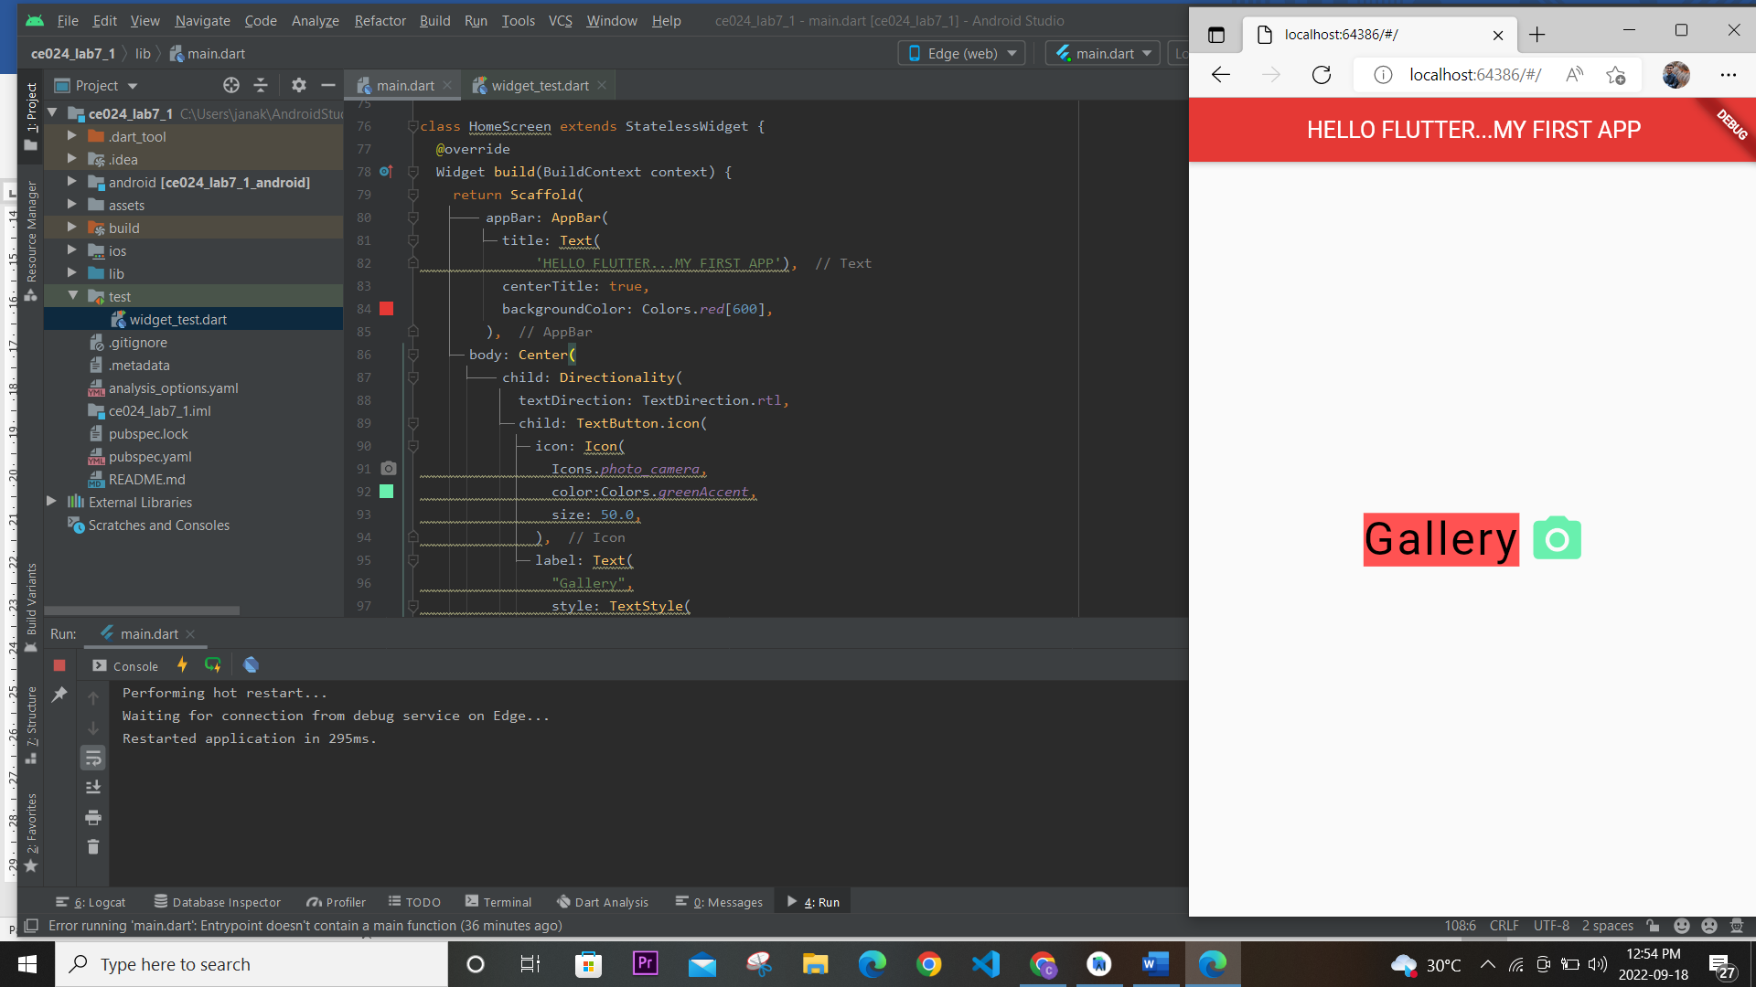

Directionality: Creates a widget that determines the directionality of text and text-direction-sensitive render objects. The textDirection and child arguments must not be null.

Final Code:

// class extends StatelessWidget {  
// const ({Key? key}) : super(key: key);  
//  
// @override  
// Widget build(BuildContext context) {  
// return Container();  
// }  
// }  
  
import 'package:flutter/cupertino.dart';  
import 'package:flutter/material.dart';  
// class HomeScreen extends StatelessWidget {  
// @override  
// Widget build(BuildContext context) {  
// return Scaffold(  
// appBar: AppBar(  
// title: Text(  
// 'HELLO FLUTTER...MY FIRST APP'),  
// centerTitle: true,  
// backgroundColor: Colors.red[600],  
// ),  
// body: Center(  
// child: IconButton(  
// icon: Icon(  
// Icons.mail\_outline\_sharp,  
// size: 30.0,  
// ),  
// tooltip: 'send mail me',  
// onPressed: () {  
// print('on console print');  
// },  
// ),  
// ),  
// floatingActionButton: FloatingActionButton(  
// onPressed: () {},  
// child: Text('Click'),  
// backgroundColor: Colors.red[600],  
// ),  
// );  
// }  
// }  
// class HomeScreen extends StatelessWidget {  
// @override  
// Widget build(BuildContext context) {  
// return Scaffold(  
// appBar: AppBar(  
// title: Text(  
// 'HELLO FLUTTER...MY FIRST APP'),  
// centerTitle: true,  
// backgroundColor: Colors.red[600],  
// ),  
// body: Center(  
// child: TextButton.icon(  
// icon: Icon(  
// Icons.photo\_camera,  
// color:Colors.greenAccent,  
// size: 50.0,  
// ),  
// label: Text(  
// "Gallary",  
// style: TextStyle(  
// color: Colors.black,  
// fontSize: 40.0,  
// letterSpacing: 2.0,  
// backgroundColor: Colors.redAccent,  
// ),  
// textAlign: TextAlign.start,  
// ),  
// onPressed: (){},  
// ),  
// ),  
// );  
// }  
// }  
  
// class HomeScreen extends StatelessWidget {  
// @override  
// Widget build(BuildContext context) {  
// return Scaffold(  
// appBar: AppBar(  
// title: Text(  
// 'HELLO FLUTTER...MY FIRST APP'),  
// centerTitle: true,  
// backgroundColor: Colors.red[600],  
// ),  
// body: Center(  
// child: Directionality(  
// textDirection: TextDirection.rtl,  
// child: TextButton.icon(  
// icon: Icon(  
// Icons.photo\_camera,  
// color:Colors.greenAccent,  
// size: 50.0,  
// ),  
// label: Text(  
// "Gallery",  
// style: TextStyle(  
// color: Colors.black,  
// fontSize: 40.0,  
// letterSpacing: 2.0,  
// backgroundColor: Colors.redAccent,  
// ),  
// textAlign: TextAlign.start,  
// ),  
// onPressed: () {},  
// ),  
// ),  
// )  
// );  
// }  
// }  
  
void main()=>runApp(MaterialApp(  
 home: HomeScreen(),  
));  
// class HomeScreen extends StatelessWidget {  
// @override  
// Widget build(BuildContext context) {  
// return Scaffold(  
// appBar: AppBar(  
// title: Text(  
// 'HELLO FLUTTER...MY FIRST APP'),  
// centerTitle: true,  
// backgroundColor: Colors.red[600],  
// ),  
// body: Center(  
// child: Image(  
// image: AssetImage('assets/sub\_assets/img1.png'),  
// )  
// ),  
// floatingActionButton: FloatingActionButton(  
// onPressed: () {},  
// child: Text('Click'),  
// backgroundColor: Colors.red[600],  
// ),  
// );  
// }  
// }  
  
// class HomeScreen extends StatelessWidget {  
// @override  
// Widget build(BuildContext context) {  
// return Scaffold(  
// appBar: AppBar(  
// title: Text(  
// 'HELLO FLUTTER...MY FIRST APP'),  
// centerTitle: true,  
// backgroundColor: Colors.red[600],  
// ),  
// body: Center(  
// child: Icon(  
// Icons.flutter\_dash,  
// color: Colors.amber,  
// size: 80.23,  
// )  
// ),  
// floatingActionButton: FloatingActionButton(  
// onPressed: () {},  
// child: Text('Click'),  
// backgroundColor: Colors.red[600],  
// ),  
// );  
// }  
// }  
  
// class HomeScreen extends StatelessWidget {  
// @override  
// Widget build(BuildContext context) {  
// return Scaffold(  
// appBar: AppBar(  
// title: Text(  
// 'HELLO FLUTTER...MY FIRST APP'),  
// centerTitle: true,  
// backgroundColor: Colors.red[600],  
// ),  
// body: Center(  
// child: TextButton(  
// onPressed: (){  
// print('Print on console');  
// },  
// child: Text('Click me'),  
// ),  
// ),  
// floatingActionButton: FloatingActionButton(  
// onPressed: () {},  
// child: Text('Click'),  
// backgroundColor: Colors.red[600],  
// ),  
// );  
// }  
// }  
  
  
  
  
  
// class HomeScreen extends StatelessWidget{  
// @override  
// Widget build(BuildContext context) {  
// // *TODO: implement build*// return Scaffold(  
// appBar: AppBar(  
// title: Text(  
// 'Button Widget App'  
// ),  
// centerTitle: true,  
// backgroundColor: Colors.red[600],  
// ),  
// body: Center(  
// child: ElevatedButton(  
// child: Text('Button'),  
// onPressed: (){},  
// style: ElevatedButton.styleFrom(  
// primary: Colors.purple[800],  
// padding: EdgeInsets.symmetric(horizontal: 50,vertical: 20),  
// textStyle: TextStyle(  
// fontSize: 40,  
// fontWeight: FontWeight.bold,  
// ),  
// ),  
// ),  
// ),  
// floatingActionButton: FloatingActionButton(  
// onPressed: (){  
// },  
// child: Text('Click'),  
// backgroundColor: Colors.purple[500],  
// ),  
// );  
// }  
// }