1、https://claude.ai/api/organizations/a88e264b-1fd1-4063-90d6-55a0659bba9f/chat_conversations/dbc0b91c-0f4f-4ef2-b5da-3f6df5a8e979/completion
2、https://claude.ai/api/organizations/a88e264b-1fd1-4063-90d6-55a0659bba9f/chat_conversations/dbc0b91c-0f4f-4ef2-b5da-3f6df5a8e979?tree=True&rendering_mode=messages&render_all_tools=true&consistency=eventual

很好的问题！你观察到的这两个接口正好体现了 AI Agent 的核心设计模式。让我详细分析。

你观察到的两个接口分析
接口1（completion） - 发送消息，获取流式响应 接口2（查询接口） - 获取对话历史和状态

核心协议选型

为什么用 SSE 而不是 WebSocket？
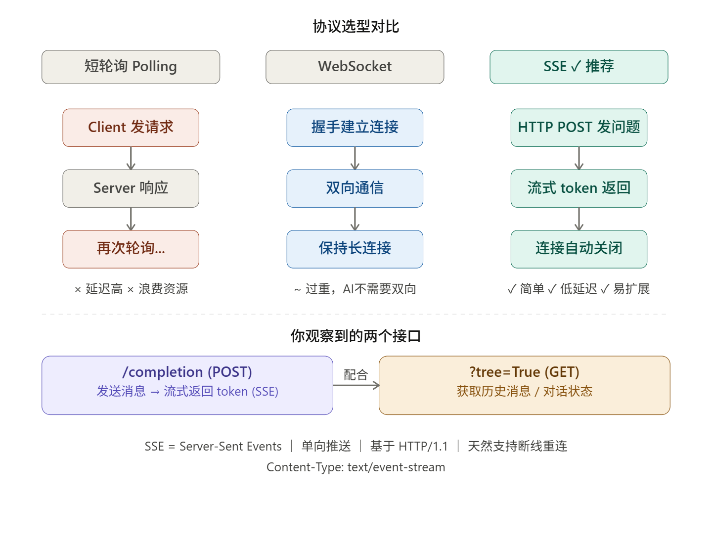

详细设计

两个接口的作用
你观察到的完全正确：
- /completion (POST + SSE) — 核心接口，发送用户消息，以流的形式逐步返回 AI 生成的 token
- ?tree=True (GET) — 辅助接口，拉取会话历史、消息树、渲染状态

为什么选 SSE 而不是 WebSocket？
维度 | WebSocket | SSE
方向 | 双向 | 服务器 → 客户端单向
协议 | 需要升级握手 | 纯 HTTP
复杂度 | 高（需处理心跳、断线重连） | 低（浏览器原生支持自动重连）
CDN/代理 | 穿透困难 | 完全兼容
AI Agent 场景 | 过重 | 完美匹配（用户问 → AI 单向流式回答）

最佳实践：完整接口设计

接口 1：发送消息（核心）
POST /api/conversations/:id/completion
Content-Type: application/json

{
"message": "用户输入的问题",
"stream": true
}

响应（SSE 格式）：
HTTP/1.1 200 OK
Content-Type: text/event-stream
Cache-Control: no-cache
X-Accel-Buffering: no ← Nginx 必须加这个，否则会缓冲

data: {"type":"token","content":"你好"}

data: {"type":"token","content":"，这"}

data: {"type":"tool_call","name":"web_search","input":{"query":"..."}}

data: {"type":"token","content":"是结果"}

data: {"type":"done","usage":{"input_tokens":42,"output_tokens":120}}

data: [DONE]

接口 2：获取会话历史
GET /api/conversations/:id?include_messages=true
{
"id": "conv_xxx",
"messages": [
{ "role": "user", "content": "..." },
{ "role": "assistant", "content": "..." }
]
}

接口 3：创建会话
POST /api/conversations
→ { "id": "conv_xxx" }

前端实现核心代码
async function sendMessage(conversationId, message) {
const response = await fetch(`/api/conversations/${conversationId}/completion`, {
method: 'POST',
headers: { 'Content-Type': 'application/json' },
body: JSON.stringify({ message, stream: true }),
});

const reader = response.body.getReader();
const decoder = new TextDecoder();

while (true) {
const { value, done } = await reader.read();
if (done) break;

const lines = decoder.decode(value).split('\n');
for (const line of lines) {
if (!line.startsWith('data: ')) continue;
const data = line.slice(6);
if (data === '[DONE]') return;

const event = JSON.parse(data);
if (event.type === 'token') {
appendToUI(event.content); // 逐字追加到界面
}
}
}
}

后端实现核心代码（Node.js）
app.post('/api/conversations/:id/completion', async (req, res) => {
// 设置 SSE 响应头
res.setHeader('Content-Type', 'text/event-stream');
res.setHeader('Cache-Control', 'no-cache');
res.setHeader('X-Accel-Buffering', 'no'); // 关键！禁止 Nginx 缓冲

const sendEvent = (data) => {
res.write(`data: ${JSON.stringify(data)}\n\n`);
};

// 调用 Anthropic API（流式）
const stream = await anthropic.messages.stream({
model: 'claude-opus-4-6',
messages: [...history, { role: 'user', content: req.body.message }],
});

for await (const chunk of stream) {
if (chunk.type === 'content_block_delta') {
sendEvent({ type: 'token', content: chunk.delta.text });
}
}

sendEvent({ type: 'done' });
res.write('data: [DONE]\n\n');
res.end();
});

关键工程细节
Nginx 配置（非常容易踩坑）：
location /api/conversations/ {
proxy_pass http://backend;
proxy_buffering off; # 禁止缓冲，否则 token 不实时
proxy_cache off;
proxy_read_timeout 300s; # AI 生成可能较慢，超时要设长
proxy_set_header Connection '';
chunked_transfer_encoding on;
}

断线重连：SSE 浏览器原生支持，通过 Last-Event-ID header 可以实现续传，非常适合网络不稳定的场景。
Agent 工具调用：在 SSE 流中插入 tool_call 事件类型，前端渲染"正在搜索..."之类的中间状态，体验更好。
总结：POST 提交 + SSE 流式返回 是 AI Agent 接口的工业标准，Anthropic、OpenAI、Google 全部采用这个模式，原因就是它完美匹配"用户问、AI 流式答"的单向通信场景，同时基于纯 HTTP，部署运维极其简单。

fastapi==0.115.0
uvicorn[standard]==0.30.6
anthropic==0.34.2
python-dotenv==1.0.1
pydantic==2.9.1
pydantic-settings==2.5.2
redis==5.1.0
python-jose[cryptography]==3.3.0
passlib[bcrypt]==1.7.4
httpx==0.27.2
structlog==24.4.0
prometheus-fastapi-instrumentator==7.0.0

2、config.py
from pydantic_settings import BaseSettings
from functools import lru_cache
from typing import List

class Settings(BaseSettings):
# App
APP_NAME: str = "AI Agent"
APP_ENV: str = "production"
DEBUG: bool = False

# Anthropic
ANTHROPIC_API_KEY: str
ANTHROPIC_MODEL: str = "claude-opus-4-6"
MAX_TOKENS: int = 4096

# Security
SECRET_KEY: str
ALLOWED_ORIGINS: List[str] = ["http://localhost:5173", "https://yourdomain.com"]

# Redis (用于会话持久化)
REDIS_URL: str = "redis://localhost:6379"
SESSION_TTL: int = 86400 # 24小时

# Rate limiting
RATE_LIMIT_RPM: int = 30 # 每分钟请求数

class Config:
env_file = ".env"
case_sensitive = True

@lru_cache()
def get_settings() -> Settings:
return Settings()

3、models.py
from pydantic import BaseModel, Field
from typing import List, Optional, Literal
from datetime import datetime
import uuid

class Message(BaseModel):
id: str = Field(default_factory=lambda: str(uuid.uuid4()))
role: Literal["user", "assistant"]
content: str
created_at: datetime = Field(default_factory=datetime.utcnow)
tokens: Optional[int] = None

class Conversation(BaseModel):
id: str = Field(default_factory=lambda: str(uuid.uuid4()))
title: Optional[str] = None
messages: List[Message] = []
created_at: datetime = Field(default_factory=datetime.utcnow)
updated_at: datetime = Field(default_factory=datetime.utcnow)

class CreateConversationRequest(BaseModel):
title: Optional[str] = None

class SendMessageRequest(BaseModel):
message: str = Field(..., min_length=1, max_length=32000)
conversation_id: Optional[str] = None

# SSE 事件数据结构
class SSETokenEvent(BaseModel):
type: Literal["token"] = "token"
content: str

class SSEDoneEvent(BaseModel):
type: Literal["done"] = "done"
conversation_id: str
message_id: str
usage: dict

class SSEErrorEvent(BaseModel):
type: Literal["error"] = "error"
code: str
message: str

class ConversationListItem(BaseModel):
id: str
title: Optional[str]
last_message: Optional[str]
message_count: int
created_at: datetime
updated_at: datetime

4、storage.py
import json
import redis.asyncio as aioredis
from typing import Optional, List
from datetime import datetime
from models import Conversation, Message
from config import get_settings
import structlog

logger = structlog.get_logger()
settings = get_settings()

class ConversationStore:
"""基于 Redis 的会话存储，生产中可替换为 PostgreSQL"""

def __init__(self):
self.redis: Optional[aioredis.Redis] = None

async def connect(self):
self.redis = await aioredis.from_url(
settings.REDIS_URL,
encoding="utf-8",
decode_responses=True,
)
logger.info("Redis connected", url=settings.REDIS_URL)

async def disconnect(self):
if self.redis:
await self.redis.aclose()

def _conv_key(self, conv_id: str) -> str:
return f"conversation:{conv_id}"

def _user_convs_key(self, user_id: str) -> str:
return f"user:{user_id}:conversations"

async def create_conversation(self, user_id: str, title: Optional[str] = None) -> Conversation:
conv = Conversation(title=title)
await self.redis.setex(
self._conv_key(conv.id),
settings.SESSION_TTL,
conv.model_dump_json(),
)
# 维护用户的会话列表 (按时间倒序)
await self.redis.zadd(
self._user_convs_key(user_id),
{conv.id: conv.created_at.timestamp()},
)
logger.info("Conversation created", conv_id=conv.id, user_id=user_id)
return conv

async def get_conversation(self, conv_id: str) -> Optional[Conversation]:
data = await self.redis.get(self._conv_key(conv_id))
if not data:
return None
return Conversation.model_validate_json(data)

async def append_message(self, conv_id: str, message: Message) -> Conversation:
conv = await self.get_conversation(conv_id)
if not conv:
raise ValueError(f"Conversation {conv_id} not found")

conv.messages.append(message)
conv.updated_at = datetime.utcnow()

# 自动生成标题（取第一条用户消息前20字）
if not conv.title and message.role == "user":
conv.title = message.content[:40].strip()

await self.redis.setex(
self._conv_key(conv_id),
settings.SESSION_TTL,
conv.model_dump_json(),
)
return conv

async def list_conversations(self, user_id: str, limit: int = 20) -> List[Conversation]:
conv_ids = await self.redis.zrevrange(
self._user_convs_key(user_id), 0, limit - 1
)
conversations = []
for cid in conv_ids:
conv = await self.get_conversation(cid)
if conv:
conversations.append(conv)
return conversations

async def delete_conversation(self, user_id: str, conv_id: str) -> bool:
deleted = await self.redis.delete(self._conv_key(conv_id))
await self.redis.zrem(self._user_convs_key(user_id), conv_id)
return deleted > 0

# 全局单例
store = ConversationStore()

5、ai_service.py
import anthropic
import json
from typing import AsyncGenerator, List
from models import Message, SSETokenEvent, SSEDoneEvent, SSEErrorEvent
from config import get_settings
import structlog
import uuid

logger = structlog.get_logger()
settings = get_settings()

# Anthropic 客户端（复用连接）
client = anthropic.AsyncAnthropic(api_key=settings.ANTHROPIC_API_KEY)

SYSTEM_PROMPT = """你是一个专业、友好的 AI 助手。
- 回答准确、简洁，必要时结构化展示
- 代码块使用 Markdown 格式
- 不确定时如实告知，不要编造信息
"""

def _format_messages(messages: List[Message]) -> List[dict]:
"""转换为 Anthropic API 格式，合并连续同角色消息"""
formatted = []
for msg in messages:
if formatted and formatted[-1]["role"] == msg.role:
# 合并连续同角色（Anthropic 要求交替）
formatted[-1]["content"] += "\n\n" + msg.content
else:
formatted.append({"role": msg.role, "content": msg.content})
return formatted

async def stream_chat(
messages: List[Message],
new_message: str,
) -> AsyncGenerator[str, None]:
"""
核心流式生成函数
yield SSE 格式字符串: "data: {...}\n\n"
"""
message_id = str(uuid.uuid4())
full_content = ""
input_tokens = 0
output_tokens = 0

# 构造历史 + 新消息
all_messages = _format_messages(messages)
all_messages.append({"role": "user", "content": new_message})

try:
async with client.messages.stream(
model=settings.ANTHROPIC_MODEL,
max_tokens=settings.MAX_TOKENS,
system=SYSTEM_PROMPT,
messages=all_messages,
) as stream:
async for text in stream.text_stream:
full_content += text
event = SSETokenEvent(content=text)
yield f"data: {event.model_dump_json()}\n\n"

# 获取最终用量统计
final_message = await stream.get_final_message()
input_tokens = final_message.usage.input_tokens
output_tokens = final_message.usage.output_tokens

# 发送完成事件
done_event = SSEDoneEvent(
conversation_id="", # 由路由层填入
message_id=message_id,
usage={
"input_tokens": input_tokens,
"output_tokens": output_tokens,
},
)
yield f"data: {done_event.model_dump_json()}\n\n"
yield "data: [DONE]\n\n"

logger.info(
"Stream completed",
message_id=message_id,
input_tokens=input_tokens,
output_tokens=output_tokens,
content_length=len(full_content),
)

except anthropic.RateLimitError:
error = SSEErrorEvent(code="rate_limit", message="请求过于频繁，请稍后再试")
yield f"data: {error.model_dump_json()}\n\n"
logger.warning("Rate limit hit")

except anthropic.APIStatusError as e:
error = SSEErrorEvent(code="api_error", message=f"AI 服务异常: {e.status_code}")
yield f"data: {error.model_dump_json()}\n\n"
logger.error("Anthropic API error", status_code=e.status_code, message=str(e))

except Exception as e:
error = SSEErrorEvent(code="unknown_error", message="服务器内部错误")
yield f"data: {error.model_dump_json()}\n\n"
logger.error("Unexpected error in stream_chat", error=str(e), exc_info=True)

6、middleware.py
import time
from collections import defaultdict
from fastapi import Request, HTTPException
from config import get_settings

settings = get_settings()

# 简单内存限流（生产建议用 Redis + 滑动窗口）
_request_counts: dict = defaultdict(list)

async def rate_limit_middleware(request: Request, call_next):
if request.url.path.endswith("/completion"):
client_ip = request.client.host
now = time.time()
window = 60 # 1分钟窗口

# 清理过期记录
_request_counts[client_ip] = [
t for t in _request_counts[client_ip] if now - t < window
]

if len(_request_counts[client_ip]) >= settings.RATE_LIMIT_RPM:
raise HTTPException(
status_code=429,
detail={
"code": "rate_limit",
"message": f"超出频率限制，每分钟最多 {settings.RATE_LIMIT_RPM} 次请求",
},
)

_request_counts[client_ip].append(now)

return await call_next(request)

7、main.py
import json
import uuid
from contextlib import asynccontextmanager
from typing import Optional

import structlog
from fastapi import FastAPI, HTTPException, Request, Header
from fastapi.middleware.cors import CORSMiddleware
from fastapi.responses import StreamingResponse
from prometheus_fastapi_instrumentator import Instrumentator

from ai_service import stream_chat
from config import get_settings
from middleware import rate_limit_middleware
from models import (
Conversation,
ConversationListItem,
CreateConversationRequest,
Message,
SendMessageRequest,
)
from storage import store

# ─── 日志配置 ────────────────────────────────────────────────────────────────
structlog.configure(
processors=[
structlog.processors.TimeStamper(fmt="iso"),
structlog.processors.add_log_level,
structlog.processors.JSONRenderer(),
]
)
logger = structlog.get_logger()
settings = get_settings()

# ─── 生命周期 ─────────────────────────────────────────────────────────────────
@asynccontextmanager
async def lifespan(app: FastAPI):
await store.connect()
logger.info("Application started", env=settings.APP_ENV, model=settings.ANTHROPIC_MODEL)
yield
await store.disconnect()
logger.info("Application stopped")

# ─── App 初始化 ───────────────────────────────────────────────────────────────
app = FastAPI(
title=settings.APP_NAME,
version="1.0.0",
docs_url="/docs" if settings.DEBUG else None, # 生产关闭 Swagger
redoc_url=None,
lifespan=lifespan,
)

# CORS
app.add_middleware(
CORSMiddleware,
allow_origins=settings.ALLOWED_ORIGINS,
allow_credentials=True,
allow_methods=["GET", "POST", "DELETE"],
allow_headers=["*"],
)

# 限流中间件
app.middleware("http")(rate_limit_middleware)

# Prometheus 指标（/metrics）
Instrumentator().instrument(app).expose(app)

# ─── 工具函数 ─────────────────────────────────────────────────────────────────
def get_user_id(x_user_id: Optional[str] = Header(None)) -> str:
"""
生产中应替换为 JWT 验证。
这里简化为从 Header 读取 user_id，若无则用 default。
"""
return x_user_id or "default_user"

# ─── 路由 ─────────────────────────────────────────────────────────────────────

@app.get("/health")
async def health_check():
"""健康检查，供 k8s/负载均衡使用"""
redis_ok = False
try:
await store.redis.ping()
redis_ok = True
except Exception:
pass
return {
"status": "ok" if redis_ok else "degraded",
"redis": redis_ok,
"model": settings.ANTHROPIC_MODEL,
}

@app.post("/api/conversations", response_model=Conversation, status_code=201)
async def create_conversation(
body: CreateConversationRequest,
request: Request,
):
user_id = get_user_id(request.headers.get("x-user-id"))
conv = await store.create_conversation(user_id=user_id, title=body.title)
return conv

@app.get("/api/conversations", response_model=list[ConversationListItem])
async def list_conversations(request: Request, limit: int = 20):
user_id = get_user_id(request.headers.get("x-user-id"))
conversations = await store.list_conversations(user_id=user_id, limit=limit)
return [
ConversationListItem(
id=c.id,
title=c.title,
last_message=c.messages[-1].content[:80] if c.messages else None,
message_count=len(c.messages),
created_at=c.created_at,
updated_at=c.updated_at,
)
for c in conversations
]

@app.get("/api/conversations/{conv_id}", response_model=Conversation)
async def get_conversation(conv_id: str, request: Request):
user_id = get_user_id(request.headers.get("x-user-id"))
conv = await store.get_conversation(conv_id)
if not conv:
raise HTTPException(status_code=404, detail="会话不存在")
return conv

@app.delete("/api/conversations/{conv_id}", status_code=204)
async def delete_conversation(conv_id: str, request: Request):
user_id = get_user_id(request.headers.get("x-user-id"))
deleted = await store.delete_conversation(user_id=user_id, conv_id=conv_id)
if not deleted:
raise HTTPException(status_code=404, detail="会话不存在")

@app.post("/api/conversations/{conv_id}/completion")
async def completion(conv_id: str, body: SendMessageRequest, request: Request):
"""
核心接口：SSE 流式返回 AI 响应
Content-Type: text/event-stream
"""
# 1. 获取会话历史
conv = await store.get_conversation(conv_id)
if not conv:
raise HTTPException(status_code=404, detail="会话不存在")

# 2. 持久化用户消息
user_msg = Message(role="user", content=body.message)
conv = await store.append_message(conv_id, user_msg)

# 3. 构造 SSE 流
assistant_content_buffer = []
message_id_holder = [None]

async def event_generator():
nonlocal assistant_content_buffer

async for chunk in stream_chat(
messages=conv.messages[:-1], # 不含刚追加的这条（stream_chat 内部会加）
new_message=body.message,
):
# 拦截 done 事件，注入正确的 conversation_id
if chunk.startswith('data: {"type":"done"'):
import json as _json
payload = _json.loads(chunk[6:])
payload["conversation_id"] = conv_id
message_id_holder[0] = payload["message_id"]

# 持久化 assistant 消息
assistant_msg = Message(
id=payload["message_id"],
role="assistant",
content="".join(assistant_content_buffer),
tokens=payload["usage"].get("output_tokens"),
)
await store.append_message(conv_id, assistant_msg)

yield f"data: {_json.dumps(payload, ensure_ascii=False)}\n\n"
else:
# 收集 token 用于持久化
if chunk.startswith('data: {"type":"token"'):
import json as _json
try:
payload = _json.loads(chunk[6:])
assistant_content_buffer.append(payload.get("content", ""))
except Exception:
pass
yield chunk

# 检测客户端断连后清理（可选）
if await request.is_disconnected():
logger.info("Client disconnected mid-stream", conv_id=conv_id)

return StreamingResponse(
event_generator(),
media_type="text/event-stream",
headers={
"Cache-Control": "no-cache",
"X-Accel-Buffering": "no", # 禁止 Nginx 缓冲
"Connection": "keep-alive",
"Access-Control-Allow-Origin": "*",
},
)

if __name__ == "__main__":
import uvicorn
uvicorn.run(
"main:app",
host="0.0.0.0",
port=8000,
reload=settings.DEBUG,
log_level="info",
access_log=False, # 使用 structlog 代替
)

