CATScore startup

Miniconda was only installed on the nwilkerson2 account due to permissions.

I installed all of the Python packages you need in the base Miniconda environment. This eliminates one step of the previous process.

The base CATScore files are in C:\Users\nwilkerson2\CATScore

- Run Anaconda prompt
  - Easiest way to do this is to hit the Windows key then begin typing 'Anaconda'. You should see a few options, any will work
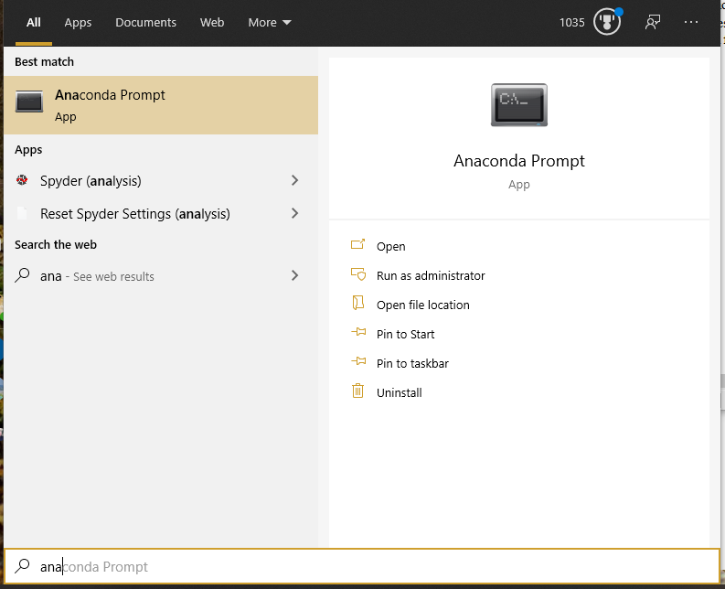
  - I placed the CATScore app in your Documents folder. Once you have Anaconda Prompt open, type: `cd Documents\CATScore` to navigate to the base directory. See screen clip, but note your directory will look like C:\Users\nwilkerson2\
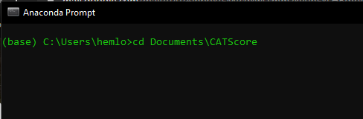
  - You can now run CATScore with the command python catscore.py

