2805ICT Milestone 1
s5169483 Peter Leddiman

1.0 Requirements

1.1 Functional Requirements

Identifier | Priority | Functional Requirement
F-R 1 | 5 | The system should use a graphical user interface (GUI) to allow the user to play the game Pac-Man, controlling a yellow avatar through a grid-like maze while collecting dots and avoiding ghosts.
F-R 2 | 5 | The system should allow the user to select different game layouts, consisting of: rectangular grid, hexagonal grid, and arbitrary graph.
F-R 3 | 5 | The system should have a start button that the player can use to start the game, which also resets the score.
F-R 4 | 5 | Once the game is started the player can control the avatar and the movement of the ghosts begins. Until the player presses the start button no activity occurs in the play area.
F-R 5 | 5 | The system should keep track of the number of ‘lives’ the player has left. When this reaches zero, the game is over.
F-R 6 | 5 | The system should detect when a ghost touches the player’s avatar; when this happens, the ‘life’ counter should decrement by one.
F-R 7 | 5 | When the game is over the system should give the player the option to start a new game.
F-R 8 | 5 | The system should disable the ability of the player to start the game or change layout while the game is in play. They will remain disabled until the game is over.
F-R 9 | 5 | The maze layout should have four ‘power pellets’ at fixed locations. When eaten by the player’s avatar, the avatar should be able to temporarily eat the ghosts instead of losing a life.
F-R 10 | 5 | The system should keep a score of the player’s progress, which is incremented when the avatar collects the dots or eats the ghosts.
F-R 11 | 5 | The system should progress to the next level when all of the dots in the play area are eaten. When this happens, the play area is reset.
F-R 12 | 5 | When a new level is reached, the game should become more difficult by having the ghosts spend more time chasing the avatar and having the duration of the power pellet’s effect reduced.
F-R 13 | 4 | The ghosts in the game should use different algorithms to chase the avatar through the maze. When a power pellet is eaten, the ghosts should instead run away while it is active.
F-R 14 | 4 | The maze should include a centre box where the ghosts start when the game is started or the play area is reset upon reaching a new level.
F-R 15 | 4 | When a ghost is eaten it should be returned to the centre box where it is regenerated.
F-R 16 | 3 | The ghosts should use graph searching algorithms to find different paths to the player’s avatar.
F-R 17 | 1 | The user can change how the layout is generated, from a fixed layout to randomly generated.
F-R 18 | 1 | The user can configure the overall size of the grid layout.
F-R 19 | 1 | The system should record the score of the player when the game is over and store scores of previous play sessions.
F-R 20 | 1 | When the game is over the user is given an option to enter their initials to be recorded alongside their score.
F-R 21 | 1 | While the game is not in play the GUI should allow the user to view previous scores sorted by value.
F-R 22 | 1 | The system should give the user an option to have the power pellets randomly placed in the grid instead of having them at default, fixed locations.
F-R 23 | 5 | At any time, even while the game is in play, the user should be able to exit the game.
F-R 24 | 5 | The system should allow the user to move the avatar through the maze via the arrow keys on the keyboard.
F-R 25 | 5 | The system shall not allow the avatar or the ghosts to pass through the wall of the maze.

1.2 Use Case

Actor: User
Description: The user of the software. The user controls the software with either mouse of keyboard to initially start the game, but thereafter with a keyboard. The user expects the software to run correctly without faults.
Aliases: Player | Inherits:

Use case: Play game in rectangular maze
Requirements satisfied: | Requirement F-R 1
Brief description: | The player uses the software with the keyboard to control an avatar through a grid-like maze, collecting dots and avoiding ghosts which chase the avatar. Having a ghost touch the avatar decrements a life counter which, if it reaches zero, causes the game to finish. Collecting all the dots causes the game to reset the play area and increase the difficulty.
Initiating actor: | User
Priority: | 5
Risk: | This requirement is essential, as everything
Preconditions: | The software was correctly initialised, or the game was reset after a previous play session. The user has already selected the rectangular grid layout, and the maze layout is correctly loaded from a file.
Postconditions: | The game is over when the life counter reaches zero. A score is recorded based on dots and ghosts eaten by the avatar and level reached.
Flow of events: | - The maze is loaded from file and displayed to the user. It contains the location of where the avatar is to spawn as well as the ghosts, and also the locations of ‘dots’ and ‘power pills’. The score is initialised to zero and the number of lives to three.  - The player uses the keyboard to control the direction in which the avatar moves, which cannot pass through walls. If the player does not select a new direction, the avatar will continue to move in the same direction if there is not a wall in the way.  - The player’s avatar makes contact with other sprites in the game.  - The avatar collides with a dot  - If this was not the last dot on the maze, the dot is removed from the maze.  - If it was the last dot, the game is progressed to the next level and the maze is reset, along with the positions of the avatar and ghosts. The system modifies the behaviour of the ghosts to make them more difficult to avoid.  - or, the avatar collides with a ghost  - A power pill is not active at the time of the collision  - If the life counter is not zero, it is decremented by one. The positions of the avatar and ghosts is reset, but the rest of the maze is not.  - If the life counter is zero, the game is over. A score is presented to the player.  - or, a power pill is active at the time of the collision. The ghost makes its way back to its spawn location. Until it reaches its target, it cannot be collided with by the avatar.  - or, the avatar collides with a power pill. The pill is removed from the maze. For some length of time, dictated by the current level, the power pill is active and will change what happens when the avatar collides with a ghost.
Activity diagram: | Refer to Figure 1
Alternative flow: | The user exits the game before it is over.

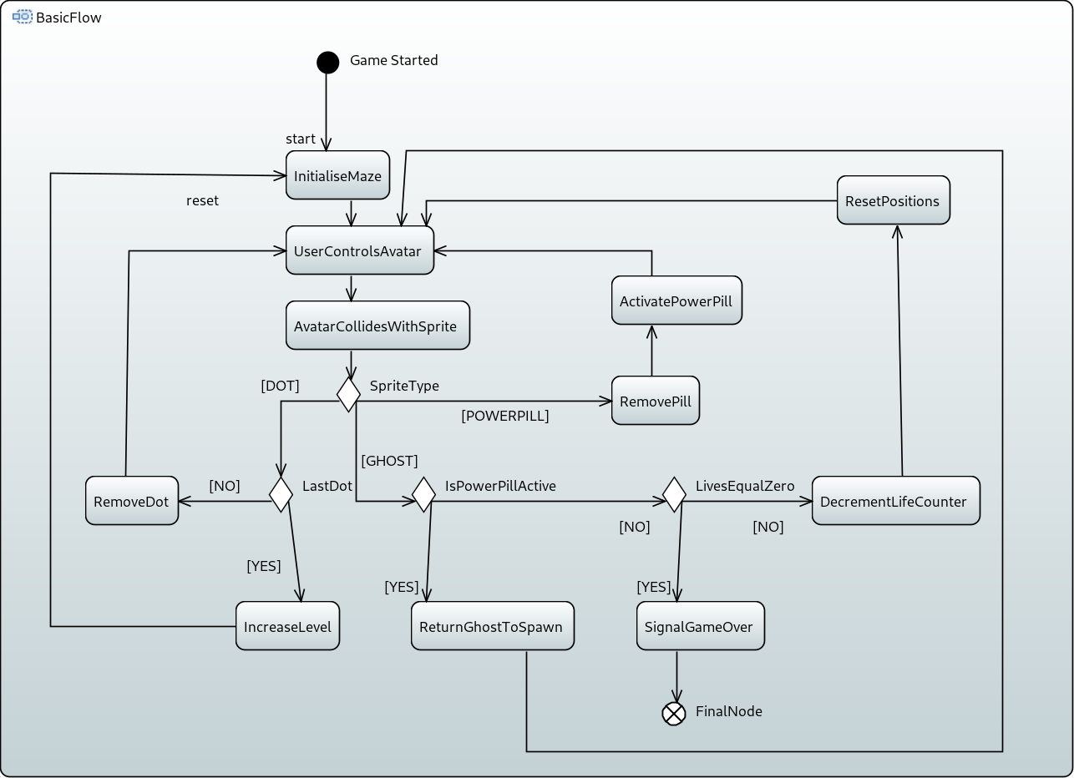Figure 1: Activity Diagram for use case Play in rectangular maze
1.3 Use case diagram

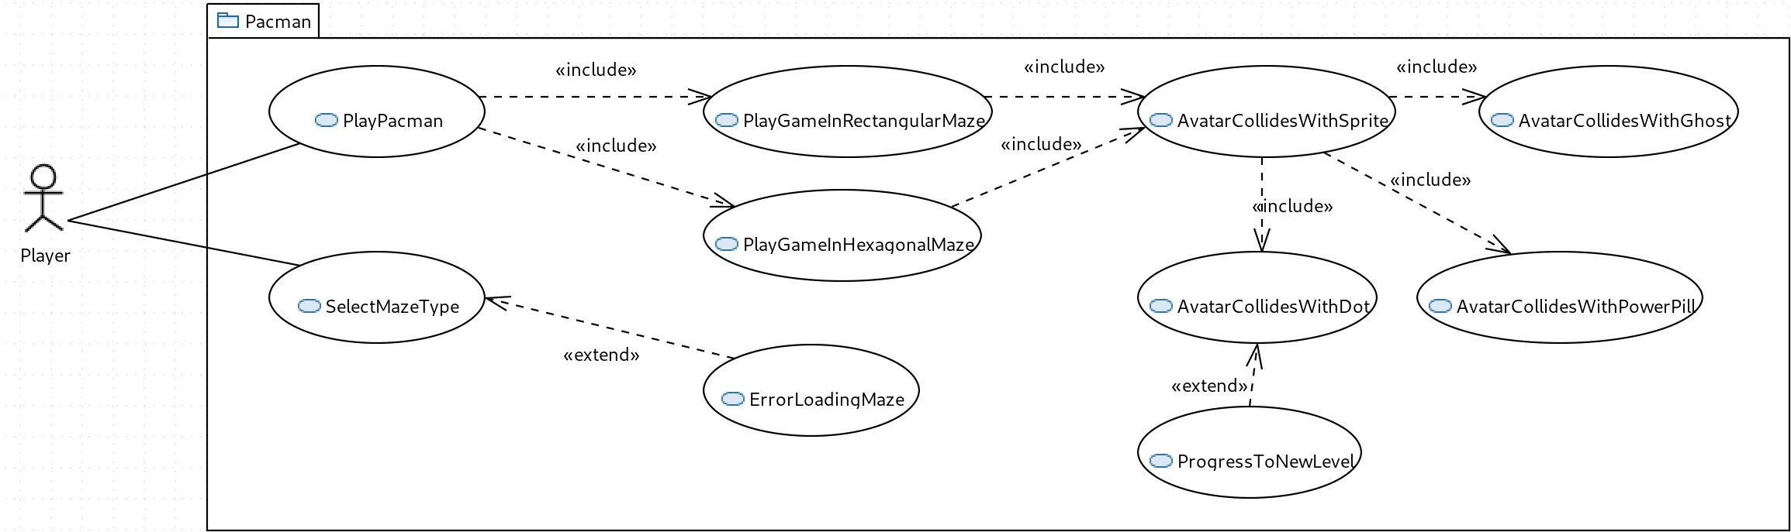Figure 2: Use Case diagram for package Pacman

1.4 Non-functional Requirements

Identifier | Priority | Non-functional Requirement
NF-R 1 | 5 | Performance: Being a relativity simple game it should run correctly on even modest hardware such as a Raspberry Pi while still achieving a minimum of 60 frames per second in order for the animation to appear smooth.
NF-R 2 | 5 | Performance: The player should perceive to have instantaneous control over the avatar. When the player selects a new direction, if that direction is possible, the avatar should change to that direction in less than 100ms.
NF-R 3 | 5 | Security: The game should not access any files other than the game’s own data files.
NF-R 4 | 5 | Reliability: The game should not crash or freeze at any time while the program is running. No combination of user input should cause the game to crash.
NF-R 5 | 5 | Reliability: Even if the program does crash, it will not corrupt any data files as they will be opened read-only.
NF-R 6 | 4 | Extensibility: It should be possible to add new mazes to the game without having to modify existing mazes or make any changes to the source code.
NF-R 7 | 5 | Reusable: The algorithms used to control the movement of the avatar and ghosts should function correctly regardless of maze type or which maze is loaded.
NF-R 8 | 3 | Supportability: The project shall run on as many platforms as possible, but at least Linux, Mac and Windows.
NF-R 9 | 1 | Extensibility: It should be easy to modify ghost behaviour by making changes to only that ghost’s class, or add new types of ghosts.
NF-R 10 | 5 | Extensibility: The system shall offer the user three difficulty levels, but new levels may be added later with minimal changes to the source code.
NF-R 11 | 4 | Maintainability: The project’s source code should be well documented, and use a documentation generator such as Doxygen.
NF-R 12 | 1 | Universality: The game’s text should be minimal and kept separate from the game source code such that adding support for new languages is very simple.

1.5 Constraints

Identifier | Constraint
C | Schedule constraint: The project must be completed according to the milestone schedule. In particular,
C
C
C
C
C
C
C
C

2.0 Project Risks

Risk Identification | Risk Type | Risk Reduction Strategy
Risk 1  Deadlines not met | ALARP | Build a prototype of a simplified version of the game with only the game proper (that is, no menu or high scores) and with only the rectangular grid.
Risk 2  Deadlines not met | ALARP | Incrementally improve the game, adding features that are most critical first. Make a version of the game using only the rectangular grid complete before adding the hexagonal layout.
Risk 3  Game does not run on multiple platforms | ALARP | Build the game using a neutral language and cross platform framework to abstract platform differences.
Risk 4  Cannot load new mazes | ALARP | Separate out maze layout into a file and make movement algorithms independent of overall maze layout.
Risk 5  Cannot load new mazes | ALARP | Use a graph based description of the maze rather than a grid.
Risk 6  Cannot add new ghosts | ALARP | Separate ghosts into their own classes with common functionality in a super class.
Risk 7  Game does not run smoothly | Intolerable | Keep work done on each frame to a minimum. If necessary, do performance analysis and rewrite slow code.
Risk 8  Ghosts do not move appropriately | Intolerable | Describe the layout of the maze using a directed graph. Use standard graph algorithms to control ghost pathing.
Risk 9  Deadlines not met | ALARP | Use a version control system (such as Git) to track development progress and estimate time remaining to implement key features.
Risk 10  Difficulty in extending project | ALARP | Separate key components (such as avatar, ghosts, dots, graph) into their own classes. Classes should be properly organised to minimise code repetition and encourage code reuse.

The language chosen for the project was Python. This was done in order to quickly build a prototype for the game, as there are existing Python libraries for game development, such as PyGame. This also means that the game is automatically playable on any platform that supports both Python and PyGame, such as Linux, Mac and Windows. Although interpreted Python is slower than compiled languages, it was felt that this was unlikely to be an issue for such a simple game.

Building of the prototype is split into phases, in order to test the most the important features first: loading and displaying the maze, displaying and controlling the avatar, displaying the ghosts, ghost movement, avatar/dot and avatar/ghost collisions, and finally win/lose conditions. Git is used to track the development of the prototype. A class hierarchy is used to maximise code reuse. For example, displayable elements (Sprites) all inherit from a Sprite class and all ghosts inherit from a Ghost class. Different elements of the game (avatar, ghosts, etc) are contained in separate classes so that they can be worked on independently and to minimise the risk that a change to one incorrectly affects another.
3.0 Feasibility Report

Pacman is a small, simple game originally intended for arcades in 1980. It takes place on a single, static playfield with few moving objects. The most difficult algorithms that could be involved are the movement of the ghosts, and for them we can use well known graph algorithms for pathing (though the original used even simpler algorithms). The game was once featured as a Google doodle, implemented in JavaScript and running in web browsers, demonstrating that it can be successfully written using interpreted languages without requiring excessive computer resources.

A prototype has been written that consists of the most important aspects, and the game is already mostly complete, at least with respect to the feature set of the original game. The hexagonal and arbitrary graph layouts have not been implemented, but the current prototype already uses a directed graph to describe the rectangular grid maze, so extending it to use non-grid layouts is not expected to be an issue.

File | Significant Lines of Code
arena.py | 59
avatar.py | 39
blinky.py | 7
clyde.py | 14
dot.py | 5
game.py | 23
game_state.py | 104
ghost.py | 72
inky.py | 16
moving_sprite.py | 76
node.py | 45
pacman.py | 4
pinky.py | 13
power.py | 5
sprite.py | 24
TOTAL | 506

As can be seen, although the current prototype already implements the core aspects of the game, it is very short at about 500 lines of code and was constructed in only a few hours. Implementing the remaining features is not expected to be an issue.

An analysis of the functional and non-functional requirements follows.

Identifier | Likelihood to be successfully implemented
Identifier | Score | Reason
F-R 1 | High | An initial prototype has already been constructed which implements the core aspects of the game, such as controlling the avatar through a maze, collecting dots and power pills, and the movement of the ghosts. Avatar/dot and avatar/ghost collision detection is working correctly.
F-R 2 | Moderate | Although the prototype only uses the rectangular grid layout, it uses a directed graph to do so. Hexagonal and arbitrary graph layouts should also be able to use this same directed graph description with very few changes to the source code.
F-R 3 | Moderate | Not implemented in the prototype.
F-R 4 | High | Already implemented in the prototype.
F-R 5 | High | Already implemented in the prototype.
F-R 6 | High | Already implemented in the prototype.
F-R 7 | Moderate | Not implemented in the prototype.
F-R 8 | Moderate | Not implemented in the prototype.
F-R 9 | High | Already implemented in the prototype.
F-R 10 | Moderate | Although the current prototype does not keep track of a score, the project is structured to easily allow this.
F-R 11 | Moderate | Although the current prototype does not advance to the next level, it does already detect when all the dots are eaten and signals this event.
F-R 12 | Moderate | Although the current prototype does not have different levels, the ghosts’ behaviour is already dictated by a few different variables and can be manipulated to increase difficulty.
F-R 13 | High | Already implemented in the prototype. The ghosts have their own ‘personalities’ as in the original game and they change behaviour when a power pill is consumed.
F-R 14 | Moderate | The ghosts already start in the centre box and return there in the prototype, but advancing to the next level is not yet implemented.
F-R 15 | High | Already implemented in the prototype.
F-R 16 | Moderate | In the current prototype, the ghosts’ movement is the same as in the original game and use only knowledge about neighbouring tiles. However, the layout of the maze is described using a directed graph, and using this information to control ghost pathing is not expected to be difficult.
F-R 17 | Low | Not implemented in the prototype. Nothing has been tested with regards to randomly generated layouts.
F-R 18 | Low | Not implemented in the prototype, which currently uses a single fixed size layout.
F-R 19 | Low | The current prototype does not keep track of a score, nor records them.
F-R 20 | Low | The current prototype does not implement the user entering their initials.
F-R 21 | Low | Nothing implemented in the current prototype.
F-R 22 | Moderate | Although not implemented in the prototype, because of the way mazes are described using a graph, this is not expected to be difficult.
F-R 23 | High | Already implemented in the prototype.
F-R 24 | High | Already implemented in the prototype.
F-R 25 | High | Already implemented in the prototype.

Identifier | Likelihood to be successfully implemented
Identifier | Score | Reason
NF-R 1 | High | The current prototype implements the core aspects of the game and uses less than 1% of a single CPU on the test machine and runs at 60 frames per second.
NF-R 2 | High | The current prototype already runs at a perfect 60 frames per second, meaning the lag time is 17ms.
NF-R 3 | High | Already implemented in the prototype.
NF-R 4 | Moderate | The current prototype does not crash at any time during testing.
NF-R 5 | High | Already implemented in the prototype.
NF-R 6 | Moderate | The current prototype keeps the layout in a separate file and describes the layout using a directed graph. All code that controls the avatar and ghosts uses only the information from the directed graph.
NF-R 7 | Moderate | The current prototype describes the layout using a directed graph. All code that controls the avatar and ghosts uses only the information from the directed graph.
NF-R 8 | Moderate | Although the prototype has only been tested on Linux, it is written in Python and uses the cross platform PyGame library.
NF-R 9 | High | Already implemented in the prototype.
NF-R 10 | Moderate | Although not implemented in the prototype, key variables affecting difficulty (namely movement and behaviour of ghosts) is already described.
NF-R 11 | Moderate | Already implemented in the prototype.
NF-R 12 | Low | Not implemented in the prototype, which is only in English.

