## 题目分析

题目逻辑很清楚，我们用爆破法很容易解出flag。

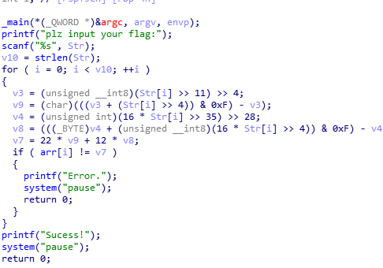

## 脚本

arr = [0xA0, 0xE6, 0x7A, 0x11E, 0xE6, 0x90, 0x122, 0xD0, 0xF0, 0x90, 0x12C, 0xD8, 0x122, 0xF4, 0xF0, 0x64, 0x100, 0x136]  
flag = ""  
for i in range(18):  
 for j in range(33,126):  
 a = (j >> 11) >> 4  
 b = (a + (j >> 4) & 0xF) -a  
 c = (16 * j >> 35) >> 28  
 d = (c + (16 * j >> 4) & 0xF) -c  
 e = 22 * b + 12 * d  
 if(e == arr[i]):  
 flag += chr(j)  
print flag

## FZQ{Za_Jiang_MiAN}