# 题目分析

使用反编译工具uncompyle将pyc文件进行反编译，可以得到反编译的代码

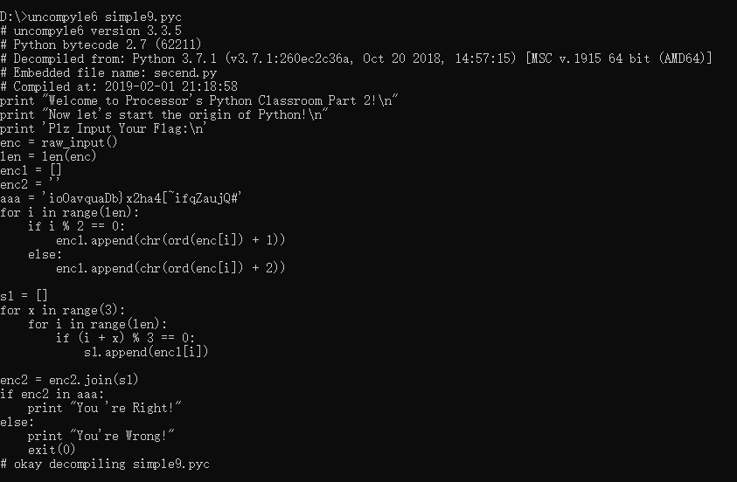

print "Welcome to Processor's Python Classroom Part 2!\n"  
print "Now let's start the origin of Python!\n"  
print 'Plz Input Your Flag:\n'  
enc = raw_input()  
len = len(enc)  
enc1 = []  
enc2 = ''  
aaa = 'ioOavquaDb}x2ha4[~ifqZaujQ#'  
for i in range(len):  
 if i % 2 == 0:  
 enc1.append(chr(ord(enc[i]) + 1))  
 continue  
 enc1.append(chr(ord(enc[i]) + 2))  
  
s1 = []  
for x in range(3):  
 for i in range(len):  
 if (i + x) % 3 == 0:  
 s1.append(enc1[i])  
 continue  
  
enc2 = enc2.join(s1)  
if enc2 in aaa:  
 print "You 're Right!"  
else:  
 print "You're Wrong!"  
 exit(0)

需要理解就是第二个for循环，我们写脚本直接打印出来i看看。

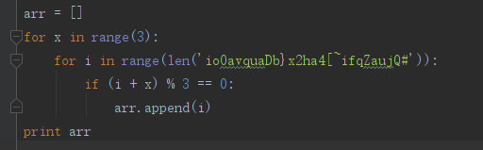



这样就很容易理解，就是隔3位进行字符置放。

## 脚本

str = "ioOavquaDb}x2ha4[~ifqZaujQ#"  
str1 = [0 for x in range(len(str))]  
flag = ""  
count = 0  
for x in range(3):  
 for i in range(len(str)):  
 if (i + x) % 3 == 0:  
 str1[i] = str[count]  
 count = count + 1  
  
for i in range(len(str)):  
 if i%2==0:  
 flag += chr(ord(str1[i]) - 1)  
 else:  
 flag += chr(ord(str1[i]) - 2)  
print flag

## flag： hgame{Now_Y0u_got_th3_PYC!}