# 题目分析

首先使用uncompyle6对pyc文件进行反编译

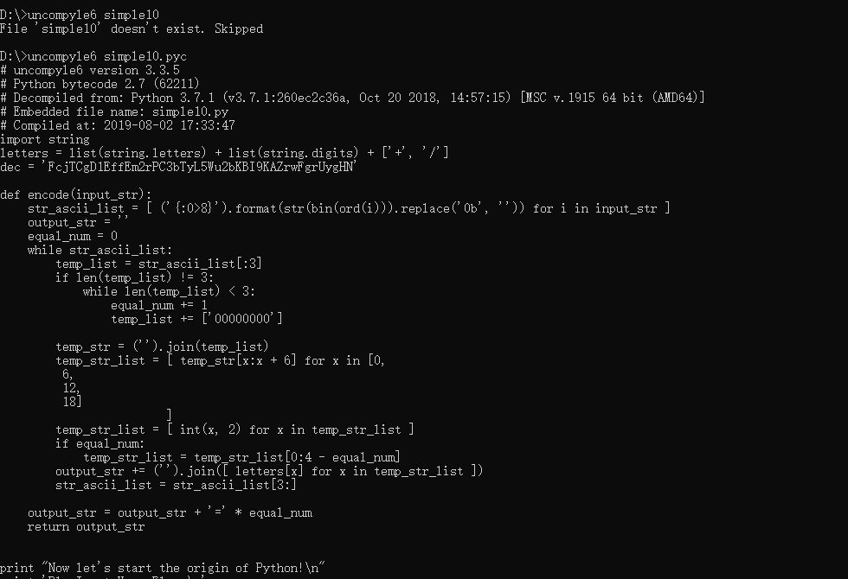

可以得到

import string  
letters = list(string.letters) + list(string.digits) + ['+', '/']  
dec = 'FcjTCgD1EffEm2rPC3bTyL5Wu2bKBI9KAZrwFgrUygHN'  
  
def encode(input\_str):  
 str\_ascii\_list = [ '{:0>8}'.format(str(bin(ord(i))).replace('0b', '')) for i in input\_str ]  
 output\_str = ''  
 equal\_num = 0  
 while str\_ascii\_list:  
 temp\_list = str\_ascii\_list[:3]  
 if len(temp\_list) != 3:  
 while len(temp\_list) < 3:  
 equal\_num += 1  
 temp\_list += ['00000000']  
  
 temp\_str = ''.join(temp\_list)  
 temp\_str\_list = [ temp\_str[x:x + 6] for x in [0,  
 6,  
 12,  
 18] ]  
 temp\_str\_list = [ int(x, 2) for x in temp\_str\_list ]  
 if equal\_num:  
 temp\_str\_list = temp\_str\_list[0:4 - equal\_num]  
 output\_str += ''.join([ letters[x] for x in temp\_str\_list ])  
 str\_ascii\_list = str\_ascii\_list[3:]  
  
 output\_str = output\_str + '=' \* equal\_num  
 return output\_str  
  
print "Now let's start the origin of Python!\n"  
print 'Plz Input Your Flag:\n'  
enc = raw\_input()  
lst = list(enc)  
lst.reverse()  
llen = len(lst)  
for i in range(llen):  
 if i % 2 == 0:  
 lst[i] = chr(ord(lst[i]) - 2)  
 lst[i] = chr(ord(lst[i]) + 1)  
  
enc2 = ''  
enc2 = enc2.join(lst)  
enc3 = encode(enc2)  
if enc3 == dec:  
 print "You're right! "  
else:  
 print "You're Wrong! "

我们可以发现这其实对输入进行了翻转，然后再奇偶位运算，最后再是base64加密。

但是直接对“FcjTCgD1EffEm2rPC3bTyL5Wu2bKBI9KAZrwFgrUygHN”进行base64加密得不到正确的flag，这是因为base64加密的编码表变化了的。

我们首先得到找到正确的编码表。

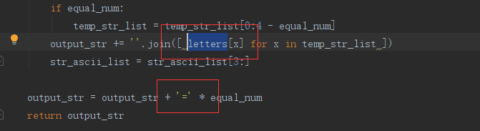

C:\Users\asus\Documents\Tencent Files\2929812422\Image\C2C\Image1\}X}MFX_E]_99}89[_]_ASZQ.png

我们写脚本来打印一下编码表。

import string  
letters = list(string.letters) + list(string.digits) + ['+', '/']  
print "".join(letters)

C:\Users\asus\Documents\Tencent Files\2929812422\Image\C2C\Image1\4%HX8{Q5N{DNAB3VEXUM196.png

可以得到正确的编码表为

“abcdefghijklmnopqrstuvwxyzABCDEFGHIJKLMNOPQRSTUVWXYZ0123456789+/”。

然后写脚本解出flag。

# 脚本

base = "ABCDEFGHIJKLMNOPQRSTUVWXYZabcdefghijklmnopqrstuvwxyz0123456789+/"  
diy\_base = "abcdefghijklmnopqrstuvwxyzABCDEFGHIJKLMNOPQRSTUVWXYZ0123456789+/"  
cipher = "FcjTCgD1EffEm2rPC3bTyL5Wu2bKBI9KAZrwFgrUygHN"  
new\_cipher = ""  
str = ""  
flag = ""  
  
for i in range(len(cipher)):  
 new\_cipher += base[diy\_base.find(cipher[i])]  
str = new\_cipher.decode("base64")  
  
for i in range(len(str)):  
 if i % 2 == 0:  
 flag += chr(ord(str[i]) + 2 - 1)  
 else:  
 flag += chr(ord(str[i]) - 1)  
print flag[::-1]

## flag：hgame{W3lc0me\_To\_anothe2\_Python!}