# 题目分析

使用uncompyle6进行反编译pyc文件。

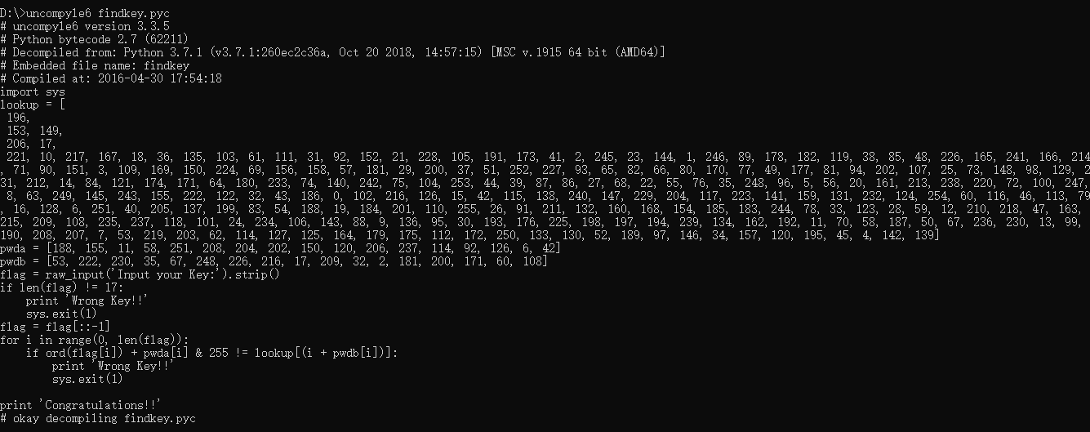

import sys  
lookup = [196,153, 149,206, 17,221, 10, 217, 167, 18, 36, 135, 103, 61, 111, 31, 92, 152, 21, 228, 105, 191, 173, 41, 2, 245, 23, 144, 1, 246, 89, 178, 182, 119, 38, 85, 48, 226, 165, 241, 166, 214, 71, 90, 151, 3, 109, 169, 150, 224, 69, 156, 158, 57, 181, 29, 200, 37, 51, 252, 227, 93, 65, 82, 66, 80, 170, 77, 49, 177, 81, 94, 202, 107, 25, 73, 148, 98, 129, 231, 212, 14, 84, 121, 174, 171, 64, 180, 233, 74, 140, 242, 75, 104, 253, 44, 39, 87, 86, 27, 68, 22, 55, 76, 35, 248, 96, 5, 56, 20, 161, 213, 238, 220, 72, 100, 247, 8, 63, 249, 145, 243, 155, 222, 122, 32, 43, 186, 0, 102, 216, 126, 15, 42, 115, 138, 240, 147, 229, 204, 117, 223, 141, 159, 131, 232, 124, 254, 60, 116, 46, 113, 79, 16, 128, 6, 251, 40, 205, 137, 199, 83, 54, 188, 19, 184, 201, 110, 255, 26, 91, 211, 132, 160, 168, 154, 185, 183, 244, 78, 33, 123, 28, 59, 12, 210, 218, 47, 163, 215, 209, 108, 235, 237, 118, 101, 24, 234, 106, 143, 88, 9, 136, 95, 30, 193, 176, 225, 198, 197, 194, 239, 134, 162, 192, 11, 70, 58, 187, 50, 67, 236, 230, 13, 99, 190, 208, 207, 7, 53, 219, 203, 62, 114, 127, 125, 164, 179, 175, 112, 172, 250, 133, 130, 52, 189, 97, 146, 34, 157, 120, 195, 45, 4, 142, 139]  
pwda = [188, 155, 11, 58, 251, 208, 204, 202, 150, 120, 206, 237, 114, 92, 126, 6, 42]  
pwdb = [53, 222, 230, 35, 67, 248, 226, 216, 17, 209, 32, 2, 181, 200, 171, 60, 108]  
flag = raw_input('Input your Key:').strip()  
if len(flag) != 17:  
 print 'Wrong Key!!'  
 sys.exit(1)  
flag = flag[::-1]  
for i in range(0, len(flag)):  
 if ord(flag[i]) + pwda[i] & 255 != lookup[(i + pwdb[i])]:  
 print 'Wrong Key!!'  
 sys.exit(1)  
  
print 'Congratulations!!'

程序的逻辑很清晰，我们采用爆破的方法来求解flag。

lookup = [196,153, 149,206, 17,221, 10, 217, 167, 18, 36, 135, 103, 61, 111, 31, 92, 152, 21, 228, 105, 191, 173, 41, 2, 245, 23, 144, 1, 246, 89, 178, 182, 119, 38, 85, 48, 226, 165, 241, 166, 214, 71, 90, 151, 3, 109, 169, 150, 224, 69, 156, 158, 57, 181, 29, 200, 37, 51, 252, 227, 93, 65, 82, 66, 80, 170, 77, 49, 177, 81, 94, 202, 107, 25, 73, 148, 98, 129, 231, 212, 14, 84, 121, 174, 171, 64, 180, 233, 74, 140, 242, 75, 104, 253, 44, 39, 87, 86, 27, 68, 22, 55, 76, 35, 248, 96, 5, 56, 20, 161, 213, 238, 220, 72, 100, 247, 8, 63, 249, 145, 243, 155, 222, 122, 32, 43, 186, 0, 102, 216, 126, 15, 42, 115, 138, 240, 147, 229, 204, 117, 223, 141, 159, 131, 232, 124, 254, 60, 116, 46, 113, 79, 16, 128, 6, 251, 40, 205, 137, 199, 83, 54, 188, 19, 184, 201, 110, 255, 26, 91, 211, 132, 160, 168, 154, 185, 183, 244, 78, 33, 123, 28, 59, 12, 210, 218, 47, 163, 215, 209, 108, 235, 237, 118, 101, 24, 234, 106, 143, 88, 9, 136, 95, 30, 193, 176, 225, 198, 197, 194, 239, 134, 162, 192, 11, 70, 58, 187, 50, 67, 236, 230, 13, 99, 190, 208, 207, 7, 53, 219, 203, 62, 114, 127, 125, 164, 179, 175, 112, 172, 250, 133, 130, 52, 189, 97, 146, 34, 157, 120, 195, 45, 4, 142, 139]  
pwda = [188, 155, 11, 58, 251, 208, 204, 202, 150, 120, 206, 237, 114, 92, 126, 6, 42]  
pwdb = [53, 222, 230, 35, 67, 248, 226, 216, 17, 209, 32, 2, 181, 200, 171, 60, 108]  
flag = ""  
for i in range(len(pwdb)):  
 for j in range(33,127):  
 if j + pwda[i] & 255 == lookup[(i + pwdb[i])]:  
 flag += chr(j)  
print flag[::-1]

# flag：PCTF{PyC_Cr4ck3r}