## 题目分析

程序逻辑很清晰，使用爆破法会十分方便。

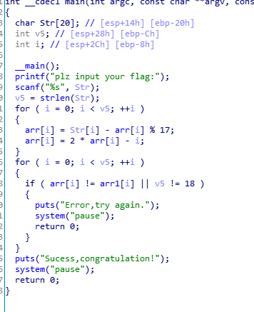

## 脚本

arr = [0x17, 0x16, 0x1A, 0x1A, 0x19, 0x19, 0x19, 0x1A, 0x1B, 0x1C, 0x1E, 0x1E, 0x1D, 0x1E, 0x20, 0x20, 0x21, 0x20]  
arr1 = [0x80, 0xA9, 0x8E, 0xE1, 0x88, 0xBD, 0xD4, 0xA5, 0x88, 0xBF,0xC6, 0x99, 0x76, 0xAB, 0x96, 0xAF, 0x12, 0xCB]  
arr2 = [0 for i in range(18)]  
flag = ""  
for i in range(18):  
 for j in range(255):  
 arr2[i] = j - arr[i] % 17  
 arr2[i] = 2 * arr2[i] - i  
 if(arr2[i] == arr1[i]):  
 flag += chr(j)  
print flag

## FZQ{Niu_Rou_Mian!}