改为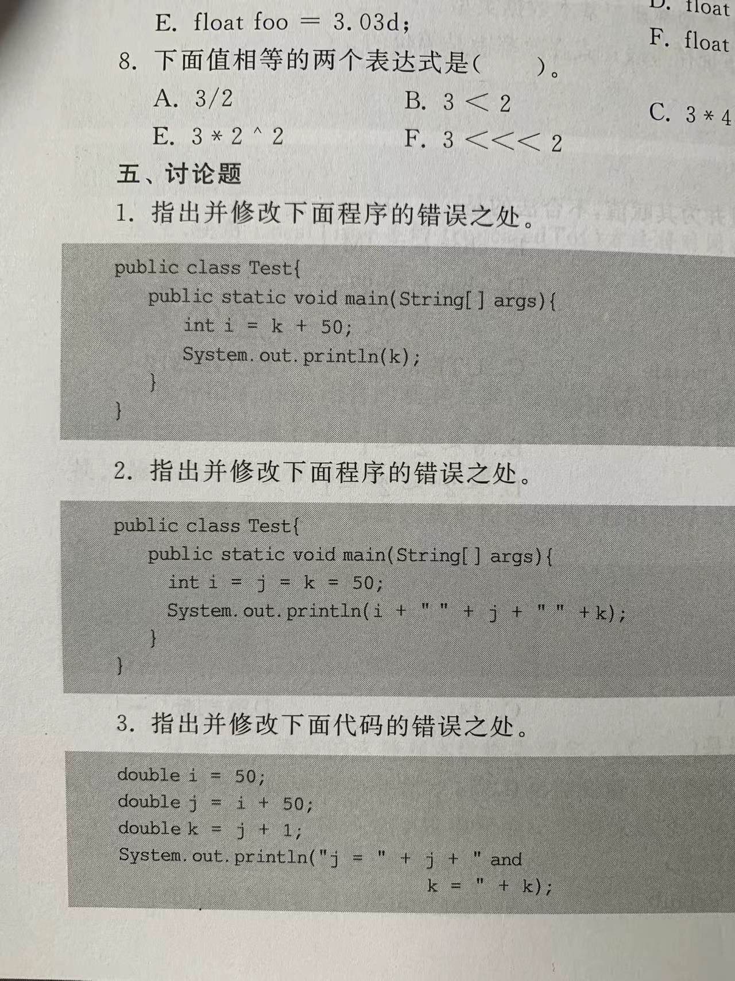int i,k;

i = k + 50;

改为 int i,j,k;

 i = j = k = 50;

应有 public class Test{

Public static void main(String[]args){

int…..

Sys….

}

}