**Git**

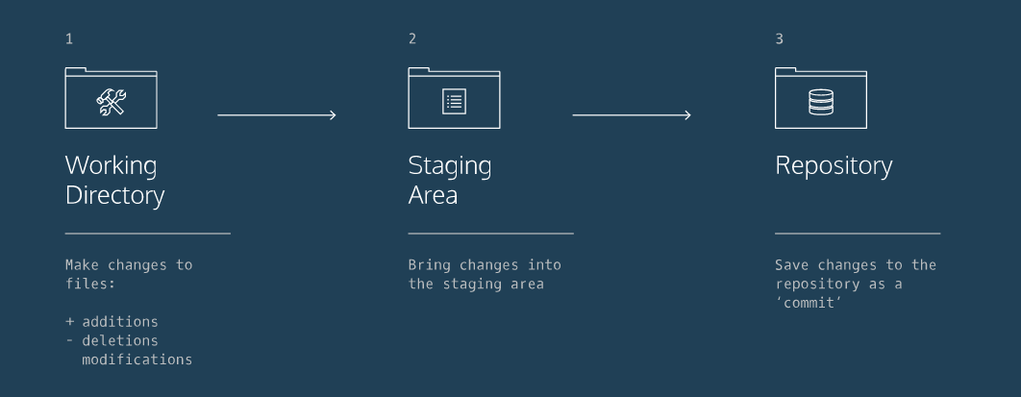

1**.  *Working Directory***: where you'll be doing all the work: creating, editing, deleting and organizing files

2.  ***Staging Area***: where you'll list changes that you make to the working directory

3.  ***Repository***: where Git permanently stores those changes as different *versions* of the project

git init creates a new Git repository.

git status inspects the contents of the working directory and staging area.

git add filename adds files from the working directory to the staging area.

git diff shows the difference between the working directory and the staging area.

git commit permanently stores file changes from the staging area in the repository.

git log shows a list (SHA etc.) of all previous commits.

The most recently made commit is the HEAD commit.

git show HEAD this command will display everything the [git log command](https://www.codecademy.com/en/courses/learn-git/lessons/git-workflow/exercises/git-log" \t "_blank) displays for the HEAD commit, plus all the file changes that were committed.

git checkout HEAD filename restore the file in your working directory to look same as the last commit.

git reset HEAD filename: remove file from the staging area.

git reset SHA: reset the commit to a previous commit with that SHA.

working in a single Git branch called master

git branch: Lists all a Git project's branches.

git branch branch\_name: Creates a new branch.

git checkout branch\_name: Used to switch from one branch to another.

git merge branch\_name: join file changes from one branch to current branch.

git branch -d branch\_name: Deletes the branch specified.

git clone remote\_location clone\_name: Creates a local copy of a remote.

remote\_location could be a web address, or a file path, it’s called origin

clone\_name is the local directory in which Git will clone the repository.

git remote -v: Lists a Git project's remotes of local.

git fetch: Fetches work from the remote into the local copy. (to update)

git merge origin/master: Merges origin/master into your local branch.

git push origin <branch\_name>: Pushes a local branch to the origin remote.