University of Waterloo

CFM 301

Data Assignment 1

Jeongseop Yi (j22yi)

**Q1)**

The mean of return and standard deviation of Amazon stock is as follows:

Mean of return: 0.02286

Standard deviation: 0.13121

The annualized return and volatility (derived from standard deviation) is as follows:

Annualized return: mean * 12 = 0.02286 * 12 = 0.27438

Volatility: 0.45453 (SD * sqrt(12))

**Q2a)**

The values of alpha, and beta are:

Alpha: 0.01317

Beta: 1.4785

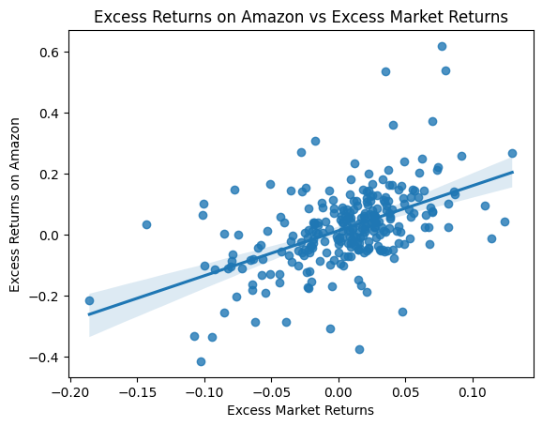

**Interpretation**:

Since the beta is greater than 0, the return on Amazon stock moves at the same parity as the return of the excess market returns. As the beta is greater than 1, Amazon stock is more responsive in terms of return compared to the excess market returns by the beta amount, 1.4785.

The alpha is close to 0, which is 0.01254, and it means that Amazon stock does not have a significant “free return” which exceeds the return of the model benchmark (xvwretd).

**Q2b)**

A sneak peek of the beta and alpha values for the rolling period with t-statistics is as follows:

Please find the data of the beta and alpha values for the rolling period with t-statistics in sheet 2b of the 2b3b.xlsx file in the assignment package.

Time series for the alpha and beta:

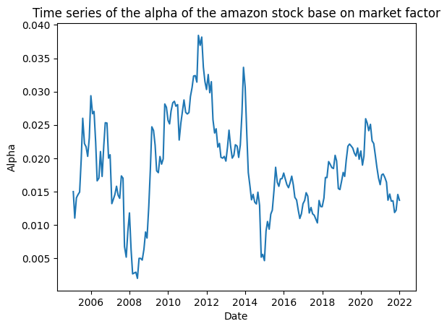

**Interpretation**:

The alpha for the rolling period is small (< 0.04) and stable (between 0 and 0.04). The alpha being close to 0 indicates that there was not that much excess return outside of the model compared to the excess market returns for the rolling period. This indicates that Amazon stock follows the CAPM model well without any extra returns on the excess market returns.

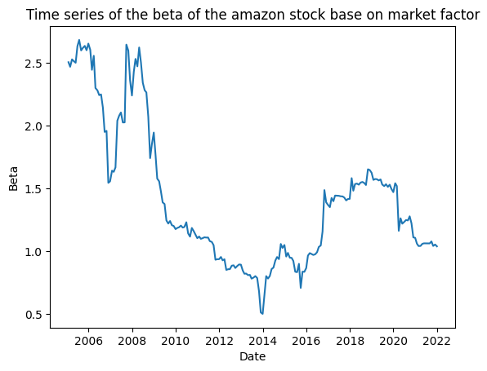

**Interpretation**:

The beta of Amazon stock was high (> 1.5) for the periods between 2005 to 2009. This means that the stock was highly responsive to the excess market returns during the period. The beta may be high due to the size of Amazon being small during the period.

A big dip exists around 2007-2008. The dip may be created by the bubble before the 2008 financial crisis. Between 2010 to around 2017, the beta decreased under 1, which means that the stock became less responsive to the excess market returns. This drop in the beta may be due to the decrease in the growth of the stock. After 2016, the beta grows again to 1.5 and stayed there around 2020, and currently have a beta around 1.1 since 2021. The increase in the stock may be due to the introduction of the new product, AWS, which changed the company structure to a technology company and to a growth company.

**Q3a)**

The alpha and beta values are:

Alpha: 0.015333

Beta-XVWRETD: 1.5323 (excess return of WRDS value-weighted returns)

Beta-SMB: -0.23859

Beta-HML: -1.26018

**Interpretation**:

The alpha is small, less than 0.02. Therefore, Amazon stock does not beat the Fama-French three-factor model. No significant “free return” exists compared to the benchmark (xvwretd) based on the alpha value from the model.

Amazon stock returns move in the same parity of the excess market returns since the beta-XVWRETD is greater than 0. Amazon stock is more responsive to the excess market returns as the beta-XVWERTD is greater than 1 by the amount of the beta value, 1.5323.

Amazon stock returns move in the different parity of the SMB as the beta-SMB is less than 0. Amazon stock is not responsive to the SMB factor as much as the SMB factor itself as the absolute value of the beta-SMB is less than 1. Negative beta value may drive from Amazon being one of the biggest companies in the stock market and the SMB factor being positive when small-value companies earn more return than big-value companies.

The returns of Amazon stock move in the different parity of the HML as the beta-HML is less than 0. Amazon stock is more responsive to the HML factor than the HML factor itself as the absolute value of the beta-HML is greater than 1. This beta may be negative as Amazon is a technology-based company, being one of the growth stocks or one of the low book-to-market ratio stocks.

**Q3b)**

A sneak peek of the beta and alpha values for the rolling period with t-statistics is as follows:

Please find the alpha and beta of Fama-French three factors for the rolling period with t-statistics in sheet 3b of the 2b3b.xlsx file in the assignment package.

The time series of the alpha and the three Fama-French factors are as follows.

**Interpretation**:

In all of the periods, the alpha value is small (< 0.05), and it means that the model is relatively correct as there is no significant “free return” of the stock based on the model. The graph shows that the alpha decreases over time. This means that the error on the model is decreasing over time as there should not be a “free return” based on the Fama-French three-factor or CAPM model.

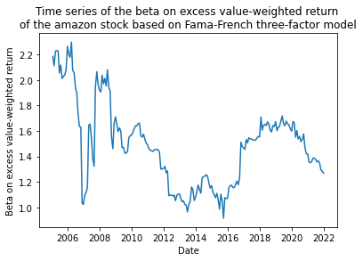

**Interpretation**:

The beta fluctuates similarly as in 2b), however, the magnitude of the fluctuations over the period has decreased as there are other factors introduced to the model which explain the movement of the return of the stock.

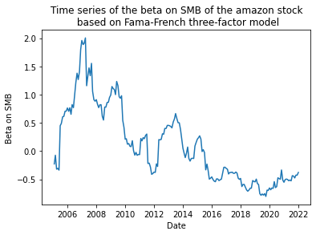

**Interpretation**:

The beta on SMB is decreasing over the rolling period. The value is kept between 0 to 2 between 2006 and 2010. The positive value of the beta over the period indicates that the return of the stock was influenced by the return of small companies, which infers that Amazon may have been small around the period between 2006 and 2010. As the company grew bigger starting in 2012, the beta keeps decreasing. Between 2016 and 2022, the beta values are negative, indicating that the return of Amazon stock does not follow the return from the small companies, which may infer that Amazon is no longer a small company to be positively correlated with the returns of small companies.

**Interpretation**:

The beta on HML is relatively constant around -1.0 throughout the holding period, except for the period around 2008, when the 2008 financial crisis happened. The negative value of the beta infers that the return of Amazon stock is negatively correlated to HML. This negativity implies that the return of Amazon stock follows the return of low book-to-market stocks, which also implies that Amazon may be one of the low book-to-market stocks for the period and one of the growth stocks for the period.

**Q4a)**

A sneak peek of the data is as follows:

Please find the data from sheet 4a in the DA1_data.xlsx in the assignment package for the downloaded data from WRDS.

**Q4b)**

A sneak peek of the data is as follows:

Please find the data from column ret in sheet q4b of the DA1_data.xlsx in the assignment package for the monthly returns of the BH portfolio.

The standard deviation for the period is 0.061.

**Q4c)**

Used CAPM and Fama-French three-factor model to calculate the alpha of the BH portfolio with excess market return (mktrf).

Coefficients with CAPM were:

Alpha: 0.007068

Beta: 1.187101

Coefficients with the Fama-French three-factor model were:

Alpha: 0.00690

Beta-MKTRF: 1.22739

Beta-SMB: -0.22486

Beta-HML: 0.02326

In both models, the alpha of the model is close to 0, being less than 0.01. This indicates that our BH portfolio does not have “free return” based on the both CAPM and Fama-French three-factor model, which indicates that our portfolio follows the model well.

However, this also indicates that the portfolio did not beat the market. If it beat the market, then the alpha should be significantly bigger than 0, which means that there is a “free return” holding the BH portfolio other than the benchmark. But as the alpha is not significantly bigger than 0, thus there is no “free return”, not beating the benchmark in the model.