University of Waterloo

CFM 301

Data Assignment 4

Jeongseop Yi (j22yi)

Q1.

1. The factors that are used, lnSize, bk2mkt, eP, beta, ivol and mom, in q1 is calculated using the data in some month t or some rolling time window where the last month of the window is month t. The dependent variable that we use in this question is in month t+1. As there is no overlap in the time window used to calculate the factors and time frame for one month ahead returns, or ret_t1, there is no look-ahead bias for return prediction in this step.

Please find each equal-weighted quintile in ‘DA1_data.xlsx` with prefix of “q1_” followed by factor names.

1. The portfolio for lnSize takes q1 – q5 portfolio to take advantage of size premium (small minus large). The portfolio for bk2mkt takes q5 – q1 portfolio to take advantage of value-growth premium (value - growth). The portfolio for eP takes q1 – q5 to take advantage of earnings-to-price premiums (low earnings ratio – high earnings ratio). The portfolio for beta takes q1 – q5 portfolio to take advantage of beta premium (low beta – high beta). The portfolio for ivol takes q1 – q5 portfolio to take advantage of low volatility risk premium (low ivol – high ivol). The portfolio for mom takes q5 – q1 to take advantage of momentum premiums, winning stocks minus losing stocks.

The CAPM alphas for lnSize and ivol are significant as the absolute value of t-stat value for the alphas are greater than 1.96. The FF4 alphas for lnSize and ivol are significant as well as the absolute value of t-stat value for the alphas are greater than 1.96. All portfolios fail to create significant excess return or positive alpha except for the lnSize factor portfolio.

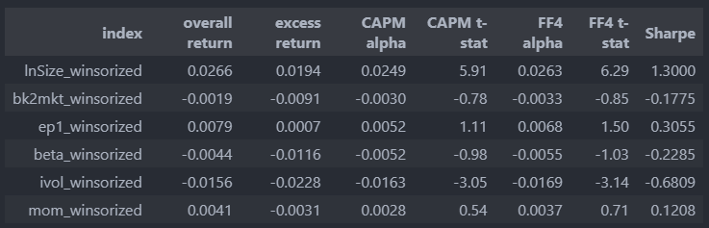

Q2.

The betting against beta (BAB) strategy normalizes the beta of the q1 (low) and q5 (high) portfolio to 1, meanwhile the simple beta portfolio does not normalize its betas of the low and high portfolio. This is why there exist a discrepancy between the BAB strategy and simple beta strategy. The quintile portfolio data is stored in q2_beta_winsorized_ret sheet of DA4_data.xlsx.



Q3.

1. As we take q1 – q5 on the idiosyncratic factor as explained in q1, the long leg portion of the portfolio is the first quintile of the equal-weighted quintile portfolios. The excess return is 0.006776 as in the table below. The t-values for the CAPM alpha and FF4 alpha is greater than 1.96, which are 4.55 and 4.62, respectively, therefore the alpha of the portfolio is significant, and the portfolio delivered value for my investors.



1. The annual turnover of the idiosyncratic factor is as follows. The initial turnover ratio at the fund creation is dropped.

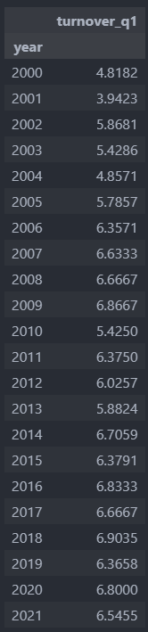

Q4. The data is stored in q4 sheet of the ‘DA4_data.xlsx’ file.

1. The return statistic table for the equal-weight portfolio of the betting-against-beta factor and the idiosyncratic volatility factor is as follows. The FF4 alpha for the portfolio is 1.01.

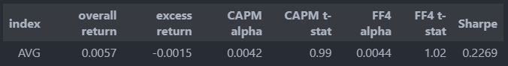

1. I used 5bp per month to replicate the management fee, which is 60bp per annum. The actual value of the monthly management fee is 4.97 and for the ease of calculation, I rounded the value to 5bp per month. The return statistic table of the multi-factor ETF is as follows.

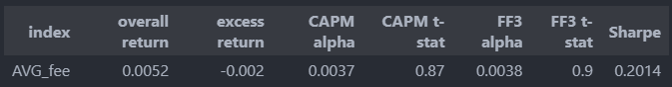

Q5. The data is stored in q5 sheet of the ‘DA4_data.xlsx’ file.

Winsorized variables are used for both dependent and independent variables. A Fama-MacBeth monthly cross-sectional test was conducted for the idiosyncratic volatility factor with CAPM beta, log size and book-to-market ratio as control variables for the dependent variable. The following table describes the summary statistics of the beta of the idiosyncratic volatility factor (ivol) from the regression with t-statistics. The t-statistic value is greater than 1.96, therefore the beta from ivol factor is significant, and it also shows that there exists risk premium associated with the ivol factor outside of control variables.



Q6. The summary statistics for the q6 data is store in the q6 sheet of the ‘DA4_data.xlsx’ file.

The size factor used in q1 was lnSize, so lnSize was used to calculate the same summary statistics as in q1 for all firms in NYSE/Nasdaq pruned with beginning-of-the-month stock price and beginning-of-the-month market capitalization. The summary statistics of the quintile portfolio is stored in q6 sheet in DA4_data.xlsx file. The return statistics of monthly returns for the size factor for NYSE/Nasdaq stocks is as follows.

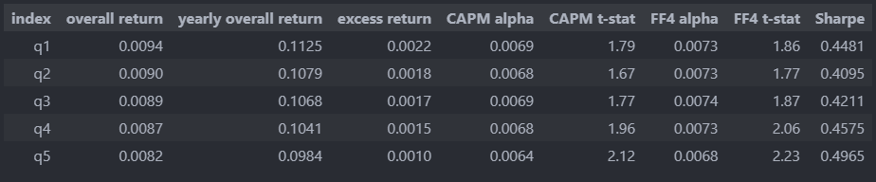

The monthly average return for q1 – q5 portfolio lnSize factor of NYSE/Nasdaq stocks, which is around 0.0012, are lower than the monthly average return for lnSize factor of Q1 stocks, which is 0.00266.

The yearly average return for lnSize factor of NYSE/Nasdaq stocks are greater for all quintile portfolios than the average return of The MSCI ACWI Minimum Volatility Index.

