SonarQube

Introduction
SonarQube is a popular tool for continuously inspecting the code quality and security of codebases, providing guidance to development teams during code reviews. It helps teams write cleaner and safer code and provides continuous code inspection through automated static code analysis rules. SonarQube's main components include code reliability, application security, and technical debt management. It supports over 27 programming languages, including Java, C#, C, C++, JavaScript, TypeScript, Python, and Go, among others.
Prerequisites

1.An EC2 instance with a minimum of 2 GB RAM (t2.small)
2.Java 11 installation
amazon-linux-extras list
amazon-linux-extras install java-openjdk11
3.SonarQube cannot be run as root on Unix-based systems, so create a dedicated user account for SonarQube if necessary.

Create the EC2 Instance
Before going further, I suggest you create an IAM Admin user in your AWS account which will have the Administrator Access IAM Policy. I will use the AWS Region: London (eu-west-2).
Let’s connect through the AWS Console and navigate to the EC2 Service (under the Compute layer).
Launch a new instance and select the first AMI Amazon Linux 2 AMI (HVM), SSD Volume Type.
SonarQube required at least 2GB RAM, so I recommend using a t2.small or higher as Instance Type. Be careful, this kind of instance type are not free tier eligible, and you will be charged for this utilization (depend on your usage).
Leave the default configuration as is and click on Review and Launch.
Before launching the EC2 Instance, if you already have a key pair, select it. If not, create a new one. This key pair will be used to connect to your EC2 Instance through ssh.
Installation steps
1.Download SonarQube latest version on to EC2 instance
cd /opt
wget https://binaries.sonarsource.com/CommercialDistribution/sonarqube-developer/sonarqube-developer-8.9.10.61524.zip
2.extract packages
unzip /opt/sonarqube-x.x.zip
3.Change ownership to the user and Switch to Linux binaries directory to start service
Add Sonar User and Privileges
Create a user named sonar and make it the owner of the /opt/sonarqube directory.
1.sudo useradd sonar
2.sudo chown -R sonar:sonar /opt/sonarqube
Start Sonarqube Service
Step 1: Login as sonar user
sudo su - sonar
Step 2: Navigate to the start script directory.
cd /opt/sonarqube/bin/linux-x86-64
Step 3: Start the sonarqube service.
./sonar.sh start
Before accessing it, you need to add a security rule to allow inbound traffic to Sonarqube.
Go to the EC2 Services > Running instances. Find your instance, and click on the Security Group associated:
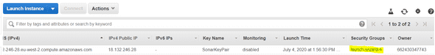
You will be redirected to your Security Group. Click on the Inbound Rules tab and edit them.
Add a new rule like below:
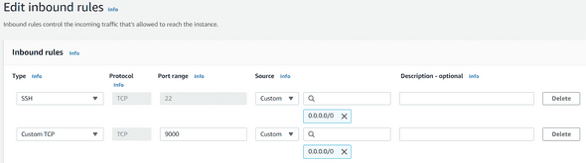
By default, SonarQube is running on port 9000. You can change this default port by editing the sonar Properties file in /opt/sonarqube/conf folder.
Do not forget to restart sonar just after.
Save your rules, and to access to your SonarQube server, find your EC2 IPv4 Public address in the EC2 Running Instances dashboard, open a new tab with this following URL: http://<< your ec2 public IP address >>:9000
The default credentials for the SonarQube will be as below
Username: admin
Password: admin
With the above credentials, log in to the SonarQube Dashboard, and let’s start the actual work (after changing the default password).
SonarQube is a static code analysis tool that can be integrated as a part of the CI/CD pipeline and before actually building the codebase we can scan the codebase for any possible bugs and security vulnerabilities and make the pipeline fail in case the code doesn’t meet the standards defined.
In this process we’ll be using AWS CI/CD pipeline.

Integrating SonarQube with AWS Code Pipeline
Let’s first create a project in SonarQube Dashboard where we’ll get to see all the bugs/issues and vulnerabilities.
Login to the SonarQube portal and click on Create project Manually.
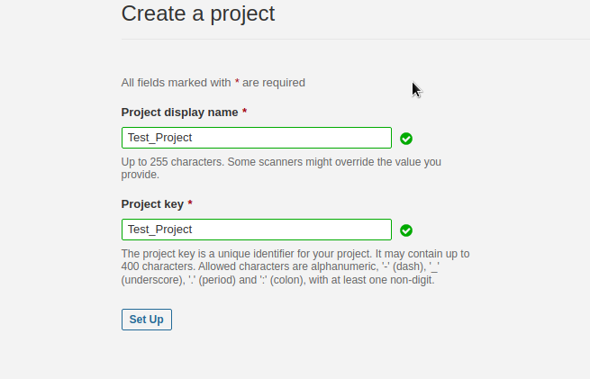
and click on setup, you’ll see the below screen.
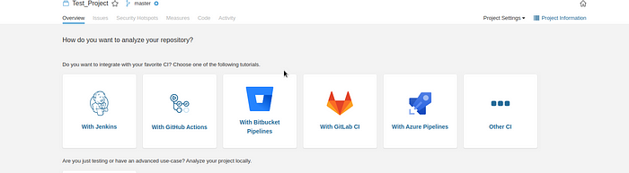
Choose Other CI and generate a taken by giving some token name.
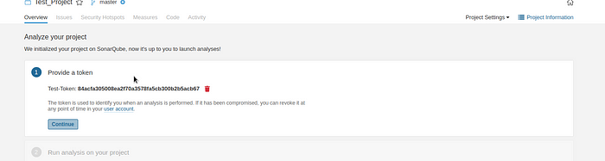
and click on setup and in the second stage choose your codebase Tech stack, Since I’m using .Net script, I’ll choose the same and select Linux as the Operating system.
After choosing options you’ll see a command to scan your codebase as below and Copy the same.
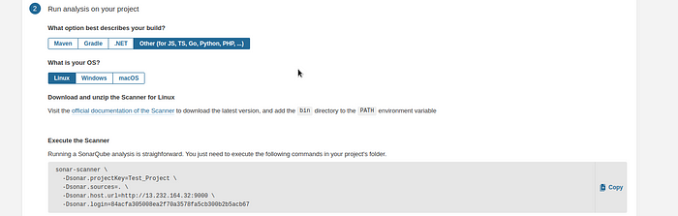
It’ll look something like as below.

sonar-scanner \
sonar-scanner -Dsonar.projectKey=Test_Project -Dsonar.sources=. -Dsonar.host.url=http://13.232.164.32:9000 -Dsonar.login=84acfa305008ea2f70a3578fa5cb300b2b5acb67
You can use the above command to scan your codebase and it’ll generate the sonar Report and it’ll be shown in the SonarQube Dashboard under Test Project.
But in our use case, we have to scan the code which is being pulled by the AWS Code pipeline, so we will create one more stage in AWS Code pipeline where we will use this command to scan the code.
Go to AWS Code pipeline Console and Create Pipeline.
click on Edit as below
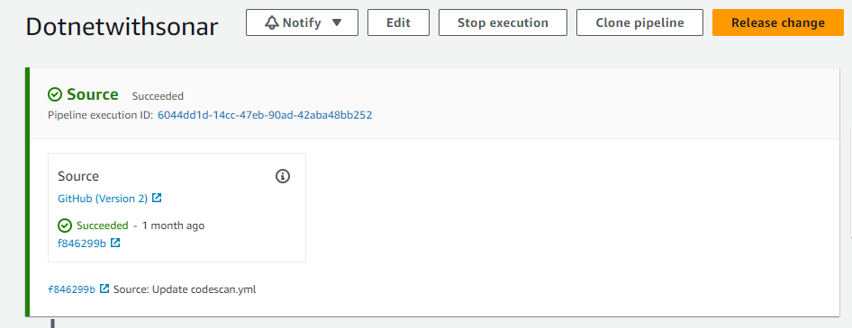
Add a stage after the source stage and give the stage name as Code-Review and click on Add Stage.
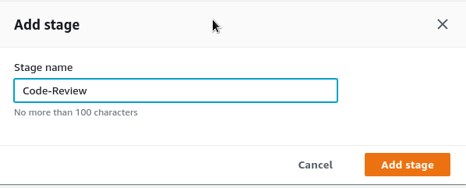
After the stage is created, click on addiction Group, and enter the below details.
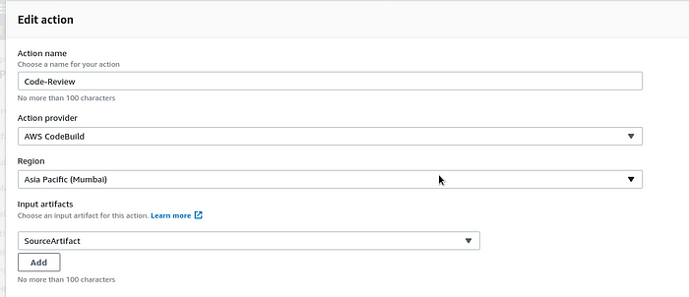
We have to create a new CodeBuild project, scroll down to the form on click on Create Project in the field of Project Name
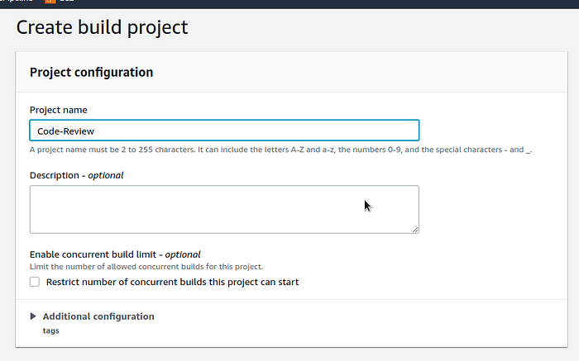
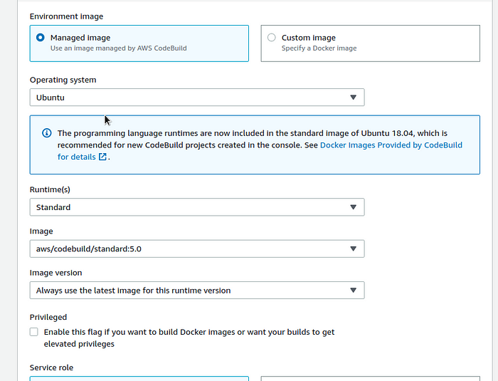
Select buildspec file.
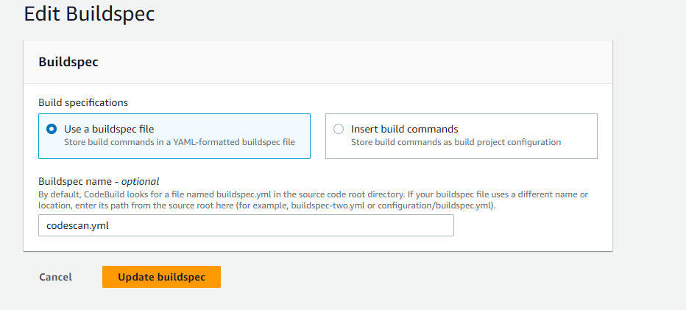
and click on Continue to pipeline and click on done and finally save the pipeline.
Finally, Release the pipeline and check the code-review stage. After the code-review stage completes, you can check in the SonarQube Dashboard for the issues.
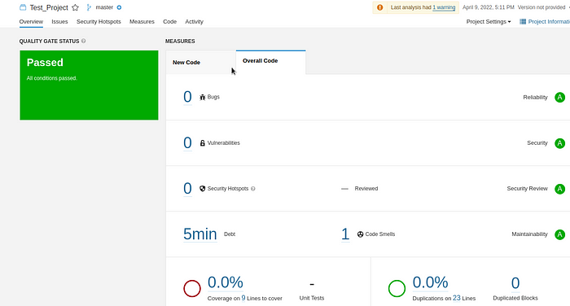
Note:
1. Quality Gate is a feature in SonarQube that can be configured to ensure coding standards are met and regulated across projects. You can set threshold measures on your projects like code coverage, technical debt measure, number of blocker/critical issues, security rating/unit test pass rate, and more. The last step calls the Quality Gate API to check if the code is satisfying all the conditions set in Quality Gate. Refer to the Quality Gate documentation for more information.
Quality Gate can return four possible responses:
ERROR: The project fails the Quality Gate.
WARN: The project has some irregularities but is ok to be passed on to production.
OK: The project successfully passes the Quality Gate.
None: The Quality Gate is not attached to project.
AWS Code Build provides several environment variables that you can use in your build commands. CODEBUILD_BUILD_SUCCEEDING is a variable used to indicate whether the current build is succeeding. Setting the value to 0 indicates the build status as failure and 1 indicates the build as success.
Using the Quality Gate ERROR response, set the CODEBUILD_BUILD_SUCCEEDING variable to failure. Accordingly, the CodeBuild status can be used to provide response for the pipeline to proceed or to stop.
2. SonarQube is a popular code quality management tool that helps developers and teams to analyze and improve the quality of their code. A quality profile in SonarQube is a set of rules that are used to analyze code and provide feedback on potential issues or areas for improvement.
A quality profile defines a set of coding standards and practices that should be followed while writing code. These standards may include best practices for code readability, maintainability, performance, security, and other factors that impact the overall quality of the code.
The use of quality profiles in SonarQube can help developers identify and fix issues in their code before they become more serious. By using these profiles, developers can ensure that their code is well-structured, efficient, and meets industry standards for quality.
Quality profiles can also be customized to meet the specific needs of different projects, teams, or organizations. This allows developers to tailor their quality management practices to their specific requirements and goals.
Overall, the use of SonarQube quality profiles can help developers improve the quality and maintainability of their code, reduce technical debt, and ensure that their code meets industry standards and best practices.

