Q1.SELECT title FROM movies;

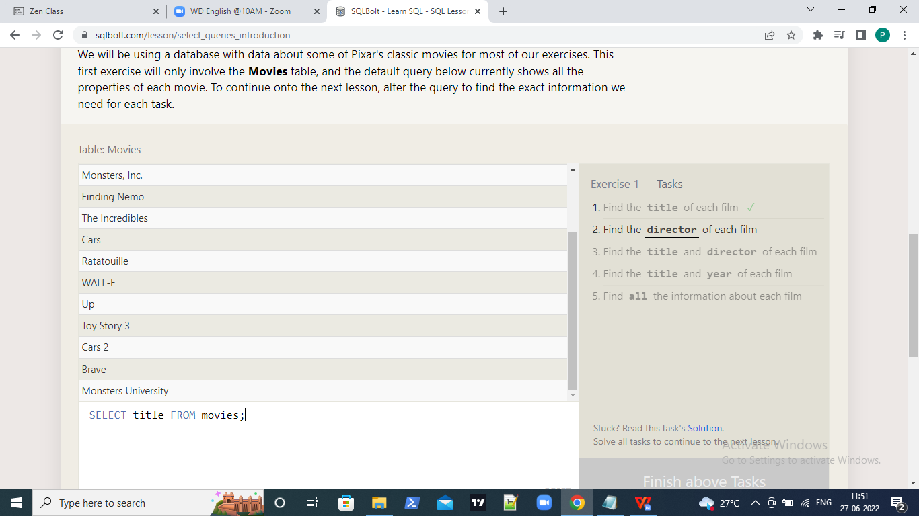

Q2.SELECT director FROM movies;

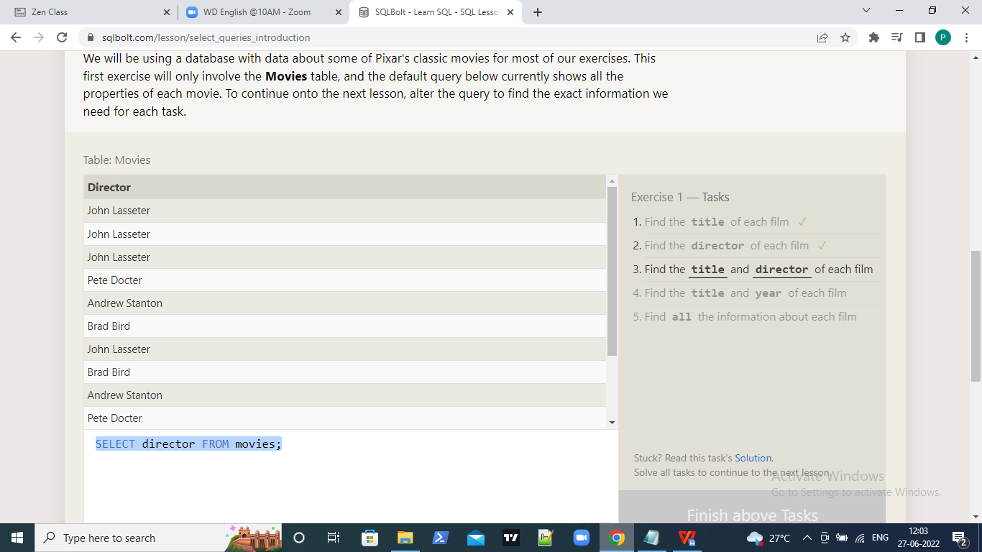

Q3.SELECT title,director FROM movies;

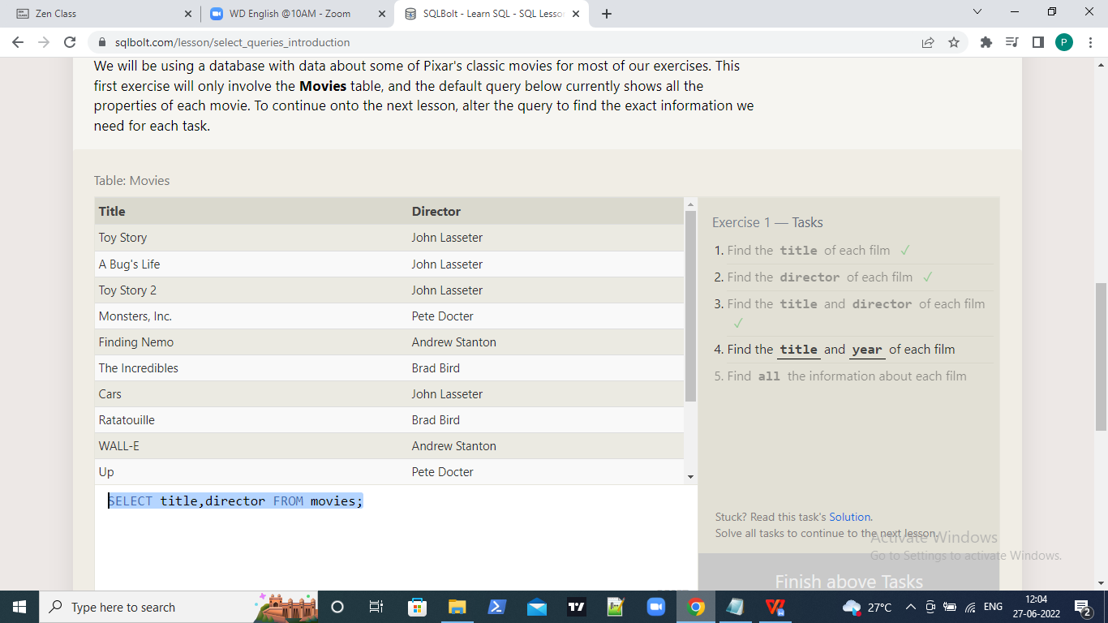

Q4.SELECT title,year FROM movies;

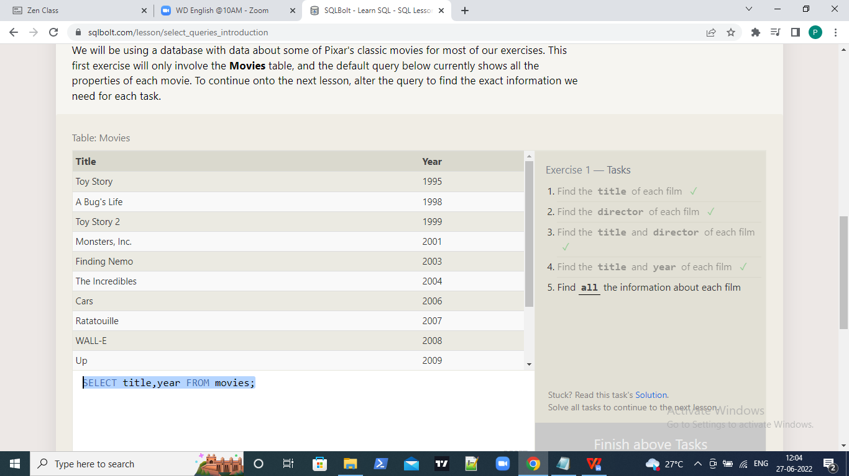

Q5.SELECT \* FROM movies;

