Q1.SELECT MAX(Years_employed) AS Longest FROM employees;
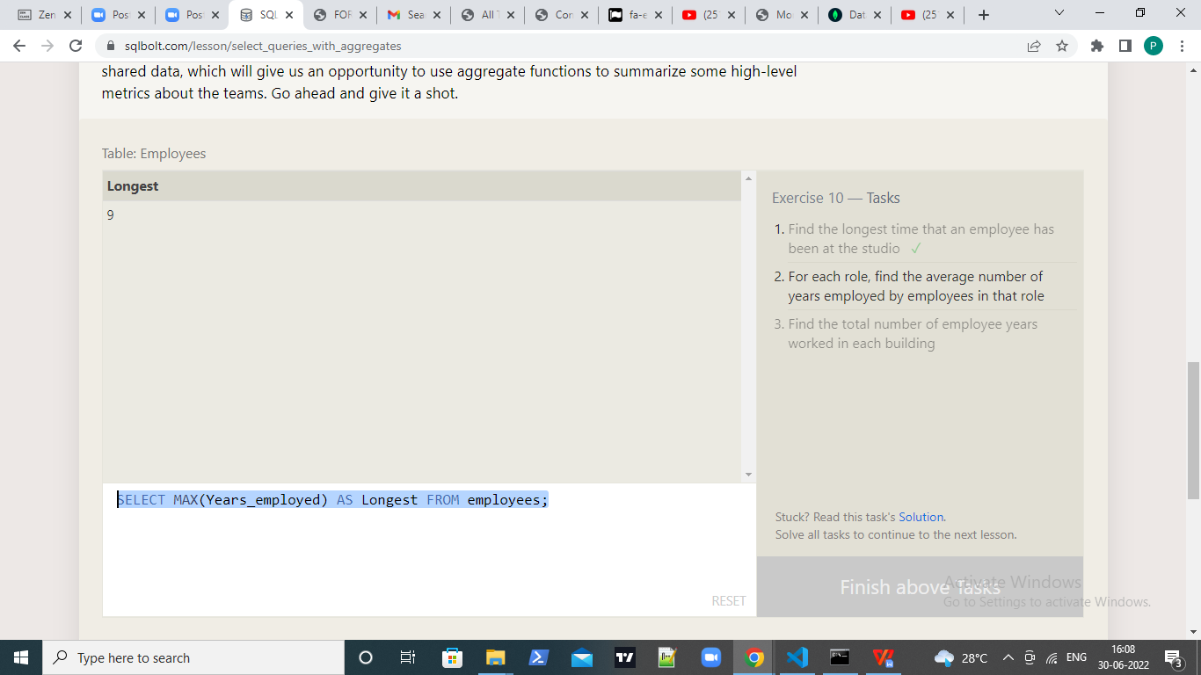

Q2.SELECT role,Avg(years_employed) FROM employees
group by role;
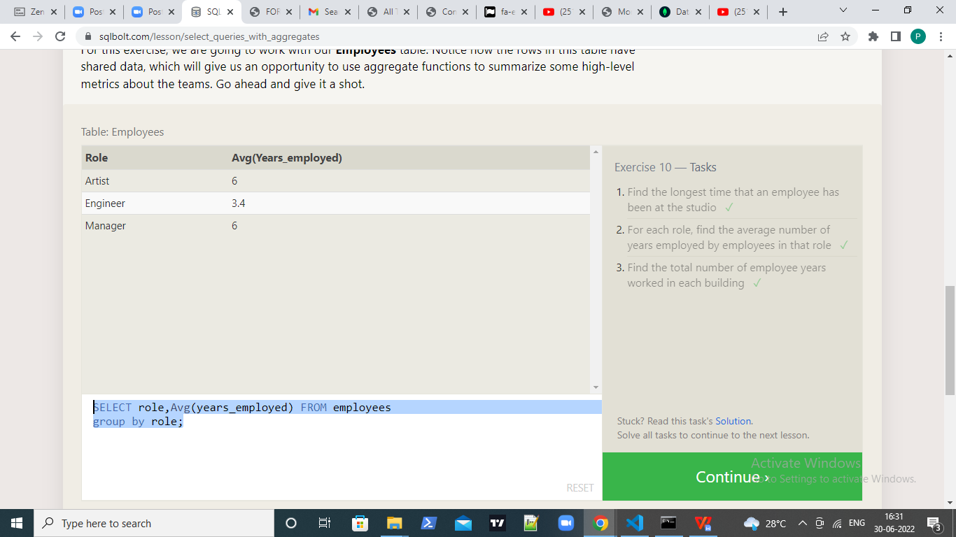

Q3.SELECT building,Sum(years_employed) FROM employees
group by building;
