Q1.SELECT Role, COUNT(*) AS Number_of_Artists
FROM Employees
WHERE Role = "Artist";
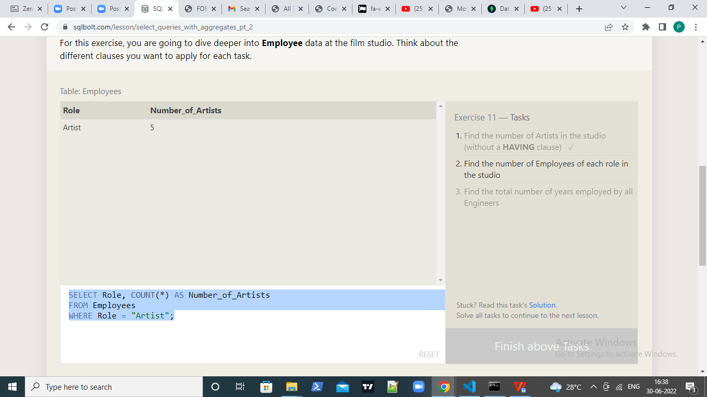

Q2.SELECT Role, COUNT(*) AS Number_of_Artists
FROM Employees
group by role;

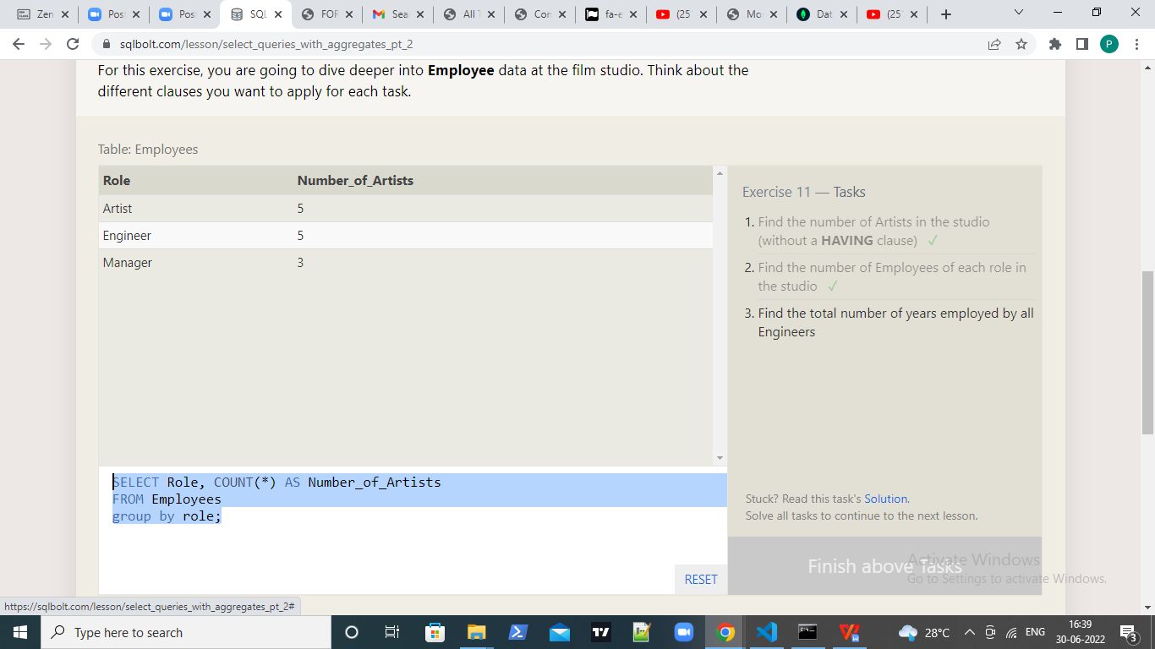

Q3.SELECT sum(years_employed) FROM employees
where role="Engineer";

