Q1.SELECT *, COUNT(Title)
FROM Movies
GROUP BY Director;
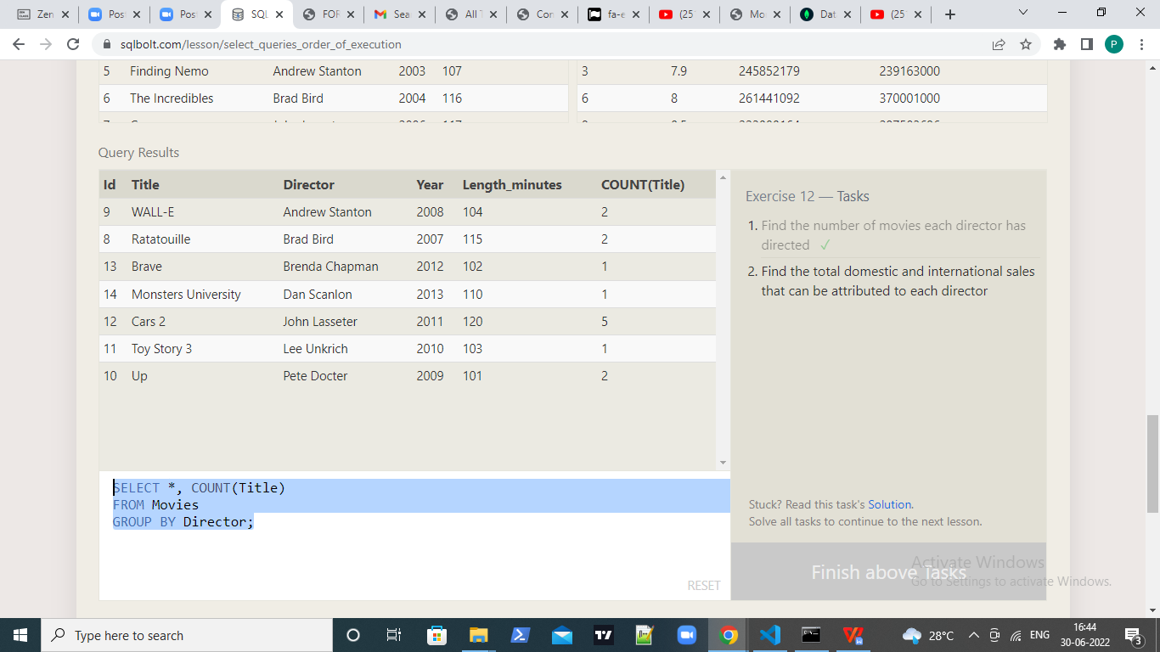

Q2.SELECT *, SUM(domestic_sales+International_sales)
FROM Movies left join boxoffice on
movies.id=boxoffice.movie_id
GROUP BY Director;

