Q1.Insert into movies values(4,”toy story 4”,”john lasseter”,2017,123);

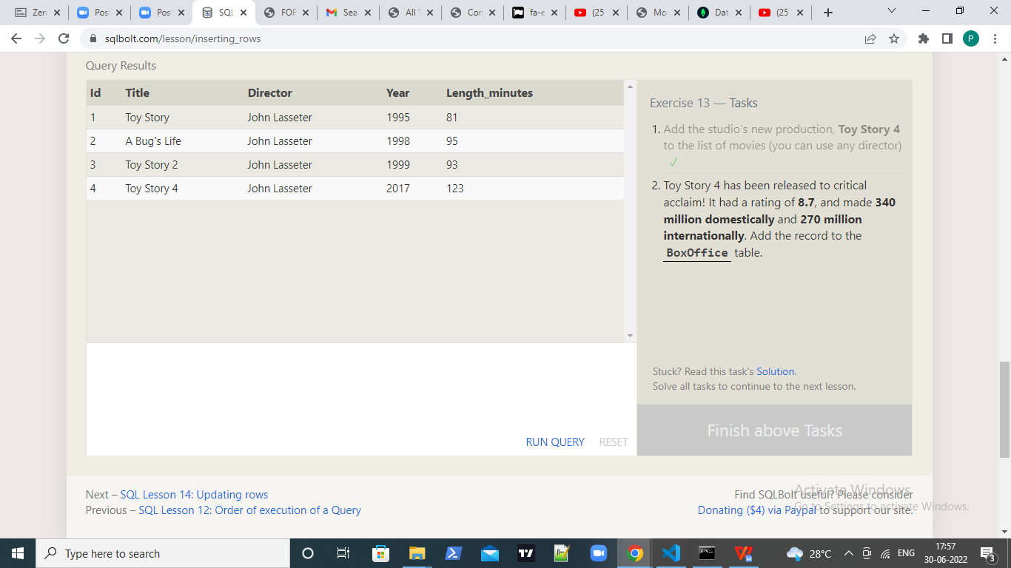

Q2.Insert into Boxoffice values(4,8.7,340000000,270000000);

