Q1.UPDATE Movies
SET Director = "John Lasseter"
WHERE Id = 2;
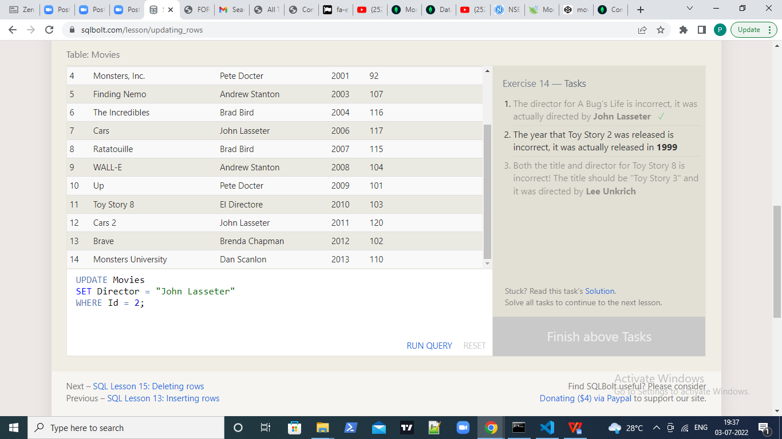

Q2.UPDATE Movies
SET Year = "1999"
WHERE Id = 3;
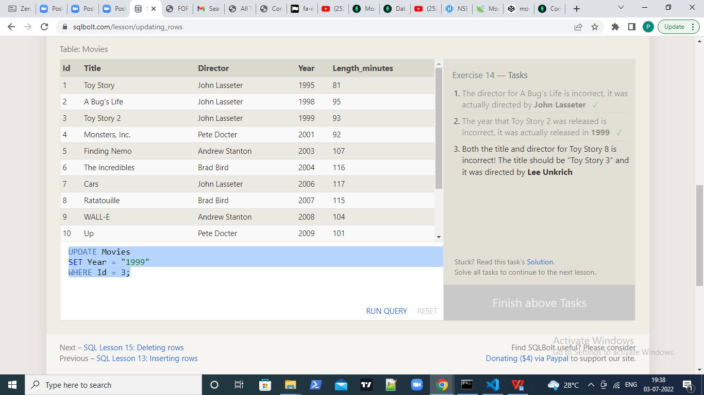
Q3.
UPDATE Movies
SET Title = "Toy Story 3", Director = "Lee Unkrich"
WHERE Id = 11;
