Q1.DELETE FROM Movies
WHERE Year<2005;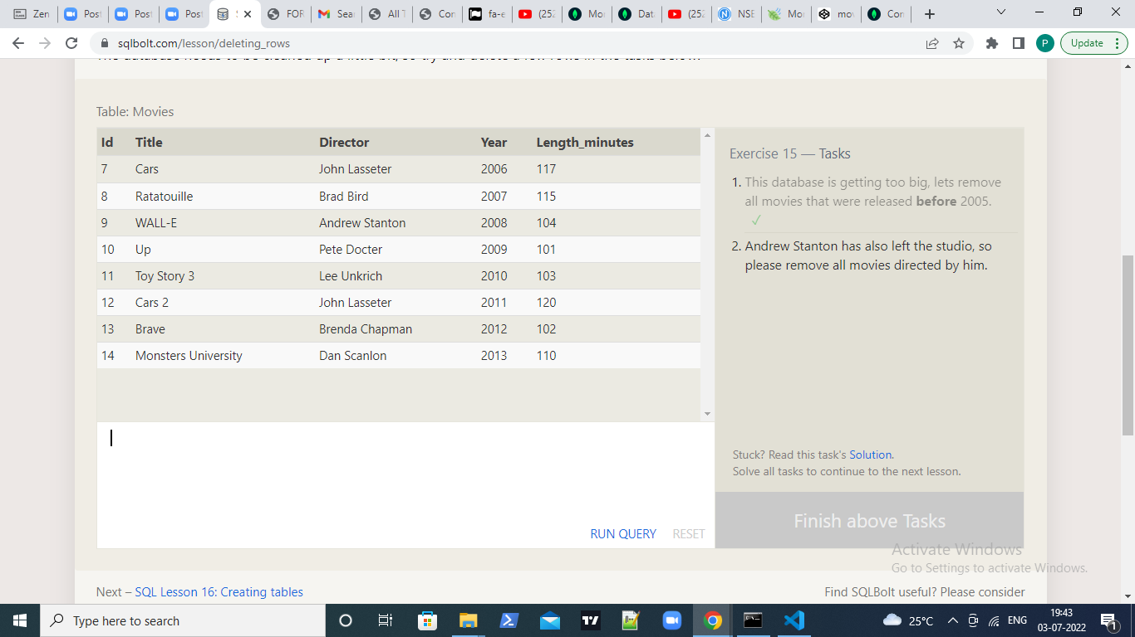

Q2.DELETE FROM Movies
WHERE Director = "Andrew Stanton";

