Q1.ALTER TABLE Movies
ADD COLUMN Aspect_ratio FLOAT DEFAULT 3;
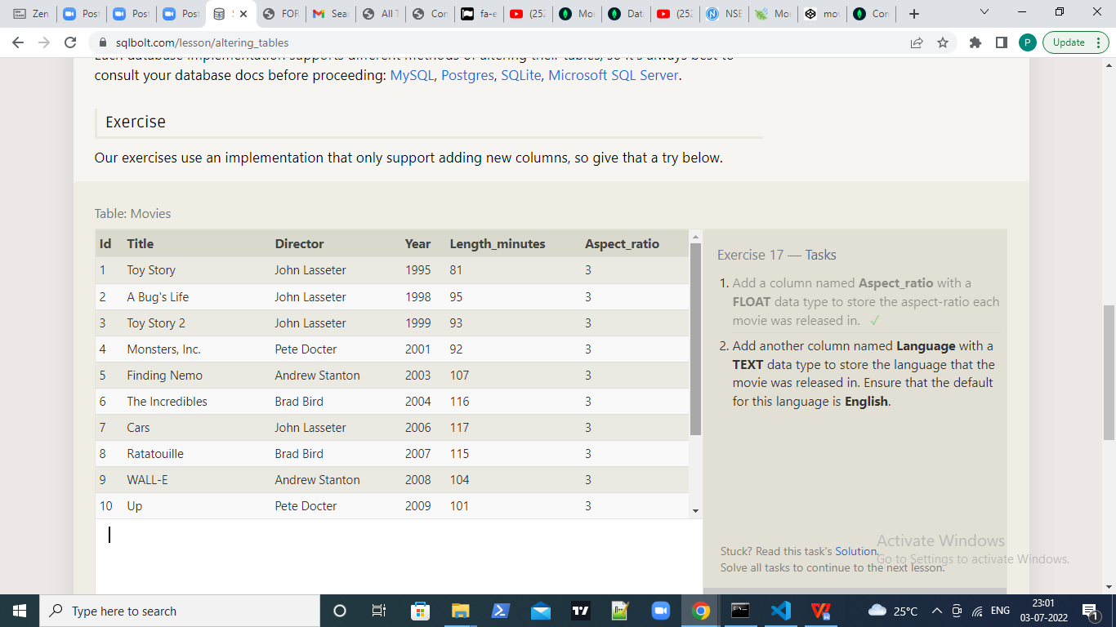
Q2.ALTER TABLE Movies
ADD COLUMN Language TEXT DEFAULT "English";
