Q1.SELECT * FROM movies
where id=6;
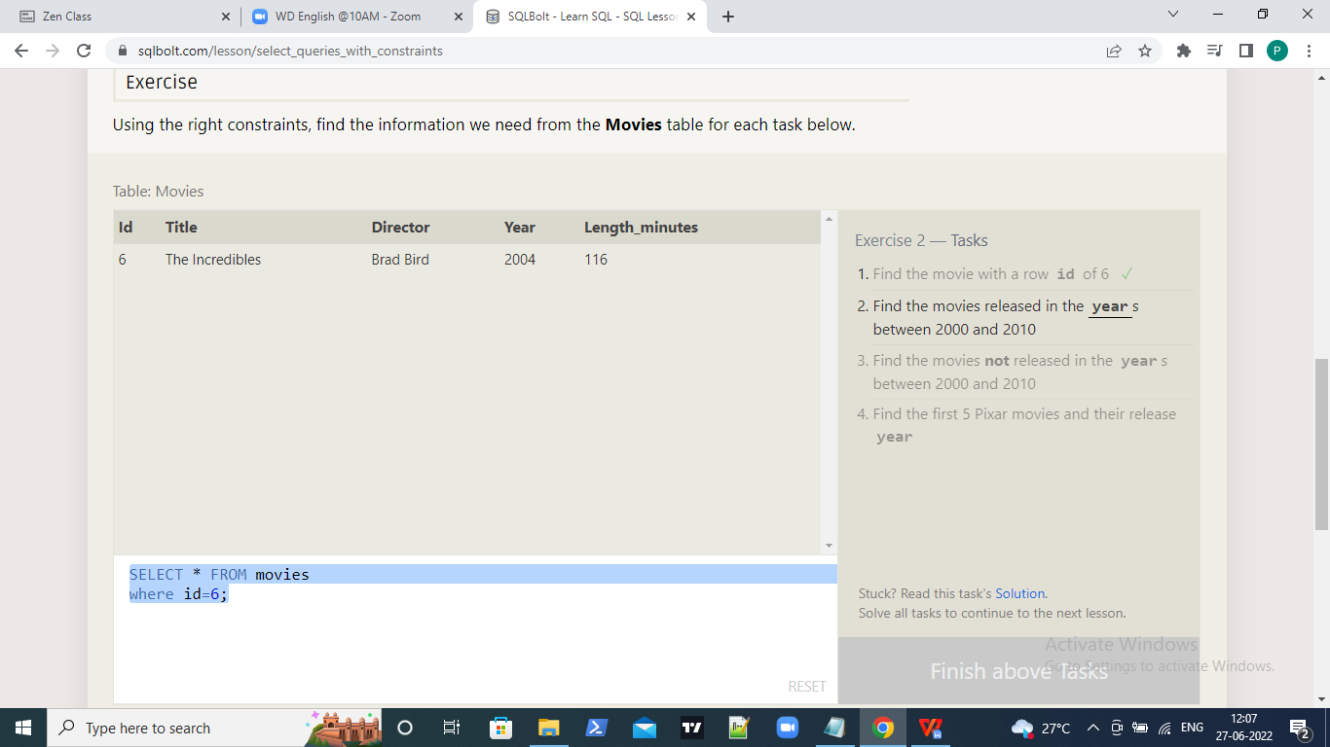

Q2.SELECT * FROM movies
where year between 2000 AND 2010;
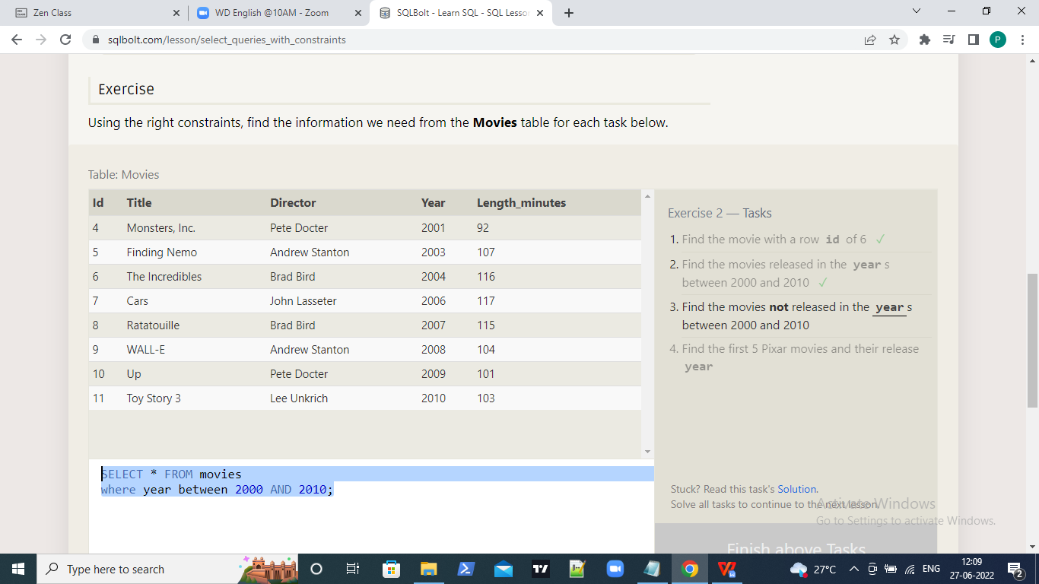

Q3.SELECT * FROM movies
where year NOT BETWEEN 2000 AND 2010;
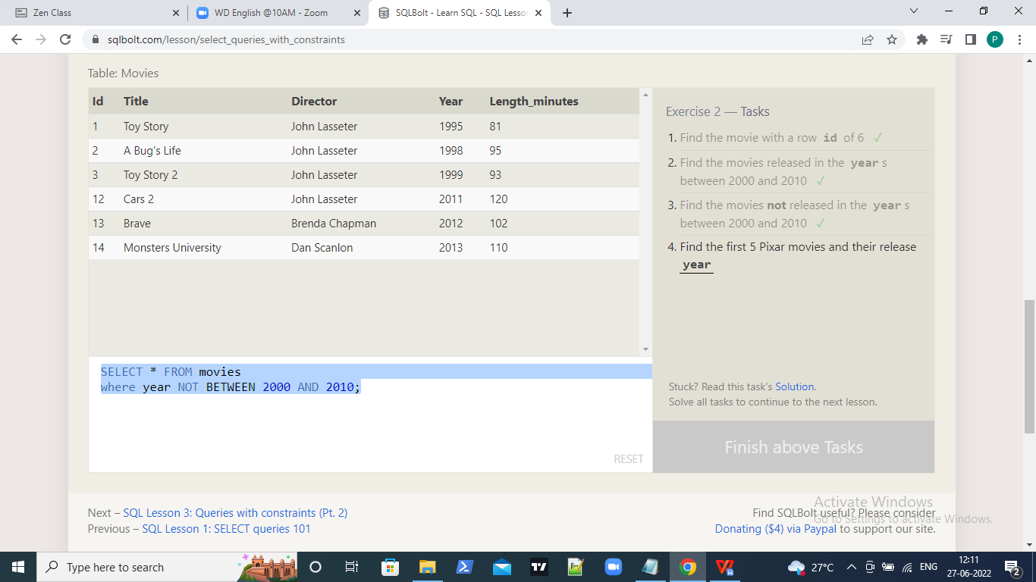

Q4.SELECT title,year FROM movies
where id BETWEEN 1 AND 5;

