Q1.SELECT Title FROM movies
where Title LIKE "%TOY%";
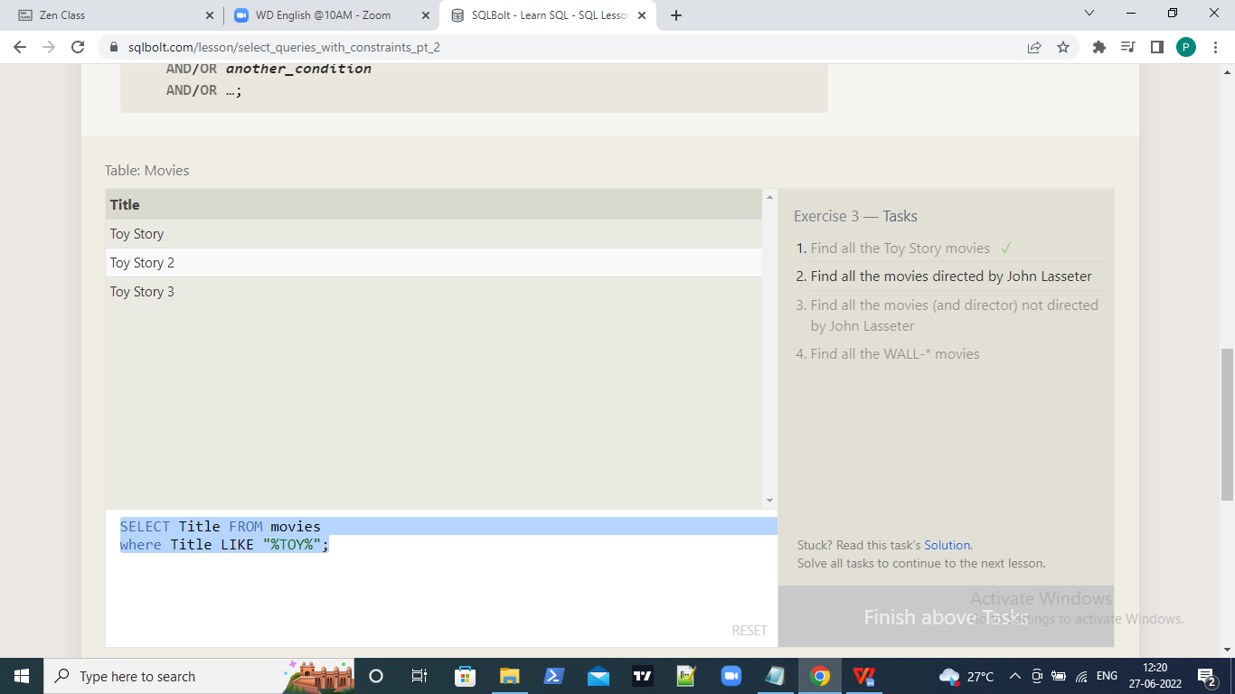

Q2.SELECT Title FROM movies
where director LIKE "%John lasseter%";
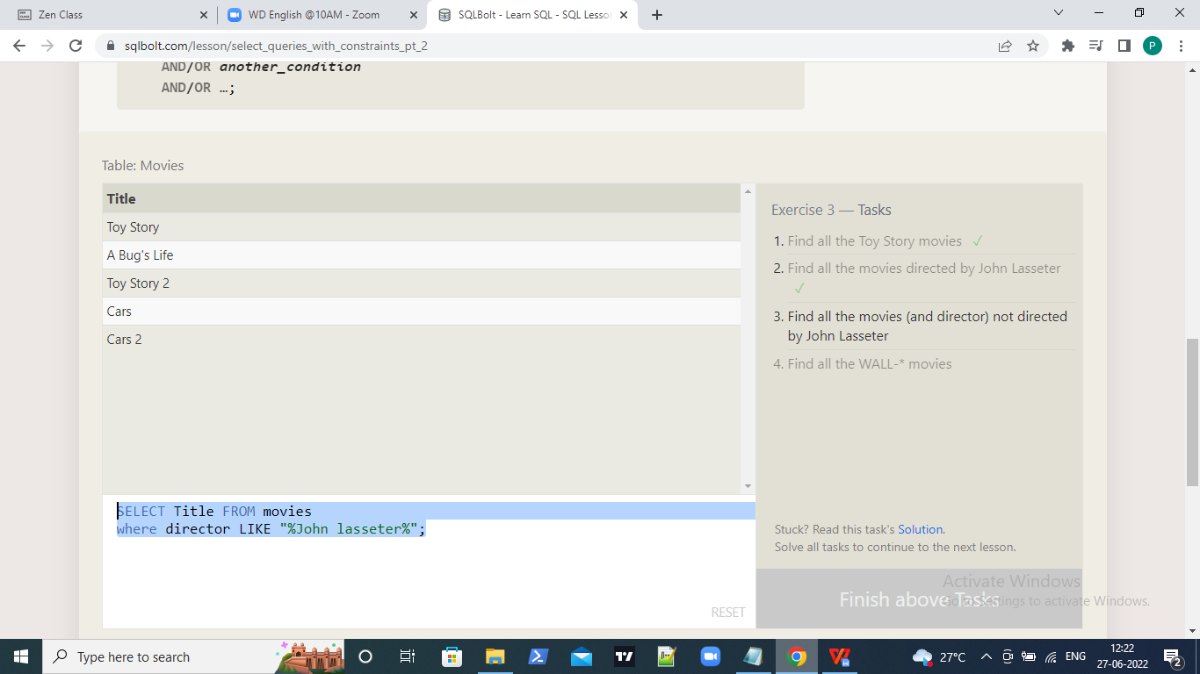

Q3.SELECT Title,director FROM movies
where director NOT LIKE "%John lasseter%";.

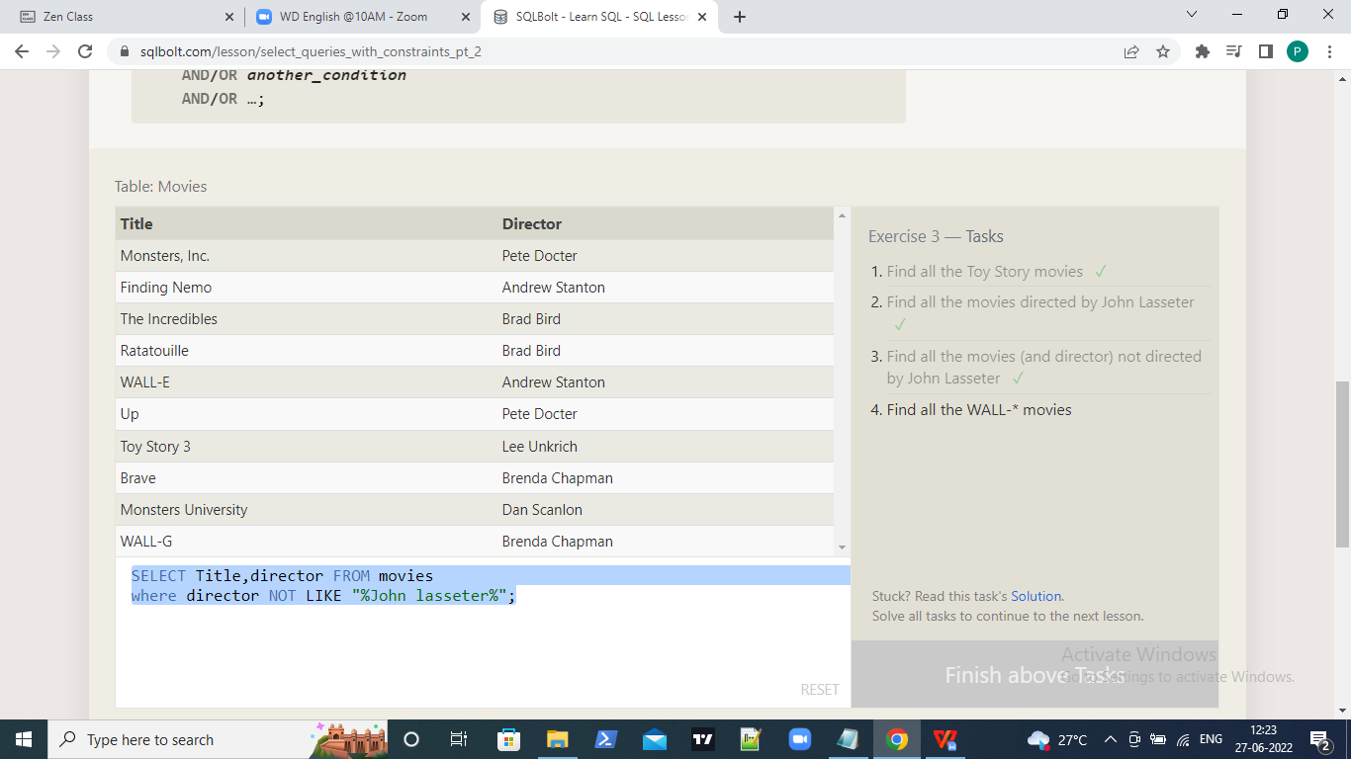

Q4.SELECT TITLE FROM movies
where title LIKE "%WALL%";
