Q1.SELECT Distinct director FROM movies
order by director;
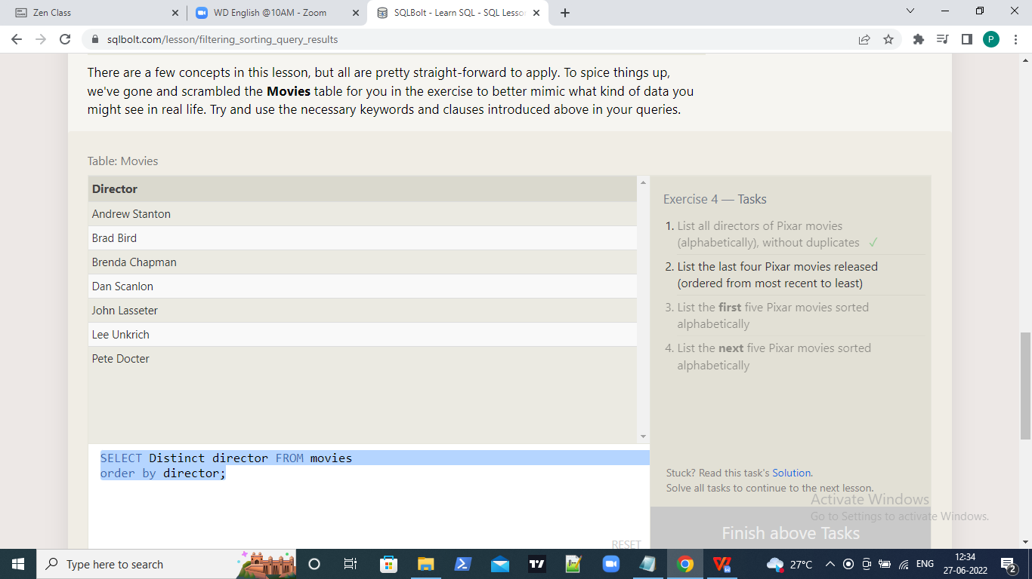

Q2.SELECT Distinct title,year FROM movies
order by year desc Limit 4;

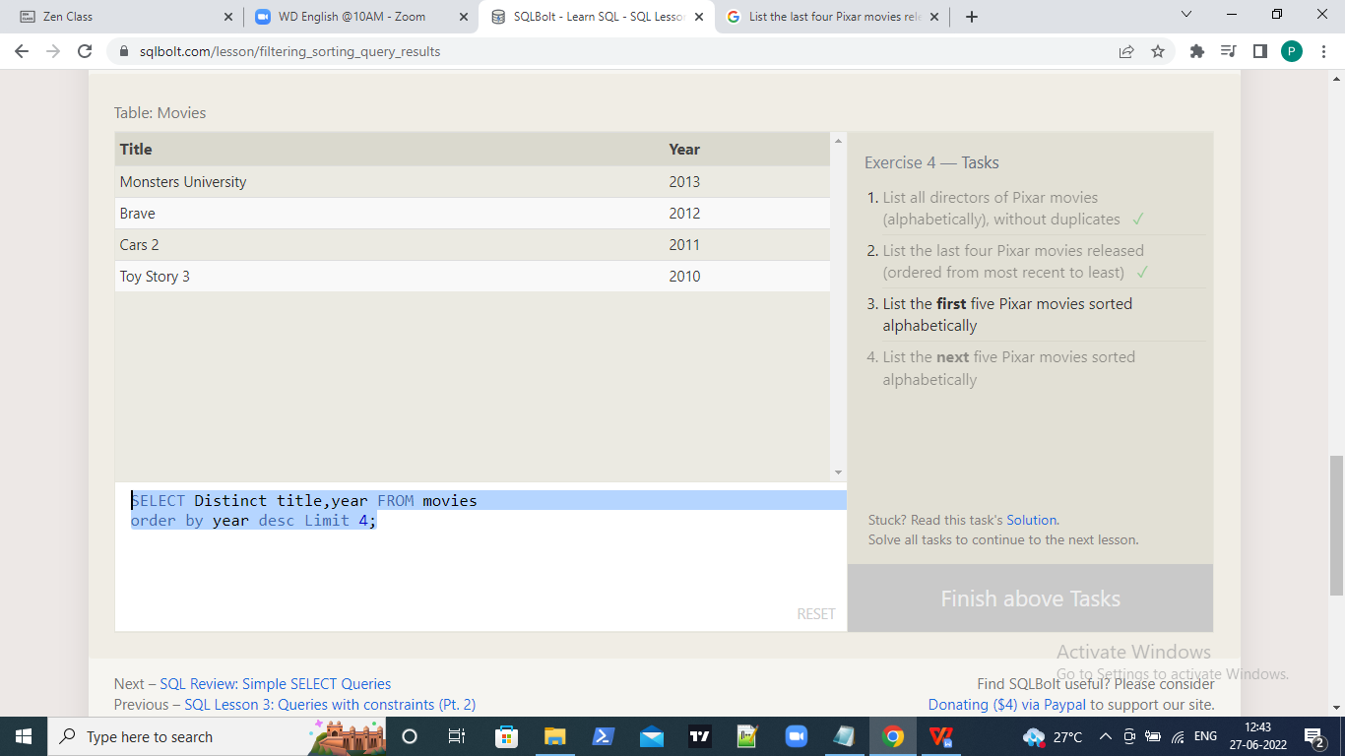

Q3.SELECT Distinct title,year FROM movies
order by title Limit 5;

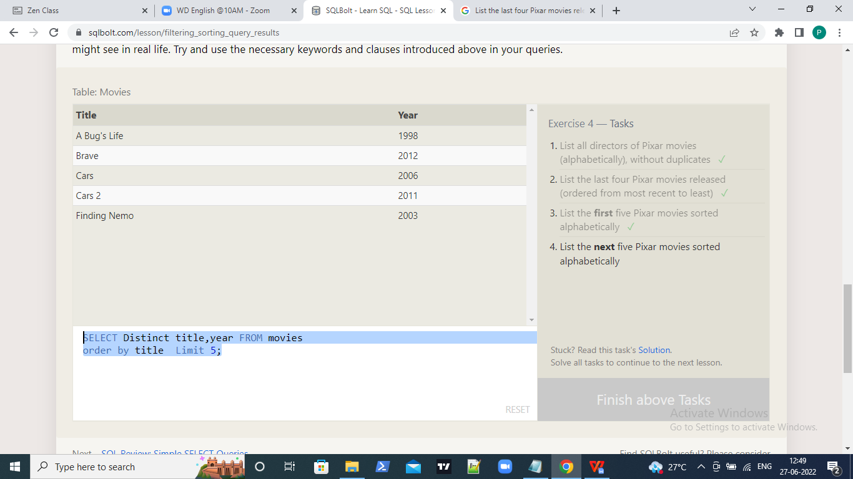

Q4.SELECT Distinct title,year FROM movies
order by title Limit 5 OFFSET 5;

