Q1.SELECT city,population,country FROM north_american_cities
where Country = "Canada";
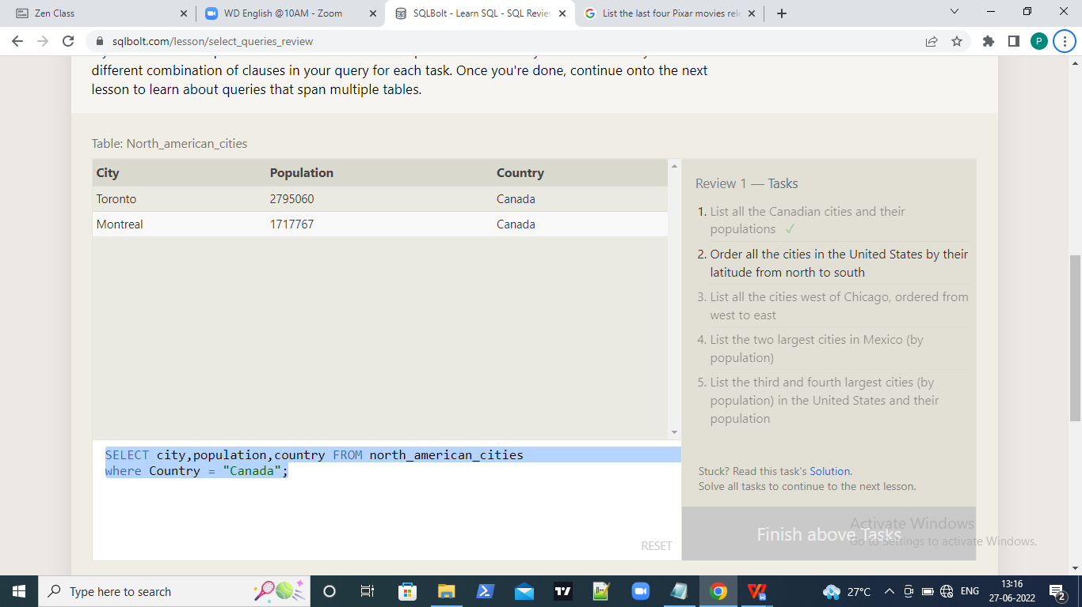

Q2.SELECT city FROM north_american_cities
where Country="United States"
order by latitude DESC;

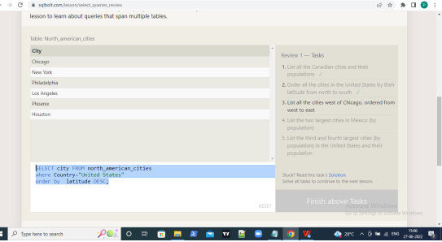

Q3.SELECT city
FROM north_american_cities
WHERE longitude < -87.629798
ORDER BY longitude;

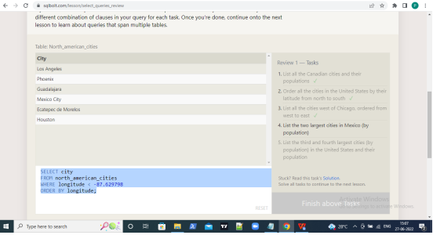

Q4.SELECT city FROM north_american_cities
where country ="Mexico"
order by population DESC
limit 2;

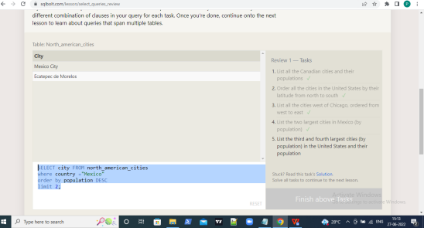

Q5.SELECT city FROM north_american_cities
where country ="United States"
order by population DESC
limit 2 offset 2;

