Q1.SELECT * FROM movies
inner join Boxoffice on
movies.id =Boxoffice.movie_id;

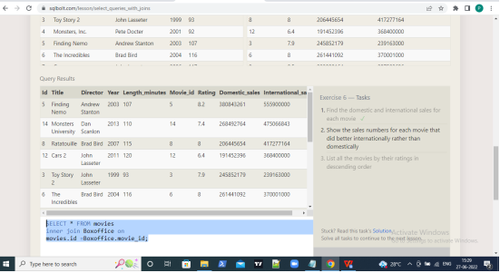

Q2.SELECT * FROM movies
inner join Boxoffice on
movies.id =Boxoffice.movie_id
where International_sales>Domestic_Sales;

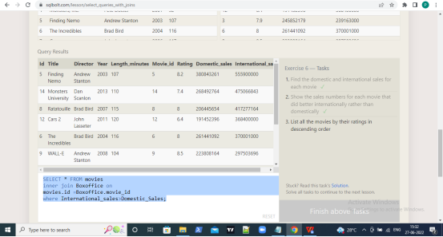

Q3.SELECT title FROM movies
inner join Boxoffice on
movies.id =Boxoffice.movie_id
order by rating Desc;
