Q1.SELECT DISTINCT building FROM employees
where building IS NOT NULL;
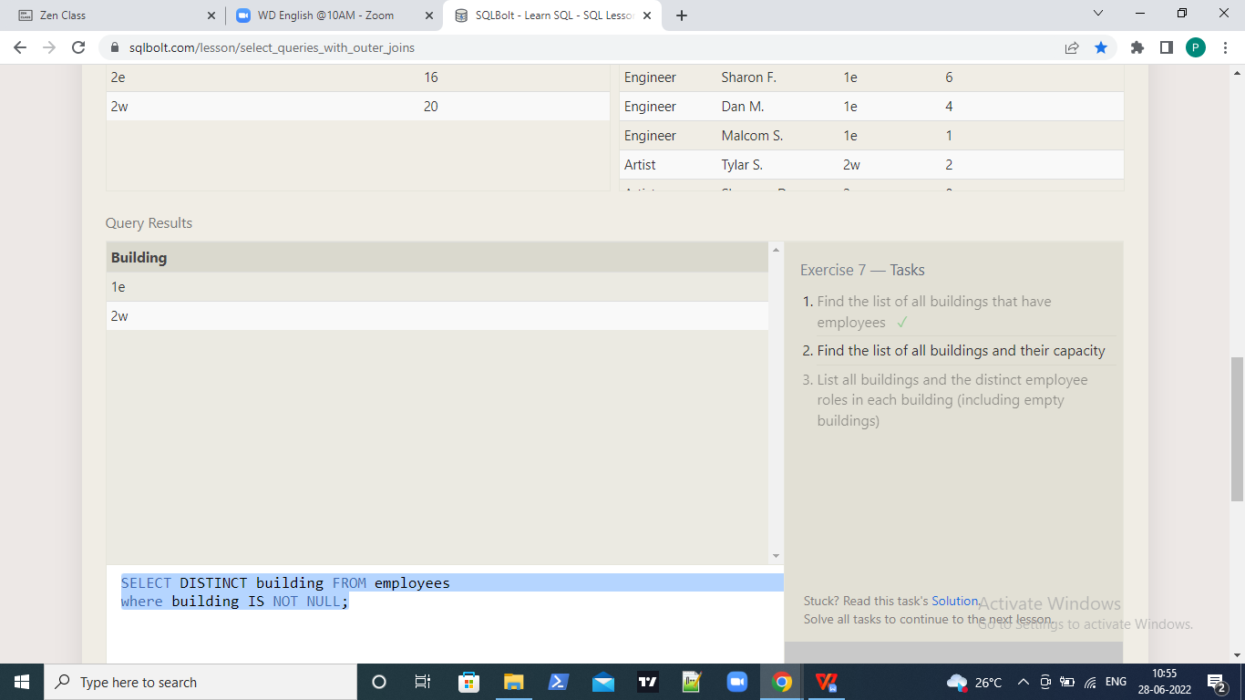

Q2.SELECT * FROM Buildings;
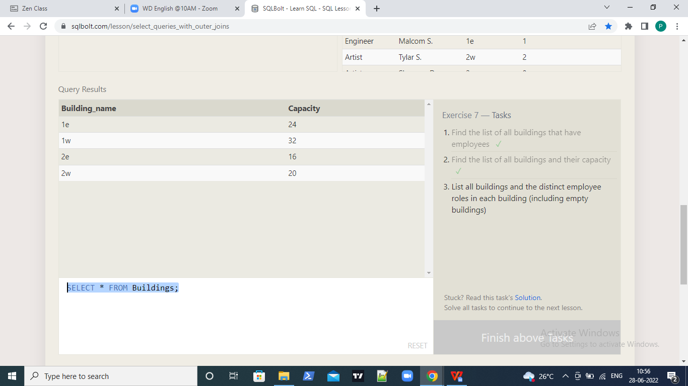

Q3.SELECT Distinct Role, Building_name FROM Buildings
left Join Employees
on Buildings.building_name= Employees.building;
