Q1.SELECT * FROM employees
where Building IS NUll;
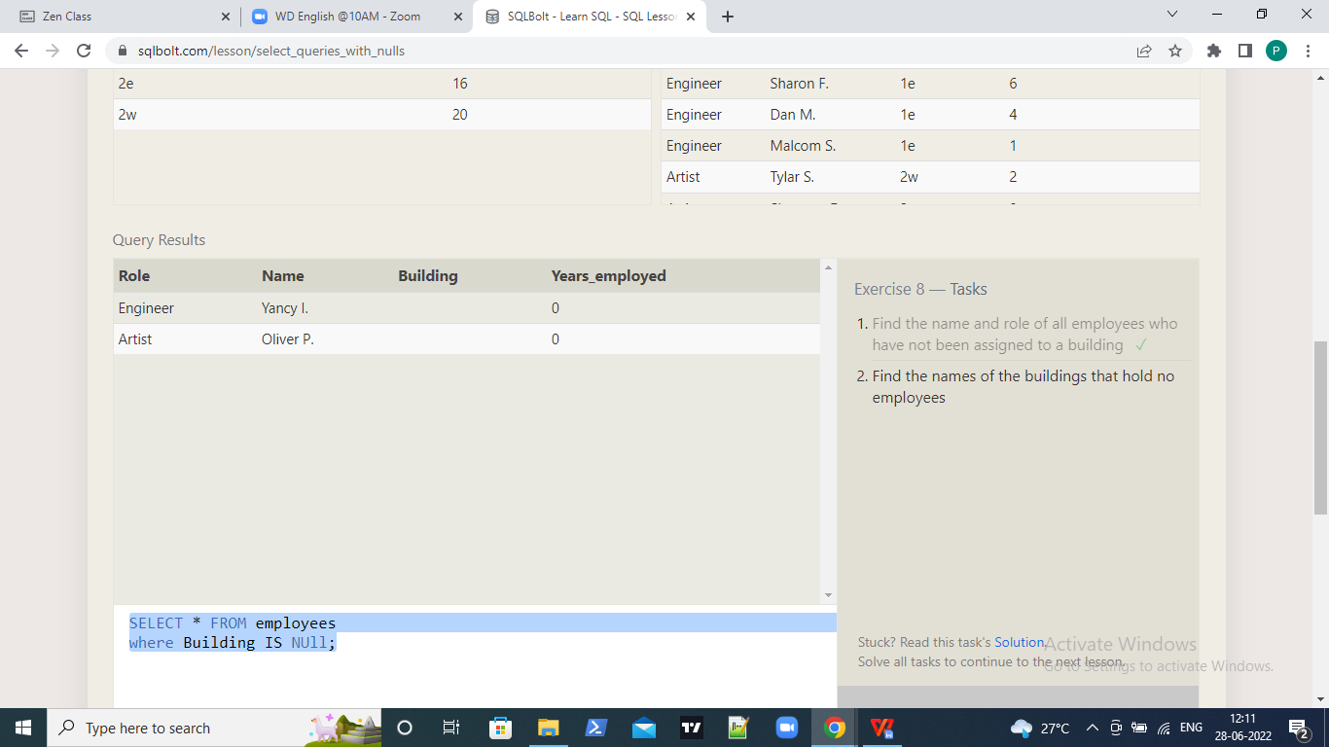

Q2.SELECT Building_name FROM Buildings
left Join Employees
on Buildings.building_name= Employees.building
where name Is null;

