Q1.SELECT DISTINCT title,
(Domestic_Sales+International_Sales)/1000000 AS SALES
FROM movies left join BOXOFFICE
on movies.id=boxoffice.movie_id;
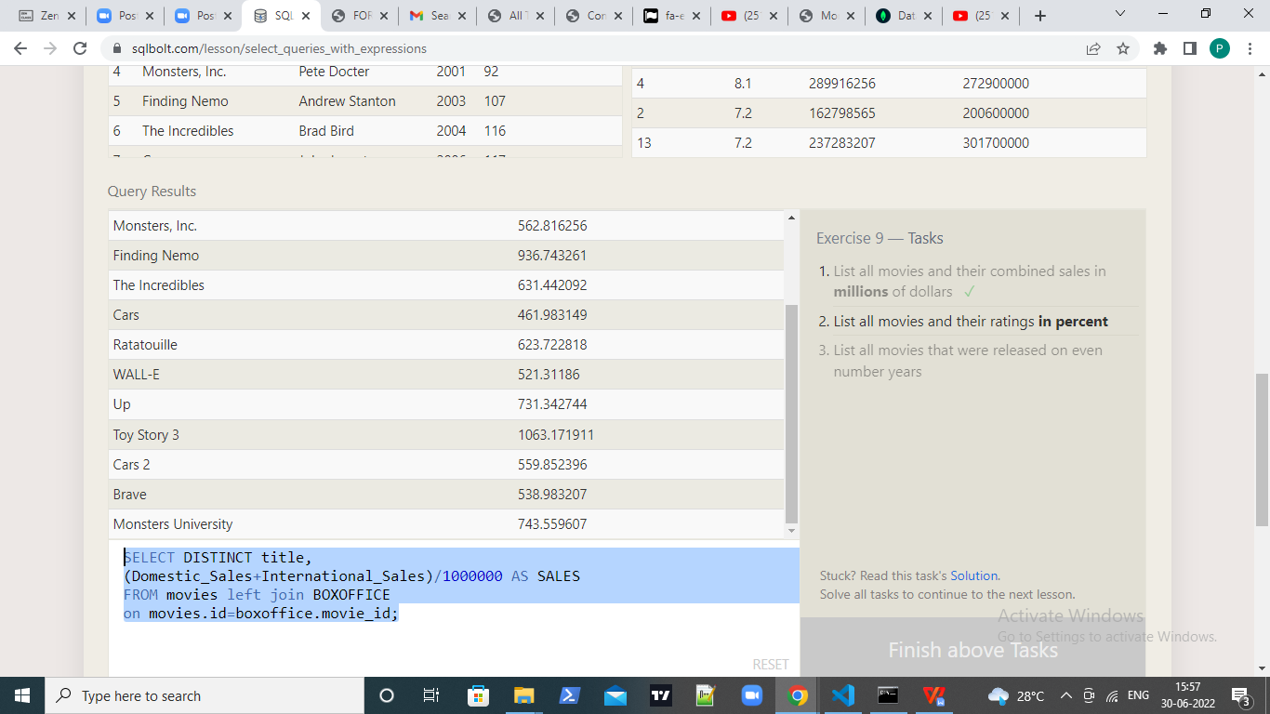

Q2.SELECT Distinct title,(Rating*10) AS rate_percent FROM movies
left join boxoffice on movies.id=boxoffice.movie_id;
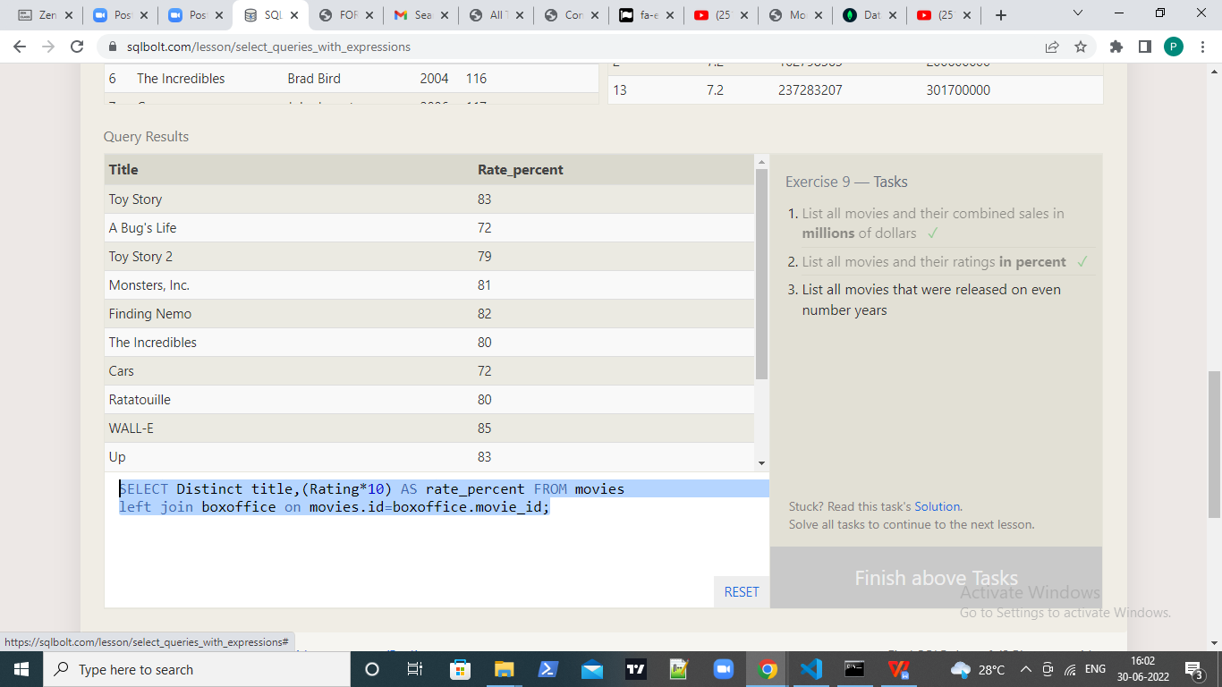

Q3.SELECT Distinct title FROM movies
where year%2==0;

