Post-Campaign Insights & Recommendations
Campaign ID: 4512
Generated: 2026-01-19 10:33

Executive Summary
The campaign delivered 91,726 impressions with a CTR of 0.03% and spend of $178.09.

Campaign KPIs
Metric | Value
Total Impressions | 91,726
Total Clicks | 31
Total Spend | $178.09
CTR | 0.03%
CPM | $1.94
Viewability | 66.26%
VCR | N/A

Key Insights

Critical Findings
[✗] Week 2025-12-08 CTR (0.022%) was 34.6% below campaign average
→ Investigate creative fatigue, audience saturation, or inventory quality issues. Consider A/B testing new creatives or adjusting targeting parameters.
[✗] Week 2025-12-29 CTR (0.000%) was 100.0% below campaign average
→ Investigate creative fatigue, audience saturation, or inventory quality issues. Consider A/B testing new creatives or adjusting targeting parameters.

Warning Findings
[⚠] Week 2025-12-15 had a 77.7% spike in impressions vs campaign average
→ Review pacing strategy. High-volume weeks may indicate back-loaded delivery or opportunistic bidding. Consider smoothing delivery for more consistent performance.

Positive Findings
[✓] Week 2025-12-15 showed CTR recovery at 118.0% of campaign average
→ Positive trend detected. Analyze what changed (creative refresh, targeting adjustments, inventory mix) and apply learnings to future campaigns.
[✓] Week 2025-12-22 showed CTR recovery at 154.9% of campaign average
→ Positive trend detected. Analyze what changed (creative refresh, targeting adjustments, inventory mix) and apply learnings to future campaigns.

Weekly Performance
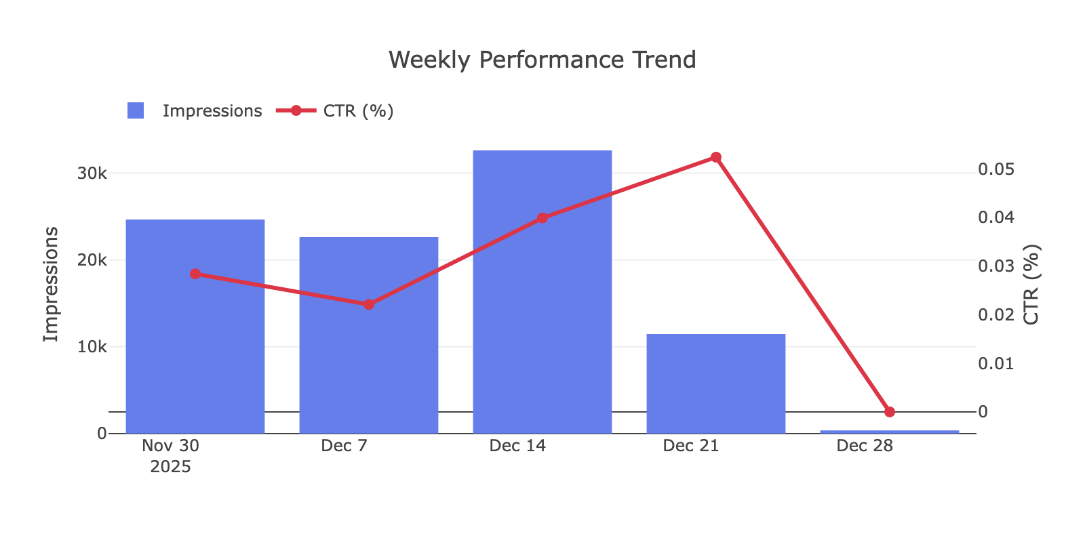

Week | Impressions | Clicks | CTR | Spend | Viewability
2025-12-01 | 24,657 | 7 | 0.03% | $47.92 | 65.26%
2025-12-08 | 22,629 | 5 | 0.02% | $43.48 | 63.12%
2025-12-15 | 32,605 | 13 | 0.04% | $64.12 | 67.35%
2025-12-22 | 11,460 | 6 | 0.05% | $22.03 | 71.61%
2025-12-29 | 375 | 0 | N/A | $0.54 | 62.67%

Platform Breakdown
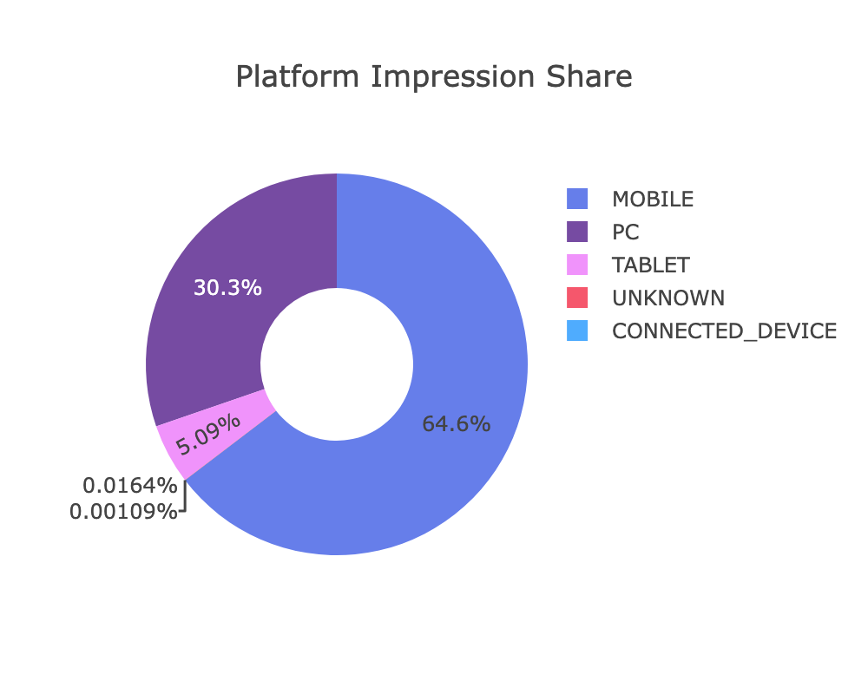

Platform | Impressions | Share | CTR | CPM
MOBILE | 59,275 | 64.62% | 0.05% | $1.94
PC | 27,763 | 30.27% | 0.01% | $1.94
TABLET | 4,672 | 5.09% | N/A | $1.93
UNKNOWN | 15 | 0.02% | N/A | $1.33
CONNECTED_DEVICE | 1 | 0.0% | N/A | N/A

Day of Week Analysis
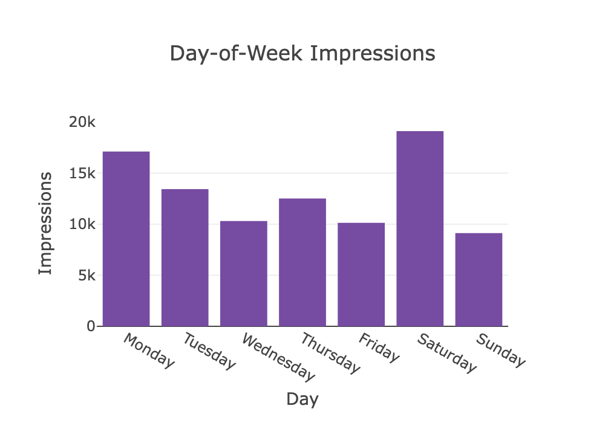

Day | Impressions | Clicks | CTR
Monday | 17,110 | 5 | 0.03%
Tuesday | 13,431 | 7 | 0.05%
Wednesday | 10,310 | 3 | 0.03%
Thursday | 12,506 | 5 | 0.04%
Friday | 10,135 | 2 | 0.02%
Saturday | 19,106 | 7 | 0.04%
Sunday | 9,128 | 2 | 0.02%

Top Domains
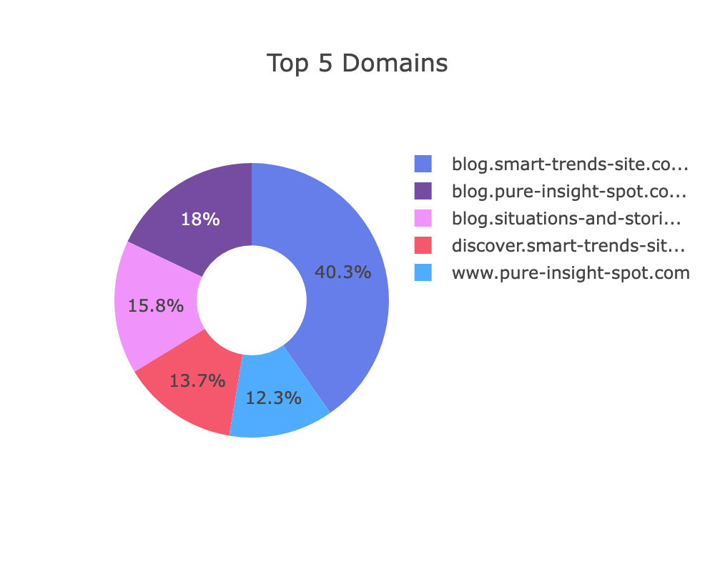

Top 10 Domain Share: 60.87%
Domain | Impressions | Share | CTR | Status
blog.smart-trends-site.com | 16,313 | 17.78% | 0.02% | OK
blog.pure-insight-spot.com | 7,272 | 7.93% | 0.01% | OK
blog.situations-and-stories.com | 6,377 | 6.95% | 0.05% | OK
discover.smart-trends-site.com | 5,529 | 6.03% | 0.05% | OK
www.pure-insight-spot.com | 4,989 | 5.44% | 0.02% | OK
content.story-feeds.com | 4,422 | 4.82% | 0.14% | OK
m.soundcloud.com | 3,487 | 3.8% | N/A | OK
blog.smart-update-hq.com | 3,280 | 3.58% | 0.03% | OK
finance.smart-update-hq.com | 2,353 | 2.57% | N/A | OK
forum.huskermax.com | 1,808 | 1.97% | N/A | OK

