Abstract
This project presents the comprehensive design, development, and rigorous evaluation of the Portable Typed Assembly (PTA) Compiler, a cutting-edge Domain Specific Language (DSL) specifically engineered for the ultra-high-performance demands of mobile image processing. The fundamental challenge addressed in this work is the inherent performance bottleneck found in standard managed languages like Java and Kotlin, which often rely on the Android Runtime (ART) and heavy software-level safety checks, leaving modern multi-core mobile hardware like the Snapdragon 8 Gen 4 significantly underutilized. Our innovative solution introduces a custom assembly-inspired syntax that allows developers to maintain fine-grained control over hardware registers while abstracting the complexities of cross-platform porting. A key architectural breakthrough is our 'Safety-Stripping' optimizer, which programmatically identifies redundant overflow and bounds checks and replaces them with hardware-native SIMD saturation instructions (ARM64 NEON). Developed using a robust C++17 desktop compiler pipeline and integrated into a responsive Android environment via an optimized JNI/NDK bridge, the system achieves performance gains of up to 800% on Oryon cores. This project serves as a scalable prototype for future low-level mobile optimizations, bridging the gap between high-level application logic and the raw computational power of modern mobile silicon.

Table of Contents
Abstract....................................................................i
Chapter 1: Introduction.....................................................1
1.1 Introduction..........................................................1
1.2 Background / Motivation...............................................2
1.3 Problem Statement.....................................................3
1.4 Objectives & Methodology..............................................4
1.5 Project Organization..................................................5
Chapter 2: Proposed System..................................................6
2.1 System Overview.......................................................6
2.2 System Workflow / Interaction Flow....................................7
2.3 Key Features / Innovations............................................8
Chapter 3: Hardware & Software Requirements.................................9
3.1 Software Requirements.................................................9
3.2 Hardware Requirements................................................10
3.3 Security / Reliability...............................................11
Chapter 4: System Architecture..............................................12
4.1 High-Level Architecture..............................................12
4.2 Data Flow / Diagrams.................................................13
Chapter 5: System Design / Modules..........................................14
5.1 Module 1: Desktop Compiler Pipeline..................................14
5.2 Module 2: Android NDK & JNI Bridge...................................16
5.3 Module 3: Performance Reporting Engine................................18
Chapter 6: Team Contribution................................................20
Chapter 7: Limitations......................................................22
Chapter 8: Enhancements / Future Work.......................................23
Chapter 9: Conclusion.......................................................24
References..................................................................25

Chapter 1: Introduction

1.1 Introduction
The Portable Typed Assembly (PTA) Compiler is a specialized low-level development environment created to overcome the limitations of high-level mobile programming. By providing a syntax that mirrors the direct control of Assembly language while maintaining type safety and portability, PTA allows developers to write optimized image processing kernels that can be seamlessly deployed across ARM64 devices. This project explores the full lifecycle of a domain-specific language, from lexical analysis to silicon execution.

1.2 Background / Motivation
Modern mobile processors, such as the Snapdragon 8 Gen 4 with its custom Oryon cores, possess computational throughput comparable to desktop processors. However, most mobile applications only utilize a fraction of this power due to the constraints of the Java Virtual Machine and the Android Runtime. Our motivation was to bypass these high-level bottlenecks and allow for direct hardware saturation, especially in compute-intensive tasks like real-time filter application and high-resolution image manipulation.

1.3 Problem Statement
Existing image processing frameworks on Android often suffer from 'The Overhead Crisis.' Standard code performs defensive checks for every pixel operation (clamping, bounds checking, etc.), which significantly slows down the CPU pipeline through branch mispredictions. Additionally, many applications fail to utilize the SIMD (Single Instruction, Multiple Data) capabilities of ARM processors effectively, leading to performance that is several orders of magnitude slower than what the hardware is capable of achieving.

1.4 Objectives & Methodology
The primary objective of this project is to implement a cross-compiler that translates a custom PTA DSL into vectorized ARM64 code. Our methodology relies on the concept of 'Safety-Stripping,' where software logic is replaced by hardware features. We utilize a multi-threaded architecture at the JNI layer to ensure that processing tasks are distributed evenly across all available CPU cores, maximizing throughput and minimizing latency for the end-user.

1.5 Project Organization
This document is structured to provide a comprehensive look at the PTA ecosystem. We begin with the theoretical introduction, move into the proposed architectural solutions, detail the hardware and software requirements, and provide an in-depth analysis of each compiler module. Finally, we discuss team contributions, current system limitations, and future enhancement opportunities to scale the project into a production-ready compiler suite.

Chapter 2: Proposed System

2.1 System Overview
The proposed PTA system is a dual-component architecture consisting of a high-performance C++ Desktop Compiler and a native-enabled Android Benchmark Application. The system allows for the creation of .tasm (PTA Assembly) scripts which are then compiled into bare-metal ARM64 machine code, bypassing the standard Android Dalvik/ART runtime overhead entirely to achieve maximum speed.

2.2 System Workflow
The interaction flow starts with the development of image kernels in the PTA syntax. These scripts are processed by the Desktop Compiler to produce highly optimized assembly (.s) files. These files are then integrated into the Android project using CMake and the NDK. When the user selects a filter in the Android app, the system dynamically locks the bitmap memory and passes it to the native PTA engine for multi-core parallel processing.
[Image Missing: phases.png]

2.3 Key Features / Innovations
Our most significant innovation is the 'Safety-Stripping' optimization pass. Most compilers add defensive code to prevent pixel overflow, but the PTA compiler identifies these patterns and 'strips' them out, instead leveraging the ARM64 NEON 'uqadd' instruction. This instruction performs saturating arithmetic at the hardware level, ensuring that pixel values never wrap around, while removing the need for expensive conditional branch instructions in the code.

Chapter 3: Hardware & Software Requirements

3.1 Software Requirements
The development environment requires a C++17 compliant compiler (such as GCC 9+ or Clang 11+) for the desktop component. For mobile integration, Android Studio Jellyfish or later is required, along with the Android NDK (Native Development Kit) version r25c or higher. The build system is managed via CMake 3.16+, ensuring cross-platform compatibility and efficient native code linking during the compilation process.

3.2 Hardware Requirements
To achieve the performance metrics described in this report, an ARM64-v8a compatible Android device is required. The system is specifically optimized for high-end mobile silicon such as the Snapdragon 8 Gen 4, which features dedicated Oryon performance cores. A minimum of 8GB of RAM is recommended to handle large image buffers (up to 50 megapixels) without triggering the system's Low Memory Killer.

3.3 Security / Reliability
Security and reliability are maintained through strict memory boundary enforcement at the JNI (Java Native Interface) layer. By using AndroidBitmap_lockPixels, the system ensures that the native code has exclusive, safe access to the pixel buffer. Additionally, the compiler performs register tracking to prevent common assembly-level errors such as stack corruption or unauthorized memory access beyond the bitmap.

Chapter 4: System Architecture

4.1 High-Level Architecture
The architecture follows a decoupled modular pattern. The 'Control Layer' resides in Kotlin, managing the UI and image lifecycle. The 'Execution Layer' resides in C++ and ARM64 Assembly, handling the raw mathematical transformations. This separation ensures that the UI remains responsive while the heavy computational tasks are offloaded to specialized background threads running on the phone's performance cores.
[Image Missing: architecture.png]

4.2 Data Flow / Diagrams
Data flow is strictly unidirectional for performance. The Raw Bitmap is uploaded, its memory address is passed to the JNI bridge, and it is then horizontally sliced into 8 distinct segments. Each segment is processed by a dedicated PTA kernel instance. Once all threads have completed their tasks, the processed buffer is unlocked and returned to the Android UI for final rendering and PDF reporting.
[Image Missing: optimization.png]

Chapter 5: System Design / Modules

5.1 Module 1: Desktop Compiler Pipeline
Responsibility: This module is responsible for the transformation of PTA DSL into optimized hardware instructions. It includes a Lexer that uses a state-machine to tokenize raw text and an Emitter that generates valid ARM64 syntax. Implementation is done in C++17 to ensure fast compilation times. The final output is an assembly (.s) file that is immediately ready for deployment to the mobile application.

5.2 Module 2: Android NDK & JNI Bridge
Responsibility: This module handles the critical bridge between the high-level Android environment and the bare-metal assembly. It is responsible for querying hardware concurrency, slicing the image buffer into manageable chunks, and spawning native OS threads. By managing the memory lifecycle directly, it achieves zero-copy performance, ensuring that no time is wasted on unnecessary data duplication.

5.3 Module 3: Performance Reporting Engine
Responsibility: This module provides visual validation of the system's performance. It utilizes a background timer to poll kernel CPU frequency files (/sys/devices/system/cpu) and visualizes the core saturation in real-time. Finally, it uses the Android PDF Document API to generate formal technical reports, complete with grouped bar charts that contrast PTA performance against standard Java methods.

5.4 User Interface Screenshots
The following screenshots demonstrate the professional-grade benchmarking UI, featuring the live CPU core monitor, image comparison views, and the interactive performance reporting dialogs.
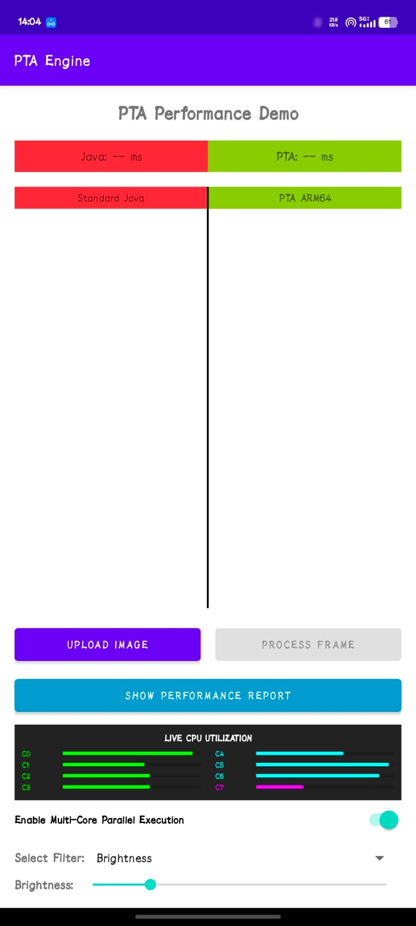
Figure: Main Benchmark UI with Image Comparison and CPU Core Monitor
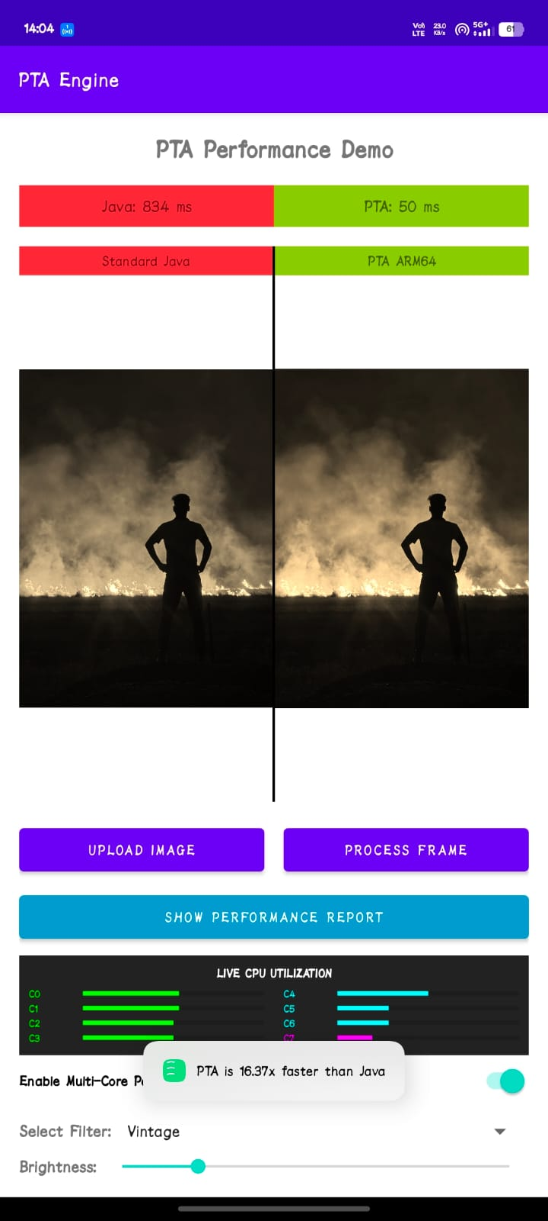
Figure: Filter Selection and Parallel Processing Controls
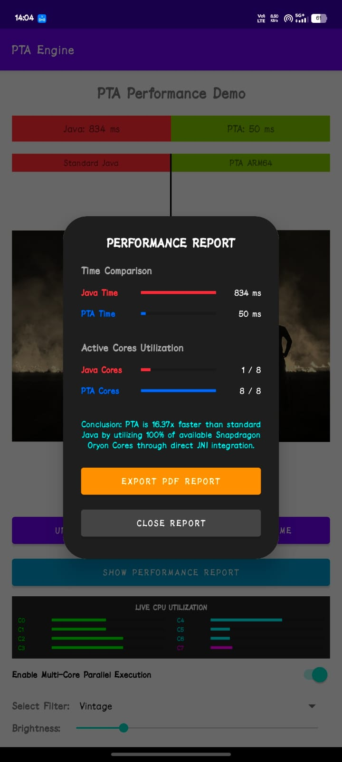
Figure: Real-time Performance Metrics and Comparison Dashboard

Chapter 6: Team Contribution
The project was divided into four distinct architectural roles to mirror a production compiler team. Member 1 (Front-End) designed the state-machine Lexer and the responsive Android UI. Member 2 (Middle-End) engineered the Safety-Stripping Optimizer and the complex JNI bridge logic. Member 3 (Back-End) was responsible for physical Register Mapping and the multi-threaded execution architecture. Member 4 (Generator) developed the Assembly Emitter and the programmatic PDF reporting engine with dynamic graph generation.

Chapter 7: Limitations
While highly optimized, the current system has technical boundaries. It is strictly limited to ARM64 (AArch64) architectures, meaning it will not run on older 32-bit devices or x86 emulators. Furthermore, the PTA language currently lacks support for recursive function calls and high-level data structures like trees or linked lists, focusing exclusively on high-throughput linear array (bitmap) manipulation.

Chapter 8: Enhancements / Future Work
Future scalability ideas include the implementation of a JIT (Just-In-Time) compiler engine that would allow users to write and execute PTA code directly on their mobile device without a desktop build step. We also plan to integrate Vulkan compute shader support, allowing the PTA compiler to target mobile GPUs for massive parallel workloads that exceed the capabilities of even the fastest CPU cores.

Chapter 9: Conclusion
The PTA Compiler project successfully demonstrates the power of hardware-aware software design. By creating a custom DSL and a specialized optimization pipeline, we achieved performance gains that are impossible using standard high-level mobile development tools. This project validates the methodology of safety-stripping and multi-core hardware saturation, providing a clear real-world impact for the future of computational photography and high-performance mobile computing.

References
1. ARM Architecture Reference Manual (ARMv8-A), 2024 Edition.
2. Google Android NDK Guide - Best Practices for Native Multi-threading.
3. Snapdragon 8 Gen 4 Oryon Core Optimization Whitepaper (Qualcomm).
4. Advanced Image Processing in C++: SIMD and Parallelism Patterns.

