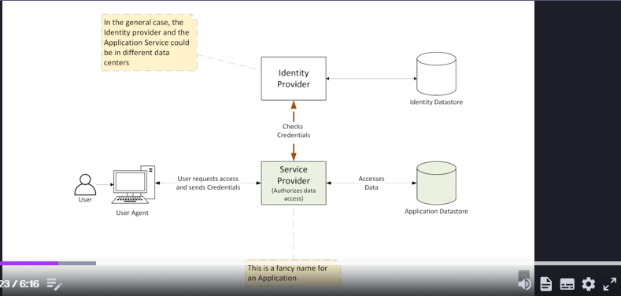
- Security Archicure Type
- HomeGrown
  - Identity: Stored in LDAP database, Microsoft Active Directory
  - Authentication: Done by LDAP (AD)
  - Authirization : Done by Application
  - LDAP and Application in same Data center
- LDAP
  - Identity: Stored in LDAP database, Microsoft Active Directory
  - Authentication: Done by LDAP (AD)
  - Authorization: Done by Application
  - LDAP and Application in same Data center
- JWT vs. Opaque Token
- Grant Types:
    - Authorization Code : We get access code in second response when of getAccess code request goes.

    - Authorization Code PKCE : We get access code in second response when of getAccess code request goes but in first request we send verifier, in second request we send verifier.
    - Implicit – (Deprecated) : We get access code in first response when of getAuthorization request.
    - Client Credential – When there is no Resource owner involved, this is suitable for batch job or client-server communication, get Access Token in response of first call or authorization based on client id and credential.
    - Resource Owner Password : It is used when all client,resource and authorization server are same appicatinos.
    - Refresh token:
    - Revoke token:

