1. Start Optimization 2020-04-22

Benchmark_128.mod

Workload with MicroProfiler 88 %– 108% without MicroProfiler 11% - 29%

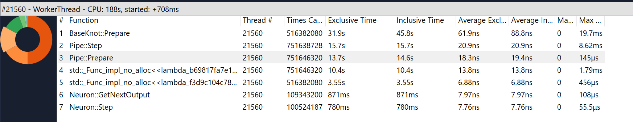

1. Made Apply2 … inline in BaseKnot::Prepare

Workload with MicroProfiler 59 %– 84% without MicroProfiler 14% - 25%

