f(x) = a\*x\*b\*\*(1-x)

f‘(x)= -a \* (ln(b)\*x-1) \* b\*\*(1-x)

Nullstelle f’(x0) = 0 => x0=1/ln(b)

f‘(x0) = (a/ln(b))\*b\*\*(1-1/ln(b))

Nullstelle vorgegeben (x0/y0) =>

a = y0 / (x0 \* (e\*\*(1/x0-1)))

b = e\*\*(1/x0)

r := 1/x0

a = y0/ (x0 \* (e\*\*(r-1))) = (y0/x0) \* e\*\*(1-r)

b = e\*\*r

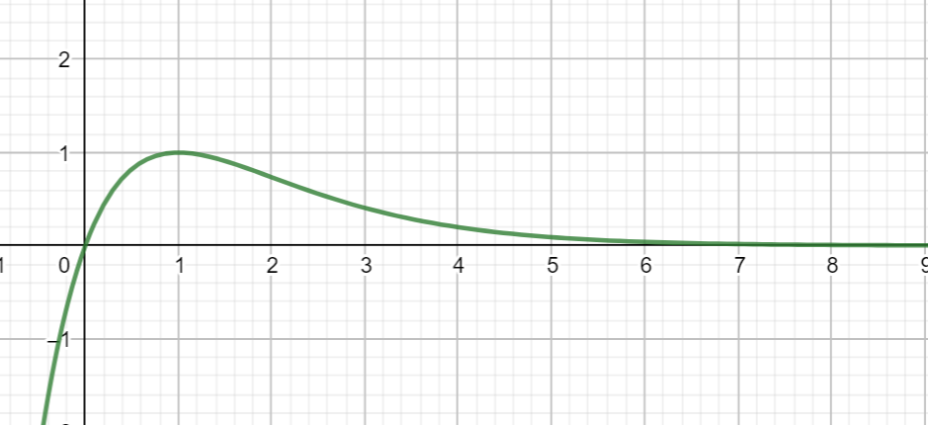

f(x) = x \* e hoch(1-x)