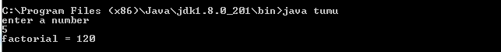

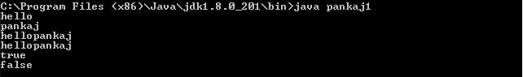

C:\Users\HPPppppppppppppppppp\Desktop\thread extends.PNG

C:\Users\HPPppppppppppppppppp\Desktop\thread implements.PNG

C:\Users\HPPppppppppppppppppp\Desktop\interface.PNG

C:\Users\HPPppppppppppppppppp\Desktop\exception handling 1.PNG

